TURKIYE PUBLIC AND MUNICIPAL RENEWABLE ENERGY PROJECT
(PUMREP)

SPP-1: 832 kWe/ 837 kWp
SPP-2: 989 kWe/ 999 kWp
SPP-3: 990 kWe/ 999 kWp
SOLAR (PHOTOVOLTAIC) POWER PLANT PROJECTS OF GİRESUN MUNICIPALITY

ENVIRONMENTAL AND SOCIAL MANAGEMENT PLAN (ESMP)

DECEMBER 2025
Document History

Revision | Submitted to | Issue Date | Revision Details
v1 | ILBANK | 15 October 2024 | Initial Draft
v2 | ILBANK | 30 November 2024 | Draft
V3 | ILBANK | 30 December 2024 | Draft
V4 | ILBANK | 20 January 2025 | Draft
V5 | ILBANK | 24 February 2025 | Draft
V6 | ILBANK | 29 April 2025 | Draft
V7 | ILBANK | 22 May 2025 | Draft
V8 | ILBANK | 06 August 2025 | Draft
V9 | ILBANK | 05 September 2025 | Draft
V10 | ILBANK | 06 November 2025 | Draft
V12 | ILBANK | 09 December 2025 | Draft

This document has been prepared by Uslu Technology Company.

Sub-Project Information
Sub-Project | Details
Name | Türkiye Public and Municipal Renewable Energy Project (PUMREP)  SPP-1: 832 kWe/ 837 kWp  SPP-2: 989 kWe/ 999 kWp  SPP-3: 990 kWe/ 999 kWp Solar (Photovoltaic) Power Plant Projects of Giresun Municipality  Environmental and Social Management Plan (ESMP)
Project Owner/ Sub-borrower | Giresun Municipality
Financial Intermediary | İller Bankası A.Ş (İLBANK)
Prepared by | Uslu Technology

Table of Contents

Table of Contents 5
List of Tables 7
List of Figures 9
Abbreviations 10
Glossary of Terms 12
EXECUTIVE SUMMARY 13
1 INTRODUCTION 15
1.1 Background 15
1.2 Objective of the ESMP 17
1.3 Overview of E&S Requirements Applicable to the Subproject 17
1.4 Review and Update 18
1.5 Implementation Arrangements 18
2 SUBPROJECT DESCRIPTION 19
2.1 Subproject Information 19
2.1.1 Sub-project Location 21
2.1.2 Site Access Route 24
2.1.3 Energy Transmission Line (ETL) 24
2.1.4 Sub-project Area of Influence 29
2.1.5 Environmental and Social Baseline 134
2.1.6 Biodiversity 141
2.1.7 Socio-economic Environment 149
3 SUBPROJECT ACTIVITIES 154
3.1 Construction Phase 154
3.1.1 Construction Activities 154
3.1.2 Construction Facilities 155
3.2 Operation Phase 155
3.2.1 Operation Activities 155
3.2.2 Operation Facilities 156
3.3 Labor Requirements 156
3.4 Land Acquisition Status 157
3.5 Permitting Status 158
4 ESMP MATRIX: RISK AND IMPACTS, MITIGATION AND MONITORING 160
4.1 E&S Risk and Impacts of the Subproject 161
4.1.1 Pre-construction phase 161
4.1.2 Construction Phase 162
4.1.3 Operation Phase 171
4.2 Construction ESMP Matrix 175
4.3 Operation ESMP Matrix 201
4.4 Monitoring and Reporting 215
4.5 List of Associated Plans and Procedures 242
4.6 Management of Change 242
5 CAPACITY DEVELOPMENT AND TRAINING 243
5.1 Organizational Capacity 243
5.2 Roles and Responsibilities 245
5.3 Capacity Building and Training 247
6 IMPLEMENTATION SCHEDULE AND COST ESTIMATES 247
6.1 Implementation Schedule 247
6.2 Cost Estimates 250
List of Annexes 252
253
Annex A – Existing Permitting Documentation 254
Annex B – Title Deed and Lease Agreement 262
Annex C – Site Photographs 268
Annex D – E&S Incident Notification Form Template 271
Annex E – E&S Incident Investigation Form Template 274
Annex F – Chance Find Procedure 277
Annex G – Change Notification Form 286
Annex H - Institutional and Legal Framework in Türkiye 288
Annex İ - Solar panel site 295
Annex J Description of Conservation Status Categories 298
Annex K . Sub project Site Layout Plan 300

List of Tables

Table 1. Sub-project information 14
Table 2. Relevance of the WB ESSs to the Subproject 16
Table 3. Subprojecst Information 18
Table 4. Subproject Location 20
Table 5. Coordinates of the Sub-Project Areas 21
Table 6. Technical Information on the ETL 24
Table 7. Summary of Baseline Site Visit 134
Table 8. Giresun Province Official Climate Statistics (General Directorate of Meteorology) 137
Table 9. Pollutant parameter amounts 138
Table 10. Flora of Area of influence 141
Table 11 Area of influence and The Surroundings Fauna List 144
Table 12 Population data of Alucra District 149
Table 13. Population data of Hacılı Neighborhood 150
Table 14. Operation Facilities 155
Table 15. Labor Requirements of the Subproject 156
Table 16. Land Acquisition Status for the Subproject and Associated Facilities 156
Table 17. Status of Permits for the Construction Phase 157
Table 18. Control of Industrial Air Pollution 162
Table 19. Working hours 163
Table 20. Diesel Properties 163
Table 21. Emission Factors Used in Calculations 164
Table 22. Emission calculations 164
Table 23. Amount of Emission 164
Table 24. Comparison of amount of emissions with limit values 165
Table 25. Usage periods of the work machines to be used in the facility 165
Table 26. Diesel Properties 166
Table 27. Emission Factors Used in Calculations 166
Table 28. Emission calculations 166
Table 29. Amount of Emission 167
Table 30. Comparison of amount of emissions with limit values 167
Table 31. Probable Ldaytime Noise Levels During the Construction Phase 168
Table 32 Key Performance Indicators for Both Construction and Operation Phases of the Subproject 214
Table 33. Construction Environmental and Social Monitoring Table 218
Table 34..Operation Environmental and Social Monitoring Table 231
Table 35. Plans and Procedures associated 237
Table 36. Roles and E&S related Responsibilities of Key Parties associated with ESMP Implementation 240
Table 37. Training Components for Training of Contractor Staff 242
Table 38. Duration of Activities 243
Table 39. Table of implementation Schedule 244
Table 40. ESMP Cost Breakdown for Implementation and Monitoring 245

List of Figures

Figure 1. Map of Subproject Location 21
Figure 2. Sub-project site access route 23
Figure 3. Map of ETL Route 25
Figure 4. Sub-project Area of Influence 27
Figure 5. Earthquake map of Sub-project Sites 136
Figure 6. Sub-project Area Tectonic Map 137
Figure 7. Biodiversty Area of influence plots 140
Figure 8. Carthamus lanatus 143
Figure 9. Rhamnus microcarpa Boiss 143
Figure 10. Sub-project sites access route 151
Figure 11. The closest cultural heritage to the sub-project sites. 151
Figure 12. Sub-project campsites 156
Figure 13. Organization Structure – Project Implementation Unit (PIU) of Giresun Municipality 239

Abbreviations

AoI | Area of Influence
CITES | Convention on the International Trade in Endangered Species of Wild Flora and Fauna
EIA | Environmental Impact Assessment
EHS | Environmental Health and Safety
EMRA | Energy Market Regulatory Authority
ESF | Environmental and Social Framework
ESMP | Environmental and Social Management Plan
ESMR | Environmental and Social Monitoring Report
ESMS | Environmental and Social Management System
ESS | Environmental and Social Standard
ETL | Energy Transmission Line
E&S | Environmental and Social
EU | European Union
FI | Financial Intermediary
GHG | Greenhouse Gas
GIIP | Good International Industry Practice
GM | Grievance Mechanism
GMCP | Grievance Mechanism Contact Person
GIS | Geographic Information Systems
IFIs | International Finance Institutions
ILO | International Labor Organization
ILBANK | Iller Bankası A.S.
KPIs | Key Performance Indicators
LOTO | Lockout Tagout
MoEUCC | Ministry of Environment, Urbanization and Climate Change
OG | Official Gazette
OHS | Occupational Health and Safety
PMU | Project Management Unit
PIU | Project Implementation Unit
PPE | Personal Protective Equipment
PUMREP | The Turkish Public and Municipal Renewable Energy Project
RE | Renewable Energy
SEP | Stakeholder Engagement Plan
SPP | Solar Power Plant
Sub-project  TAP | SPP-1 SPP-2 and SPP-3 Solar (Photovoltaic) Power Plant Projects of Giresun Municipality  Türkiye Portable Battery Manufacturers and Importers Association
TurkStat | Turkish Statistical Institute
IUCN | International Union for the Conservation of Nature
WB | World Bank
WBG | World Bank Group
WHO | World Health Organization

Glossary of Terms

Associated facilities | Facilities or activities that are not funded as part of the Subproject and are:  (a) directly and significantly related to the project;  (b) carried out, or planned to be carried out, contemporaneously with the project; and  (c) necessary for the project to be viable and would not have been constructed, expanded or conducted if the project did not exist.  For facilities or activities to be Associated Facilities, they must meet all three criteria.
Contractor | A person or organization providing services to an employer at the client worksite in accordance with agreed specifications, terms and conditions.
Excavated material | Materials/soils that are generated as a result of excavation and other similar activities carried out prior to construction
Legally protected area | Designated terrestrial, aquatic or marine ecosystems managed under the related legislation to protect and sustain the biodiversity features, natural and associated cultural resources.  Legally protected areas of Türkiye include a diversity of natural ecosystems and associated features ranging from coastal zones to mountains, deltas, forests, plains, steppe, lakes, river systems, deep valleys, canyons, and glaciers.
Material borrow site | Sites, where loose material containing gravel, sand, silt, and clay, which is formed by the natural and geological processes of rock fracturing, fragmentation, alteration, transportation, and/or in-situ sedimentation, and which has the characteristics of slope debris, are extracted to be used as fill material.
Off-site accommodation | Accommodation of workers at hotels, rented housing, etc. available in the vicinity of Subproject area.
On-site accommodation | Accommodation of workers at temporary exploration camps, construction camps, dormitories, etc. established for the Subproject on site.
Risk | A combination of the likelihood of an occurrence of a hazardous event and the severity of injury or damage to the health of people caused by this event.
Topsoil | Part of soil that provides organic and inorganic materials, air and water required for vegetative growth, and is required to be stored separate from the subsoil.

EXECUTIVE SUMMARY
The Turkiye Public and Municipal Renewable Energy Project (PUMREP) is designed to support the Government of Türkiye in promoting the use of renewable energy (RE) in the public sector, with a particular focus on central government buildings and municipalities. The project aims to expand the distributed RE market within public facilities, assist Türkiye in meeting its climate mitigation commitments, and demonstrate leadership in sustainable energy use across the public sector, thereby enhancing energy security.
PUMREP is financed by the World Bank (WB) to facilitate the deployment of RE technologies by municipalities. ILBANK serves as the Financial Intermediary (FI). The installed RE systems are primarily intended to offset energy consumption in public facilities (e.g., administrative buildings, water supply and treatment plants, public lighting), ultimately reducing energy costs for municipalities.
To ensure proper environmental and social risk management, ILBANK has implemented an Environmental and Social Management System (ESMS), effective as of December 24, 2023. The ESMS establishes procedures to identify, assess, manage, monitor, and report environmental and social (E&S) risks and impacts associated with IFI-financed projects and sub-projects. These procedures must be applied continuously throughout the loan period, in alignment with national laws, Türkiye's ratified international treaties, and the E&S standards of the relevant IFIs—namely, the World Bank for PUMREP. A cornerstone of this system is ILBANK’s Environmental and Social Policy, which applies to all relevant projects.
As part of PUMREP Component-2, Giresun Municipality has prepared solar power plant (SPP) projects to reduce electricity expenditures and meet energy demands through sustainable and renewable sources. These sub-projects are to be financed under PUMREP and involve the installation of solar power facilities with a total capacity of 2,835 kWp / 2,811 kWe.
The sub-project comprises three separate SPP installations located in Giresun province, Alucra district, Hacılı Neighborhood, on the following parcels:
SPP-1: 837 kWp / 832 kWe (Block 138, Lot 1),
SPP-2: 999 kWp / 989 kWe (Block 139, Lot 1),
SPP-3: 999 kWp / 990 kWe (Block 140, Lot 1).
The land where the solar power plants will be constructed is owned by Hacılı Neighborhood and leased to Giresun Municipality.
According to ILBANK’s ESMS and the World Bank’s Environmental and Social Framework (ESF), the sub-project has been classified as having a Moderate E&S risk level. In line with these requirements, an Environmental and Social Management Plan (ESMP) has been prepared. This document outlines the necessary environmental and social measures to be taken during the construction and operational phases, in accordance with national legislation, the World Bank Environmental and Social Standards (ESSs), the WBG General Environmental, Health and Safety Guidelines, and relevant industry-specific guidelines.
The ESMP provides a comprehensive framework for managing and mitigating potential environmental and social impacts. It includes project details, site characteristics, current environmental and social conditions, anticipated impacts, mitigation and monitoring measures, institutional responsibilities, implementation timelines, and estimated costs.
As per the Environmental Impact Assessment (EIA) Regulation published in the Official Gazette dated 25.11.2014 (No. 29186), the subprojects are below the threshold requiring a full EIA. The Giresun Governorship Environment and Urbanization Provincial Directorate confirmed this with a letter dated 06.11.2024 (No. 85645151-220-02-E.2024489) (See Annex A).
The subproject sites are located approximately 800 meters from the nearest settlement (Hacılı Neighborhood) and is not expected to adversely affect local communities. No sensitive institutions such as schools or healthcare facilities are situated along the access roads. The Energy Transmission Line (ETL) to be constructed to connect the solar power plants to the grid is planned as a 1,250-meter-long underground line. The energy transmission line (ETL) to be constructed as part of the sub-projects will pass mostly through the cadastral road. Only the last 28 meters of the ETL are located within Lot 1 of Block 133. This lot is also leased by the municipality from Hacılı Neighborhood. The lease agreement is provided in Annex B.. The land designated for the Energy Transmission Line (ETL) is also owned by the Hacılı Neighborhood legal entity and has been leased by the municipality. The sub-project areas do not reduce existing grazing lands, as there issufficientland available for livestock activities nearby.
Strict adherence to occupational health and safety (OHS) procedures is required during and after the plant installation. Maintenance and repair activities are to follow manuals provided by the contractor or equipment manufacturer. No personnel should be employed on-site without prior training, which must be both theoretical and practical.
Although the region does not present significant natural disaster risks such as floods, landslides, or avalanches, the ESMP includes provisions for emergency preparedness, particularly for fire and similar hazards.
During the construction phase, temporary environmental impacts such as dust emissions, noise, and waste generation may occur. Social impacts may include traffic congestion from construction vehicles and limited communication with local residents. All potential impacts and corresponding mitigation measures are outlined in the ESMP Matrix to ensure environmental and social sustainability throughout sub-projects implementation.

INTRODUCTION

Background
The Public and Municipal Renewable Energy Project (PUMREP) (hereinafter referred to as “the Project”) aims to increase the use of renewable energy through self-generation in public facilities. The project will contribute to expanding the distributed renewable energy (RE) market in public facilities help demonstrate leadership in the public sector to use sustainable energy solutions to deliver on the country’s climate mitigation commitment and enhance energy security.
The PUMREP is financed by World Bank (WB) to support introducing RE technologies in municipalities. İller Bankası A.Ş. Department of International Relations (ILBANK) acts as the Financial Intermediary (FI). The project will be implemented through 4 components:
Component 1: Renewable energy investments in central government facilities
Component 2: Renewable energy investments in municipalities
Component 3: Technical assistance and project implementation support
Component 4: Contingent Emergency Response Component (CERC).
Giresun Municipality (hereinafter referred to as “the Sub-borrower”) has applied to ILBANK for sub-financing of "Giresun Municipality SPP-1: 837 kWp / 832 kWe, SPP-2: 999 kWp / 989 kWe, SPP-3: 999 kWp / 990 kWe Solar Power Plants Project" (here in after referred to as “the Sub-project”) under Component 2. The sub-projects are located in Hacılı Neighborhood of Alucra District of Giresun Province.
Basic information about the sub-projects are given in Table 1.
Table 1. Sub-project information
 | Installed Power | Annual Average Electricity Production* | Project Land | Project Area | EIA
Giresun Municipality SPP-1 | 832 kWe /837 kWp | 1,468,405 kWh/year | 138/1 | 16,702 m² | EIA is not required
Giresun Municipality SPP-2 | 989 kWe / 999 kWp | 1,793,933 kWh/year | 139/1 | 15,254m² | EIA is not required
Giresun Municipality SPP-3 | 990 kWe / 999 kWp | 1,791,662 kWh/year | 140/1 | 15,532m² | EIA is not required

ILBANK has established an Environmental and Social Management System (ESMS) effective on 24th of Dec 2023. The ESMS is aligned with the requirements of World Bank (WB) Environmental and Social Framework (ESF, 2018) including Environmental and Social Standards (ESSs) forming part of the ESF, and E&S polices and standards of other International Financial Institutions (IFIs) ILBANK collaborates with. It will be applicable to all ILBANK projects and Subproject financed through International Financial Institutions (IFIs).
The ESMS is aimed at ensuring systematic identification, assessment, management, monitoring, and reporting of the environmental and social (E&S) risks and impacts of the projects and Subproject financed by the International Finance Institutions (IFIs). This process will be implemented on an ongoing basis throughout their loan duration in line with the requirements of the national legislation, international agreements and conventions ratified by Turkiye and E&S standards of lending IFIs (World Bank for the PUMREP). As a critical element of the ESMS, ILBANK has adopted and published an E&S Policy applicable to all ILBANK projects and sub-project financed through IFIs.
Within the scope of the ILBANK’s ESMS and World Bank Environmental and Social Framework (ESF), sub projects are classified as High Risk, Substantial Risk, Moderate Risk or Low Risk taking into account relevant potential risks and impacts, such as the type, location, sensitivity and scale of the Subproject; the nature and magnitude of the potential E&S risks and impacts; the capacity and commitment of the sub-borrower; and other relevant areas of risks that may result in unintended impacts.
ILBANK considers financing the sub-projects under the PUMREP. In line with the ESMS, ILBANK carried out an E&S screening and risk classification of the sub-projects and rated the activity as having “Moderate” E&S risk. The Sub-borrower has retained a third-party consultancy company for the preparation of the E&S instruments required as per the E&S risk category assigned to the sub-projects.
This Environmental and Social Management Plan (ESMP) has been prepared by Uslu Teknology for the sub-projects in line with the applicable E&S requirements as set out in Section 4. List of the Individuals/Organizations that Prepared or Contributed to the ESMP development is present in Annex A.
A stand-alone Stakeholder Engagement Plan (SEP) has also been developed for the sub-project.

Objective of the ESMP
This ESMP has been prepared to detail the measures to be taken during the implementation and operation (throughout the sub-financing agreement life cycle) of the sub-project to eliminate or offset adverse E&S impacts, or to reduce them to acceptable levels; and the actions needed to implement these measures.

Overview of E&S Requirements Applicable to the Subproject
The sub-projects will be implemented in compliance with the requirements of the applicable national legislation and international agreements and conventions to which Turkiye is a party of, and in accordance with the following international requirements:
- WB Environmental and Social Framework (ESF, 2018) and the Environmental and Social Standards (ESSs) forming part of the ESF,
- WB Group General Environmental, Health and Safety Guidelines (EHSGs) (2007)
- GIIP
- WBG EHS Guidelines for Electric Power Transmission and Distribution (2007)
Table 2 Identifies the relevance of the WB ESSs to the sub-project.
Table 2. Relevance of the WB ESSs to the Subproject
ESSs | Definition | Relevance to the Subproject
ESS 1 | Assessment and Management of E&S Risks and Impacts | Relevant
ESS 2 | Labor and Working Conditions | Relevant
ESS 3 | Resource Efficiency and Pollution Prevention and Management | Relevant
ESS 4 | Community Health and Safety | Relevant
ESS 5 | Land Acquisition, Restrictions on Land Use and Involuntary Resettlement | Relevant
ESS 6 | Biodiversity Conservation and Sustainable Management of Living Natural Resources | Relevant
ESS 7 | Indigenous Peoples/Sub-Saharan African Historically Underserved Traditional Local Communities | Not relevant in Türkiye
ESS 8 | Cultural Heritage | Relevant
ESS 9 | Financial Intermediaries | Not relevant to Subproject
ESS 10 | Stakeholder Engagement and Information Disclosure | Relevant

When national requirements differ from the levels and measures presented in the EHSGs, the sub-project will achieve or implement whichever is more stringent.
A summary of the national legislation and international standards applicable to the management of environmental, social, health, and safety aspects of the sub-project is provided in Annex H.

Review and Update
This ESMP will be reviewed and updated by the Sub-borrower during sub-projects implementation as necessary to reflect changes in national legislative framework, ILBANK’s policies and other developments or in specific circumstances such as in case there are changes in the organization structure, following significant incidents, following incorporation of new tools, software or database into the ILBANK E&S Risk Management System, etc.
The Sub-borrower will notify ILBANK of any update to the ESMP.
The Sub-borrower will ensure that changes to the ESMP do not result in deviation from the requirements set forth by the national legislation and the E&S requirements applicable to the sub-projects.

Implementation Arrangements
The Sub-borrower will hold ultimate responsibility for implementation of this ESMP by the Sub-borrower and contractor teams (engaged in connection with the sub-project – including sub-contractors) throughout the sub-financing agreement life cycle.
The Sub-borrower will ensure that adequate financial and human resources for effective ESMP implementation are available at sub-borrower, supervision consultant and contractor organizations throughout the sub-financing agreement life cycle.
The Sub-borrower will decide on the arrangements for the operation of the sub-project and be responsible for ensuring that operations are compliant with the national legislation and operation ESMP.
The roles and responsibilities of the Sub-borrower, contractor and sub-contractor teams regarding the ESMP implementation are described in Chapter 5.
This ESMP provides instructions, responsibilities and guidelines to the responsible parties, as well as a set of mitigation, monitoring and institutional measures to be taken during the construction and operation of the sub-project to prevent or reduce potential adverse environmental and social impacts to acceptable levels. Technical parameters for all monitoring requirements are defined, along with appropriate responsibilities and reporting procedures. In addition, a Grievance Mechanism (GM) for receiving and evaluating all grievances, concerns and comments regarding the sub-project is specified in the sub-project specific SEP. The ESMP has identified mitigation measures and monitoring activities to reduce and avoid impacts and risks associated with the sub-project. A summary of mitigation measures is provided in Section 4.2 and 4.3.
During the construction and operation phases, PIU assigned by Giresun Municipality will ensure compliance with national and international legislation.

SUBPROJECT DESCRIPTION

Subproject Information
The sub-projects activity subject is related to the establishment and operation of "Giresun Municipality Solar Power Plants SPP-1: 837 kWp / 832 kWe, SPP-2: 999 kWp / 989 kWe, SPP-3: 999 kWp / 990 kWe by Giresun Municipality. These plants will be constructed on parcels located on Lot 1 of Block 138, Lot 1 of Block 139, and Lot 1 of Block 140, within the boundaries of Hacılı Neighborhood, Alucra District, Giresun Province.
The sub-projects parcels are registered as "land" in the land registry. According to the Turkish Environmental Impact Assessment (EIA) Regulation (Official Gazette No. 31907, dated 29.07.2022), the sub-projects are considered outside the scope of EIA requirement.
The main objective of the sub-projects are to generate electricity from solar energy an environmentally friendly and renewable source by installing solar panels. This will allow Giresun Municipality to utilize its electricity budget more efficiently.
Specifically, the sub-projects aims to meet approximately 62.3% of the municipality’s electricity demand, thereby significantly reducing energy expenditures and promoting sustainable energy use. In doing so, the subprojects also contributes to the protection of the environment and human health.
The sub-projects components to be financed consist of SPP-1, SPP-2, SPP-3 and ETL. Key technical information on the sub-projects are summarized in Table 3. The ETL to be constructed to connect the solar power plants to the grid is planned as a 1,250-meter-long underground line. Further details about the ETL is provided in Section 2.1.3.
Table 3. Subprojecst Information
SPP | Information | Remarks/ Notes
SPP-1 | Technology | Photovoltaic
SPP-1 | Installed Power | 837 kWp
SPP-1 | Connection Power | 832 kWe
SPP-1 | Annual Electricity Generation | 1.468 MWh
SPP-1 | Solar Panel Type | CW Solar Monoperc 144PM10
SPP-1 | Annual Carbon Emission Reduction | 985 ton
SPP-1 | Lifetime Carbon Emission Reduction | 24,625 ton
SPP-1 | Households Powered | 641
SPP-1 | Economic Life of the Power Plant (Operation Duration) | 25

SPP | Information | Remarks/ Notes
SPP-2 | Technology | Photovoltaic
SPP-2 | Installed Power | 999 kWp
SPP-2 | Connection Power | 989 kWe
SPP-2 | Annual Electricity Generation | 1.793 MWh
SPP-2 | Solar Panel Type | CW Solar Monoperc 144PM10
SPP-2 | Annual Carbon Emission Reduction | 1,002 ton
SPP-2 | Lifetime Carbon Emission Reduction | 25,050 ton
SPP-2 | Households Powered | 645
SPP-2 | Economic Life of the Power Plant (Operation Duration) | 25

SPP | Information | Remarks/ Notes
SPP-3 | Technology | Photovoltaic
SPP-3 | Installed Power | 999 kWp
SPP-3 | Connection Power | 990 kWe
SPP-3 | Annual Electricity Generation | 1.791 MWh
SPP-3 | Solar Panel Type | CW Solar Monoperc 144PM10
SPP-3 | Annual Carbon Emission Reduction | 1007 ton
SPP-3 | Lifetime Carbon Emission Reduction | 25,175 ton
SPP-3 | Households Powered | 643
SPP-3 | Economic Life of the Power Plant (Operation Duration) | 25

Sub-project Location
The lands determined for the SPP-1, SPP-2, SPP-3 have been planned to be carried out by the Giresun Municipality on the lands which are lot 1 of block 138, lot 1 of block 139 and lot 1 of block 140 belongs to Hacılı Neighborhood Legal Entity. The lands have been leased by Giresun Municipality for 35 years starting from 2021. They are registered as lands in the title deeds. There is no agricultural or animal husbandry activity within the undisturbed area (See Table 4). Images of the lands are given in Annex C.
Information on the sub-projects location is presented Table 4.
Table 4. Subproject Location
Information | Remarks/ Notes
Province | Giresun
District | Alucra
Neighborhood/ Village | Hacılı
Lot/Block No. | lot 1 of block 138,  lot 1 of block 139  lot 1 of block 140
Land Area (ha) | Around ~4,8 ha,  138/1 parcel: SPP-1 site has an area of 16,702 m²,  139/1 parcel: SPP-2 site has an area of 15,254 m²,  140/1 parcel: SPP-3 site has an area of 15,532 m² and  The total area of 47,488 m² will be used for the sub-project
Land Use Type according to Title Deed | Land use type is “Land” according to title deed
Current Land Use | There have been no grazing activities or agricultural use in the sub-projects areas for the last 2 years. Lands are not currently in use.
Other Nearby Facilities and Activities | There are no facilities or activities around the sub-projects areas.
A map of the sub-project location is presented in Figure 1.
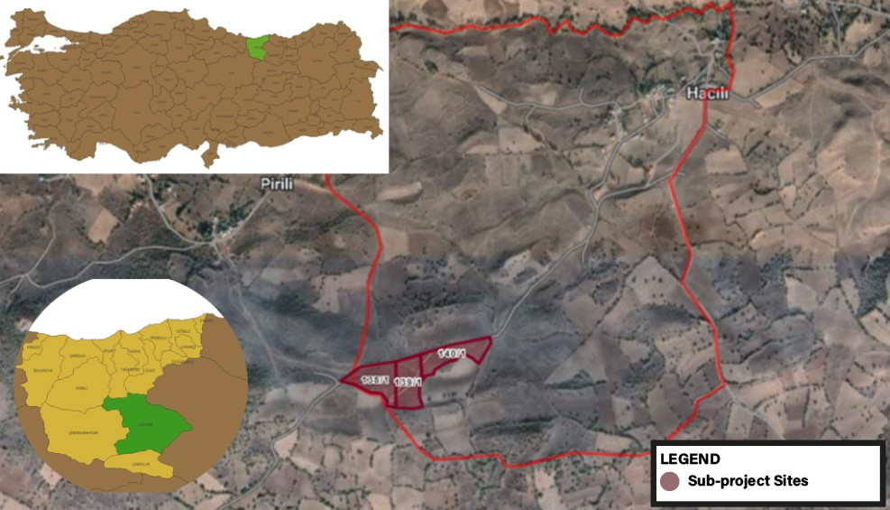
Figure 1. Map of Subproject Location

Table 5. Coordinates of the Sub-Project Areas
Unit | Coordinates (UTM in decimals)
Unit | Y | X
SPP-1 (138/1) | 482862.39 | 4464599.58
SPP-1 (138/1) | 422862.43 | 4464579.58
SPP-1 (138/1) | 482862.47 | 4464559.58
SPP-1 (138/1) | 482862.51 | 4464539.58
SPP-1 (138/1) | 482862.55 | 4464519.58
SPP-1 (138/1) | 482862.58 | 4464499.58
SPP-1 (138/1) | 482862.62 | 4464479.48
SPP-1 (138/1) | 482862.66 | 4464458.8
SPP-1 (138/1) | 482832.57 | 4464460.5
SPP-1 (138/1) | 482830.52 | 4464463.58
SPP-1 (138/1) | 482832.64 | 4464477.3
SPP-1 (138/1) | 482811.50 | 4464508.91
SPP-1 (138/1) | 482712.78 | 4464587.9
SPP-1 (138/1) | 482713.67 | 4464588.56
SPP-1 (138/1) | 482732.87 | 4464599.52
SPP-1 (138/1) | 482744.28 | 4464602.8
SPP-1 (138/1) | 482780.35 | 4464608.69
SPP-1 (138/1) | 482840.03 | 4464614.89
SPP-1 (138/1) | 482862.36 | 4464619.58
SPP-2 (139/1) | 482864.3565 | 4464619.999
SPP-2 (139/1) | 482874.0674 | 4464622.037
SPP-2 (139/1) | 482907.3246 | 4464633.234
SPP-2 (139/1) | 482950.2968 | 4464646.756
SPP-2 (139/1) | 482951.2403 | 4464626.779
SPP-2 (139/1) | 482952.1838 | 4464606.802
SPP-2 (139/1) | 482953.1273 | 4464586.825
SPP-2 (139/1) | 482954.0707 | 4464566.848
SPP-2 (139/1) | 482954.6444 | 4464554.702
SPP-2 (139/1) | 482952.3995 | 4464542.895
SPP-2 (139/1) | 482947.5459 | 4464529.562
SPP-2 (139/1) | 482945.5756 | 4464519.409
SPP-2 (139/1) | 482947.7372 | 4464503.571
SPP-2 (139/1) | 482946.0521 | 4464497.203
SPP-2 (139/1) | 482949.37 | 4464479.207
SPP-2 (139/1) | 482956.7694 | 4464462.006
SPP-2 (139/1) | 482924.1154 | 4464454.249
SPP-2 (139/1) | 482893.0338 | 4464456.472
SPP-2 (139/1) | 482864.6594 | 4464458.648
SPP-2 (139/1) | 482864.6219 | 4464478.648
SPP-2 (139/1) | 482864.5843 | 4464498.648
SPP-2 (139/1) | 482864.5468 | 4464518.648
SPP-2 (139/1) | 482864.5092 | 4464538.648
SPP-2 (139/1) | 482864.4717 | 4464558.648
SPP-2 (139/1) | 482864.4341 | 4464578.649
SPP-2 (139/1) | 482864.3966 | 4484598.649
SPP-3 (140/1) | 482952.2695 | 4464647.381
SPP-3 (140/1) | 482973.907 | 4464654.24
SPP-3 (140/1) | 482979.948 | 4464656.38
SPP-3 (140/1) | 483009.1678 | 4464664.597
SPP-3 (140/1) | 483034.0004 | 4464671.2
SPP-3 (140/1) | 483057.433 | 4464676.672
SPP-3 (140/1) | 483079.4911 | 4464681.344
SPP-3 (140/1) | 483097.987 | 4464686.597
SPP-3 (140/1) | 483137.912 | 4464695.246
SPP-3 (140/1) | 483179.141 | 4464702.756
SPP-3 (140/1) | 483198.2731 | 4464706.521
SPP-3 (140/1) | 483160.3052 | 4464611.123
SPP-3 (140/1) | 483154.4547 | 4464619.814
SPP-3 (140/1) | 483134.1779 | 4464835.04
SPP-3 (140/1) | 483109.41 | 4464645.052
SPP-3 (140/1) | 483090.6641 | 4464540.71
SPP-3 (140/1) | 483079.9695 | 4464626.829
SPP-3 (140/1) | 483043.4065 | 4464818.904
SPP-3 (140/1) | 483022.9833 | 4464603.626
SPP-3 (140/1) | 483003.4816 | 4464590.278
SPP-3 (140/1) | 482999.2916 | 4464581.813
SPP-3 (140/1) | 482998.0297 | 4464574.937
SPP-3 (140/1) | 482985.4596 | 4464573.783
SPP-3 (140/1) | 482968.7471 | 4464568.196
SPP-3 (140/1) | 482956.261 | 4464556.249
SPP-3 (140/1) | 482955.3859 | 4494576.23
SPP-3 (140/1) | 482959.5107 | 4464596.211
SPP-3 (140/1) | 482953.6358 | 4464816.191
SPP-3 (140/1) | 482952.9793 | 4464631.177

Site Access Route
Hacılı Neighborhood of Alucra district of Giresun province is located approximately 5 km northeast of the district center. The sub-projects sites are 1.5 km away from the Bayburt-Şebinkarahisar road. The road to the sites is the currently used road from Alucra district to Hacılar neighborhood.
Access to parcels numbered 138/1, 139/1, 140/1 is provided via existing roads and no new road works will be carried out within the scope of the sub-project. There are existing roads around the sub-project areas. The sub-project sites’ access road is a stabilized road and is suitable for the passage of vehicles that will work during the construction and operation phases. There is no need for repair/improvement except for possible minor damage to the road. The main road access to the sub-project areas are shown in Figure 2 below.
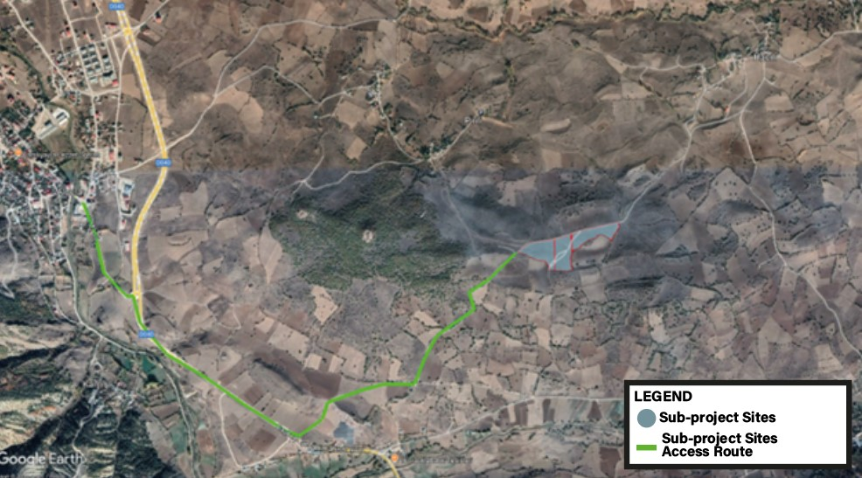
Figure 2. Sub-project site access route

Energy Transmission Line (ETL)

The Energy Transmission Line (ETL), which will be jointly used for each solar power plant sites, is planned to be constructed underground, with a total length of approximately 1,250 meters. In addition, three underground lines extending from the concrete kiosk located in lot 1 of block 133 and connecting to the Çamoluk Transformer Center have been planned, with an underground length of approximately 100 meters.
Except for the last 28 meters, the entire ETL route passes through existing cadastral roads/gaps. The remaining 28-meter section crosses lot 1 of block 133, which is owned by Hacılı Neighborhood and has been leased by Giresun Municipality for 35 years starting from 2021. The title deed and lease agreement for this parcel are provided in Annex B.
A new transformer center will be constructed for the connection of the ETL to the national grid. Among the three planned connections to the existing transformer center, two will be made along the existing power line route, so no new connection poles will be required. The third connection will be constructed underground along the cadastral road.
The existing ETL and poles located on the parcels listed below are situated on existing cadastral roads or on public property; therefore, no additional easement right is required for these areas:
- Lot 9 of block 129: 20 meters
- Lot 1 of block 124: 25 meters
- Lot 3 of block 122: 13 meters
- Lot 8 of block 128: 25 meters
- Lot 49 of block 130: 185 meters
- Lot 11 of block 130: 12 meters
- Lot 12 of block 130: 39 meters
- Lot 1 of block 136: 18 meters
Site inspections confirmed that no agricultural, livestock, or grazing activities are conducted along the ETL route.
Technical details about the ETL, as well as a map showing the ETL route and the national grid connection point, are provided in Figure 3.
Table 6. Technical Information on the ETL
Information | Remarks / Notes
Status of ETL | The planned ETL will be newly constructed and will consist entirely of underground cables, including:  1,250 meters of underground line  100 meters of additional underground line connecting from the concrete kiosk in lot 1 of block 133 to the Çamoluk Transformer Center.
Transformer station (for national grid connection) | Camoluk Transformer Center
Length of the route (km) | 1,250
Voltage level (kV) | 31.5 kV
Number of parcels subject to expropriation | There is no need for expropriation.
Number of parcels not subject to easement rights | These parcels lie along the ETL route but do not require establishment of easement rights:  129/9  124/1  122/3  128/8  130/49  130/11  130/12  136/1  133/1
Number of parcels subject to leasement | 133/1,

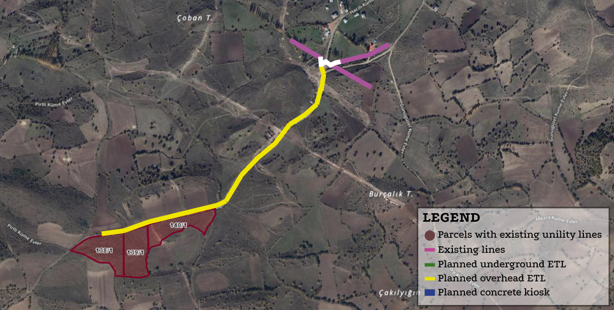

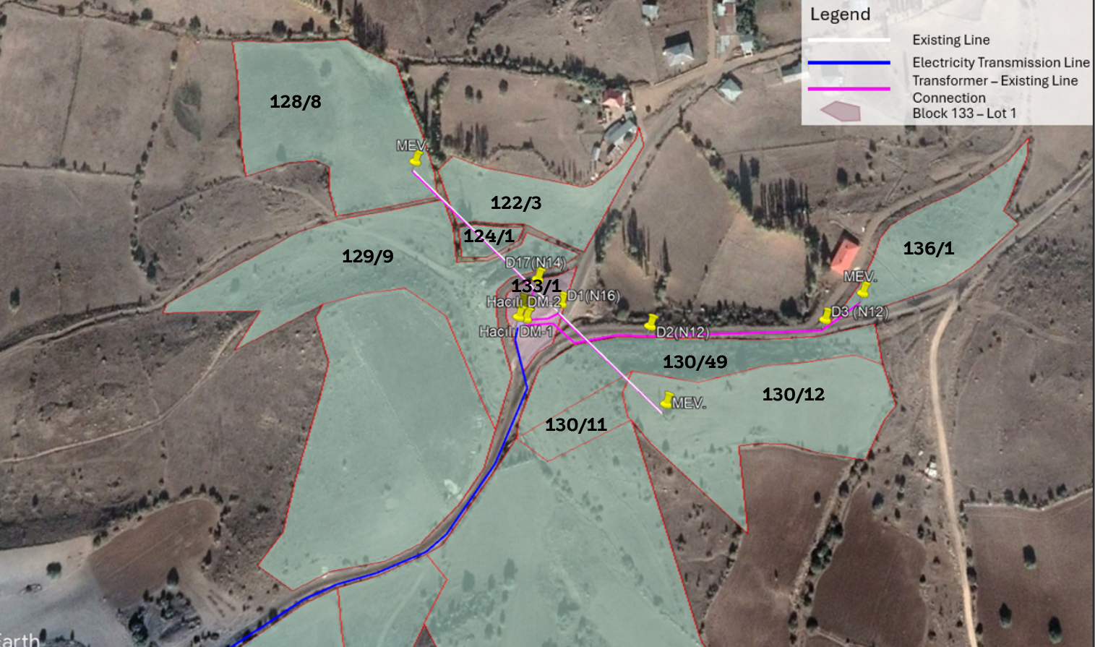

Figure 3. Map of ETL Route

Sub-project Area of Influence
The sub projects are located in Hacılı Neighborhood, approximately 750 meters away from the neighborhood center. The access road leading to the sub project sites passes in front of Alucra District. Along this access route, there are no critical facilities that provide emergency services, such as health centers, schools, or fire departments.
In the context of the sub-project preparation, a field visit was conducted on 15 May 2025, during which consultations were held with local residents and the mukhtar of Hacılı Neighborhood. Based on these consultations, the area of influence was determined by evaluating several environmental and social components, including potential dust emissions, environmental noise, local employment opportunities, the perspectives of the local community, and the presence of vulnerable or disadvantaged groups. No such vulnerable or disadvantaged households were identified along the access road, and the mukhtar confirmed that the sub project is not expected to negatively affect any of these groups.
The closest sensitive receptors to the sub-projects are three residential structures located at varying distances from the subproject components. A household is situated approximately 620 meters northwest of the SPP-1 area, while individual residences are located 653 meters and 756 meters south of the SPP-2 and SPP-3 areas, respectively. These are considered the nearest sensitive receptors potentially subject to sub-project-related impacts.
Environmental noise generated during the construction phase was assessed using a conservative model assuming simultaneous operation of all equipment. According to the calculations, noise levels attenuate significantly after a distance of 50 meters and remain below the 65 dBA threshold specified in Table 1 of Annex II of the Environmental Noise Control Regulation (Official Gazette No. 32029, dated 30.11.2022) and in accordance with the IFC Noise Guidelines. In practice, actual noise levels are expected to be lower than those estimated. However, when any complaints arise, on-site noise measurements will be conducted, and if necessary, additional mitigation measures such as the installation of noise barriers or the adjustment of working hours will be implemented.
Similarly, dust emissions expected during construction were calculated to remain below the regulatory limit of 1.0 kg/hour, as stipulated in Annex 2 of the Industrial Air Pollution Control Regulation (Official Gazette No. 27277, dated 03.07.2009). Consequently, further air quality modeling was deemed unnecessary.
Based on the assessment of these environmental aspects, the primary area of influence is defined as the zone within 50 meters of the construction site. Traffic impacts are expected to remain localized within the immediate vicinity of the sub-project area and are not anticipated to extend into Hacılı Neighborhood. Additionally, Pirili Neighborhood, located approximately 600 meters northwest of the site, is not situated along the access road and lies outside the predicted impact zone for dust and noise. For these reasons, it has been excluded from the defined area of influence.
Identified environmental impacts such as noise and dust are expected to be temporary and limited to the construction phase. The spatial boundaries of the area of influence have been defined accordingly and are illustrated in Figure 4 of this report.
To ensure that the environmental and social impacts remain within acceptable limits, regular monitoring activities will be conducted throughout the construction phase. These will include periodic air quality and noise measurements, visual inspections for soil erosion, and engagement with the local community to receive and address any complaints or concerns. All monitoring results will be documented and made available upon request.
Although no significant environmental or social risks have been identified beyond the defined area of influence, a precautionary approach will be adopted. If unforeseen impacts emerge during implementation—such as complaints from communities beyond the current boundaries—the area of influence may be redefined, and necessary mitigation actions will be taken promptly.
While the sub-project footprint does not currently intersect with ecologically sensitive areas, ongoing attention will be given to any potential disturbances to flora or fauna due to land use changes, especially along the access road. Should any impact on local biodiversity be detected, appropriate habitat protection or restoration measures will be developed.
Engagement with stakeholders, particularly residents of Hacılı Neighborhood, will continue throughout sub-project implementation. Feedback mechanisms will be established to facilitate ongoing dialogue, ensure transparency, and maintain community trust.

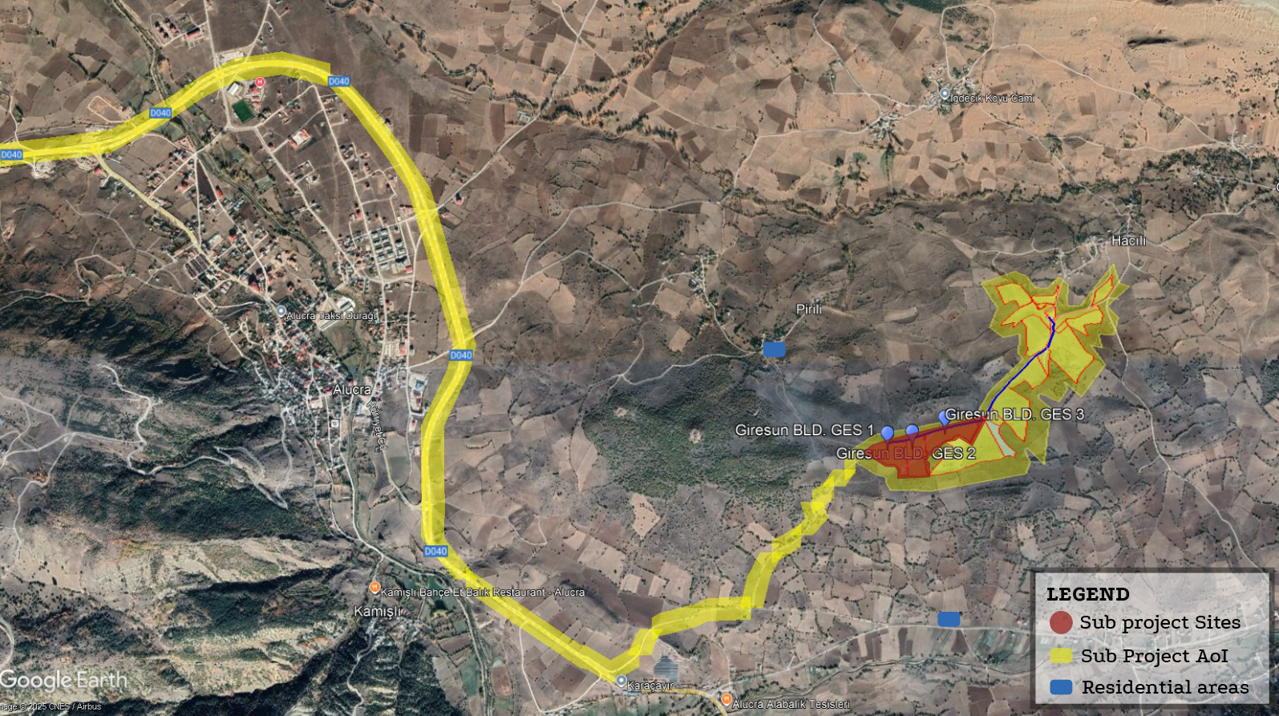
Figure 4. Sub-project Area of Influence

Environmental and Social Baseline
This section includes baseline data on the physical, biological and socioeconomic status of the sub-projects and ETL’s area of influence. The explanations and information provided in this section on the current status of the sub-project areas and its immediate surroundings are based on reports from relevant public and private organizations (Ministry of Agriculture and Forestry, Disaster Emergency Management Presidency, General Directorate of Meteorology, Ministry of Environment and Urbanization, Chamber of Industry and Commerce, Turkish Crops Data Service, Turkish Statistical Institute, Provincial Sectoral Action Plans, etc.) on site visit Geographical Information Systems (GIS) studies and satellite images for environmental physical, biological and socio-economic determinations.
A site visit was made by Uslu Technology company on 15.05.2025.
In order to determine the impact of the activities within the scope of the sub-projects on the local people, the neighborhood's demographic structure, education status, availability of infrastructure services, access to social infrastructure facilities, opinions and suggestions about the sub-projects were consulted with the mukhtar of Hacılı neighborhood. Four people from the local community were consulted about their level of knowledge about the sub-projects and their opinions and suggestions. In addition to consultations with the mukhtar and four residents of Hacılı Neighborhood, interviews were also conducted with the heads of the three closest households located approximately 620 meters northwest of the SPP-1 area, 653 meters south of the SPP-2 area, and 756 meters south of the SPP-3 area. These interviews aimed to assess their awareness of the sub-projects, potential concerns regarding dust and noise emissions, and whether any household members belong to vulnerable or disadvantaged groups. No such vulnerable conditions were identified during the consultations.
During the site visit made on 15.05.2025, interviews were held with the mukhtar of Hacılı neighborhood and 4 residents of Hacılı neighborhood. In addition, opinions were exchanged with both the interviewees and the mukhtar regarding the rental status of lot 1 of block 133, which belongs to the legal entity of Hacılı neighborhood. In the interview with the mukhtar, the population, demographic structure, education status, infrastructure services and accessibility to health-education services of the neighborhood were discussed. There are no sensitive structures such as schools or health centers within the area of influence.
The three households located near the sub-projects components were each consulted through interviews with their respective household heads. The household near SPP-1 consists of a couple (husband and wife) with no children. The household near SPP-2 is composed of three individuals, including a 14-year-old child. Similarly, the household near SPP-3 includes three people, one of whom is a 16-year-old adolescent. None of the interviewed household heads reported any pre-existing health conditions or vulnerabilities that could be exacerbated by dust or noise emissions during the construction phase of the sub-projects.
Opinions and suggestions regarding the sub-projects were also received from 4 residents of Hacılı neighborhood, as well as from the mukhtar and the heads of the nearest households. Their concerns and curiosities were discussed. Within the scope of the interviews;Table 7 summarizes the baseline site studies conducted for the ESMP study.
Table 7. Summary of Baseline Site Visit
Subject | Date of the Field Study | Mukhtar | Local People (4 households) | Nearby Households (3 households) | Observation / Assessment (Uslu Technology Environmental Expert, Social Expert and Freelance Biologist)
The level of knowledge about the sub-project | 15.05.2025 | Attended the information meeting. | Learned about the sub-projects from Giresun Municipality, the Mukhtar, or neighbors, and received more detailed information during the field visit. | Heard from the Municipality and Mukhtar; more detailed information was provided during the field visit. | Local people are aware of the sub-projects.
The demographic structure of the neighborhoods, | 15.05.2025 | Mainly livestock breeding. | Small and large livestock; some rely on pension income. | Livestock activities, pension income. | Livestock breeding is common in the area; some households rely on pension income.
The usage status of the sub-project area | 15.05.2025 | Field farming and small livestock are common. | Household-level vegetable cultivation, large and small livestock. | Livestock; in some households no animal husbandry is practiced. | Livestock breeding dominates; except for small-scale vegetable production, no significant agricultural income-generating activities are observed.
The socio-economic status of the local people | 15.05.2025 | Electricity, water, and internet available. | Services are available and sufficient. | Electricity, roads, and infrastructure generally sufficient. | Electricity, water, and internet services are available and adequate.
Agricultural and animal husbandry activities carried out in the neighborhoods | 15.05.2025 | No school in the village; students go to Alucra district center. | Children attend schools through busing; health services are accessed in Alucra district center. | Education and health accessed in the district center. | Education and health services are obtained from Alucra district center.
The status of infrastructure services, access to education and health opportunities | 15.05.2025 | Expects the project to create employment. | Expect income-generating contributions. | Expect job opportunities. | Local employment is expected during both construction and operation phases of the sub-project.
Opinions, suggestions and concerns about the sub-project, information about vulnerable groups | 15.05.2025 | Presence of elderly, persons with disabilities, individuals with chronic illnesses, female-headed households, low-income households, and women with low literacy. | – | – | Elderly persons, individuals with disabilities, people with chronic illnesses, female-headed households, low-income households, and women with low literacy levels are present in the area. These groups may face challenges in participating in project processes due to mobility restrictions, care needs, economic hardship, or social and cultural barriers.
Biodiversity and soil structure studies | 15.05.2025 | Species such as hawks, rock pigeons, rabbits, hedgehogs and toads are frequently observed in the region. | – | – | No dense fauna or flora populations requiring special protection were detected. Visual checks will be carried out before construction, and nesting areas will be marked to allow species to move away without intervention.

Physical Environment
This section includes information on the physical, biological and socio-economic status of the sub-projects, including the ETL and the recent period. The explanations and information provided in this section regarding the current status of the sub-projects areas and its immediate surroundings are based on field studies, Geographic Information Systems (GIS) studies and reports obtained from satellite images of relevant public and private institutions (Ministry of Agriculture and Forestry, Disaster Emergency Management Presidency, General Directorate of Meteorology, Ministry of Environment, Urbanization and Climate Change, Chamber of Industry and Commerce, Turkish Plants Data Service, Turkish Statistical Institute(TurkStat), Provincial Sectoral Action Plans, etc.) for environmental physical, biological and socio-economic determinations.
The field visit within the scope of the sub-projects was carried out on May 15, 2025. During the site visit, meetings were held with Giresun Municipality Authorities, Hacılı muhtar and local people living in these neighborhoods.

Topography
The most important streams flowing into the Black Sea are the Harşıt and Aksu streams. Lakes are not common in Giresun province, but there are glacial lakes in high areas. The most important lake is the Karagöl crater lake.
Alucra District, which is located on a plain at an altitude of 1,450 m among the extensions of the Eastern Black Sea Coastal Mountains in the middle part, has Giresun Mountains in the north and Berdiga Mountains in the south as the dominant relief. The waters of the Alucra Plain, which is separated by Şebinkarahisar in the west and Şiran Plain in the east, are drained by Bağırsak Creek. This stream, which continues southwest, joins the Kelkit Creek, which flows along an east-west line in the south of Sarıçiçek Mountains in Şebinkarahisar.
Hacılı neighborhood, where the sub-project sites are located, has mountainous and rugged terrain. The sub-project sites have a lower slope compared to the Hacılı neighborhood.

Geology
In the sub-project areas; from oldest to youngest, Jurassic-Lower Cretaceous Berdiğa formation limestone, Upper-Crateceous Paleozoic Altınoluk formation gravelly sandy limestones, sandstones, Volcanites, Eocene Masuran Formation, Eocene Çalkan volcanics, andesite, Oligo-Miocene Şebinkarahisar formation, Upper-Miocene Kadıköy Formation, Quaternary Travertine and Quaternary Alluvium constitute the geology of the area of influence. Sub-project areas located in, Alucra district Hacılı neighborhood is located in the Altınoluk Formation.

Tectonics and Seismicity
The Eastern Black Sea Region is the source of earthquakes affecting the region due to its proximity to the North Anatolian Fault Zone (NAFZ) in the Alpine-Himalayan belt, one of the most active earthquake zones in the world. There is no fault producing earthquakes within the borders of Giresun Province.
The regions of Giresun affected by the earthquake are mostly the districts of Şebinkarahisar, Alucra and Çamoluk located in the inner parts. These districts are located in the first-degree earthquake zones. The regions outside these districts are third- and fourth-degree earthquake zones (Figure 5).
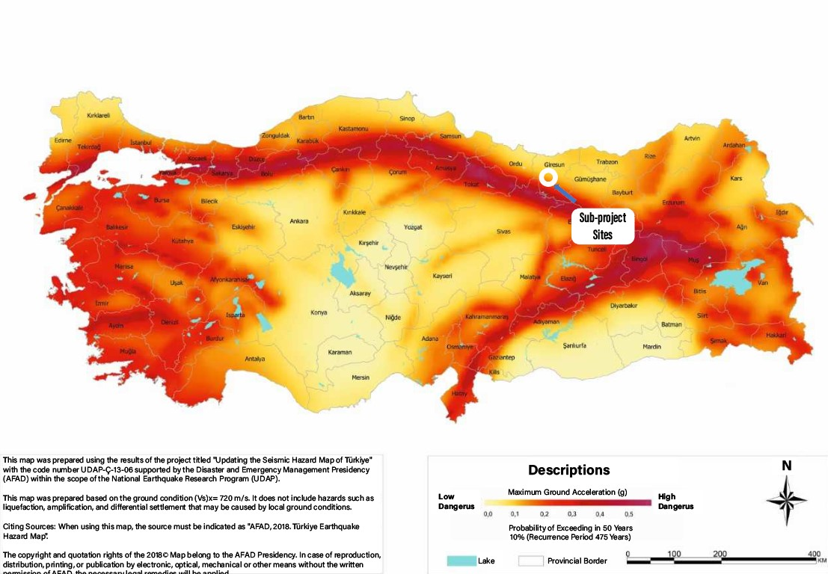
Figure 5. Earthquake map of Sub-project Sites

Sub-project sites will be implemented in the 1st degree earthquake zone. The most up-to-date Earthquake Regulations for buildings will be followed.
According to the Earthquake Hazard Map of Turkiye, which was published in the Official Gazette dated 18.03.2018 and numbered 30364 and entered into force on 01.01.2019, the maximum expected ground acceleration PGA-475 values in sub-project sites ( lot 1 of block 138, lot 1 of block 139 and lot 1 of block 140) is 0.281 g(tdth.afad.gov.tr) (See Figure 6).
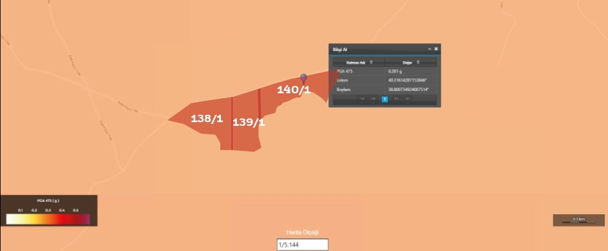
Figure 6. Sub-project Area Tectonic Map

Soil and Land Composition
The soil types in the sub-project areas are brown forest soils, non-calcareous brown forest soils, colluvial soils, alluvial soils and bare rocks not in any soil group.

Meteorology and Climatic Characteristics
The climate of the Alucra region, unlike the Black Sea climate, is cold and snowy in winter and hot and dry in summer. The melting of snow continues until mid-April and spring rains extend until June. In spring, parallel to the melting of snow and the beginning of rain, the flow of rivers increases. The annual rainfall is 560 mm³, the average temperature is 18ºC and the average cold is -1ºC. As can be seen, when the flow of rivers and the annual rainfall are taken into account, an irregular regime is observed. In this state, Alucra's climate is more similar to our neighbors in Eastern Anatolia than to the Black Sea.
The part of the province facing the Black Sea, which covers a large part of the province, has warm and rainy climate characteristics, while the part facing the Kelkit basin, which is south of the Eğribel pass, has continental climate characteristics. The amount of rainfall, which is high in the coastal area, decreases as you go inland.
Table 8. Giresun Province Official Climate Statistics (General Directorate of Meteorology)
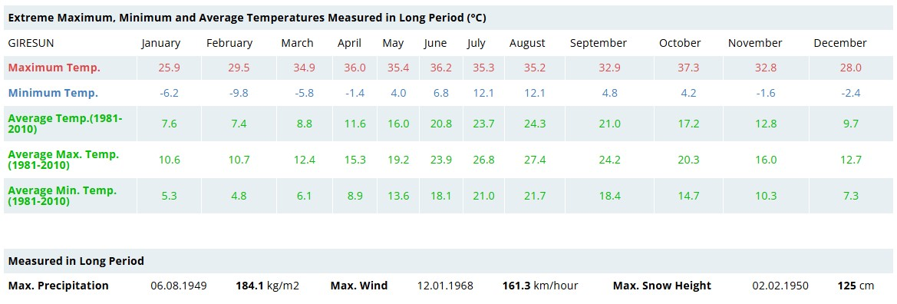Source: General Directorate of Meteorology (https://www.mgm.gov.tr/eng/forecast-cities.aspx?m=GIRESUN)

Air Quality
In order to determine the extent of air pollution in Giresun province; there are 2 (two) air quality monitoring stations established in the city center, in the Giresun Environment, Urbanization and Climate Change Provincial Directorate area and in the Mithatpaşa Secondary School area. Particulate Matter (PM10) and Sulfur Dioxide (SO₂) pollutants are measured at the first measurement station, and Particulate Matter (PM10), Sulfur Dioxide (SO₂), NOx, CO and O₃ pollutants are measured at the second measurement station. The measurement results are monitored online from the air quality monitoring network of the Ministry of Environment and Urbanization. According to the Giresun Province Environmental Status Report, annual average of the monthly pollutant parameters for 2023 have been presented in Table 9.
Table 9. Pollutant parameter amounts
Pollutant Parameter | Amount
SO₂ | 6.32µg/m³
PM₁₀ | 22.81 µg/m³
NO₂ | 29.59 µg/m³
CO | 530.50 mg/m³
O₃ | 32.36 µg/m³
Source: Giresun Province, Environmental Status Report (https://ced.csb.gov.tr/2023-yili-il-cevre-durum-raporlari-i-112399, 2024)

Noise
The sub-projects are located in a rural area, with the nearest sensitive receptor situated more than 500 meters away from the site. There are no industrial noise sources in the vicinity of the sub-project areas, and since the construction period is relatively short approximately two months no significant or long-term noise impacts are expected. For these reasons, baseline environmental noise measurements were not conducted for these sub-projects.
Considering the rural characteristics of the sub-project areas and the absence of major anthropogenic noise sources, the baseline environmental noise level is assumed to be within the range of 35–45 dBA (LAeq) during the daytime and 30–40 dBA at night, in line with WHO (2018) and EEA (2020) references for quiet rural areas. These values are also consistent with the Regulation on Control of Environmental Noise of Türkiye (Official Gazette dated 30.11.2022, No. 32029) and the World Bank Group (WBG) General Environmental, Health, and Safety (EHS) Guidelines (2007), both of which allow a maximum increase of 3 dBA above ambient levels at the nearest sensitive receptors.
In Türkiye, the Regulation on Control of Environmental Noise specifies limit values for various zones (e.g., industrial, residential, or mixed-use areas) and defines thresholds applicable for three different time periods. Similarly, the WBG EHS Guidelines set out allowable noise levels for two types of receptors and time periods. These guidelines emphasize that project-related noise should not exceed the prescribed limits or cause more than a 3 dBA increase in background noise levels at the nearest off-site receptor.
For newly established facilities, noise prevention measures are addressed in Environmental Impact Assessment (EIA) Reports prepared in accordance with the Environmental Law No. 2872 and the EIA Regulation. Furthermore, in the event of noise-related complaints submitted to the Provincial Directorate of Environment, Urbanization, and Climate Change, official inspections and environmental noise level measurements are conducted. Where necessary, source-based insulation or noise reduction measures are implemented to ensure compliance with regulatory limits.
In residential areas, prolonged exposure to high noise levels generated by construction machinery and heavy vehicles can negatively impact mental health and overall community well-being. However, the sub-project area is devoid of such high-impact activities or structures that would contribute to environmental noise. Therefore, no adverse noise-related effects on the local population are anticipated.

Water Resources
Giresun is generally fed by surface water resources. The water coming during the rainy season is collected in dams and regulators and given to the city after the necessary purification processes.
Rivers
The streams flowing into the Black Sea are listed as follows from east to west; Harşit Stream in Tirebolu District, Gelevera Stream in Espiye District, Yağlıdere Stream in Yağlıdere District, Aksu Stream and Baltama Stream in Merkez District, Pazarsuyu Stream in Bulancak District.
There are small glacial lakes in the high parts of our province. The northwestern, northern and northeastern slopes of the Karagöl mass are formed by approximately 10 calves (cirques). Elmalı Calves, located in the northwest of Karagöl Summit, are a typical staircase calves with three levels. At the base of these, there is a calf lake called Elmalı Lake at an altitude of 2650 meters and at its lowest point. This lake, which is 10 meters deep and 100 meters in diameter, is surrounded by 400-meter-high steep walls in the south, east and northeast. The part of the lake open to the northwest is made up of large and small blocks. It is covered with a series of glacial rocks (morun).
Groundwater
Groundwater aquifers in Giresun Province are formed by alluviums formed by streams such as Pazarsuyu, Aksu, Yağlıdere. The most productive basin in terms of groundwater is the Harşıt Valley. Groundwater resources throughout the province are mainly used for irrigation and drinking-use purposes, and to a lesser extent for industrial purposes.

Natural Hazards (such as flooding, landslides, fire, etc.)
Giresun province, located in the west of the Eastern Black Sea Region, is one of the provinces where landslides, floods and rock falls frequently occur due to meteorological factors and topography. The morphology, geology, climate characteristics of the region, decomposition of rocks, excavations for various purposes, destruction of vegetation, artificial (blasting, etc.) tremors are the main causes of mass movements. Other than the disaster types mentioned, other disaster types experienced in the province can be listed as storm, earthquake and avalanche. When the slope values ​​of the landslide inventory are examined, it is striking that landslides are concentrated in the 6-8-degree slope range. Another disaster type that is effective in Giresun province after landslides is floods. Flood events develop due to rainfall, especially in the coastal settlements of our province and in the Şebinkarahisar and Doğankent districts in the interior. The Eastern Black Sea Region is the source of earthquakes affecting the region due to its proximity to the North Anatolian Fault Zone (NAFZ) located in the Alpine-Himalayan belt, one of the most active earthquake zones in the world. There is no fault that produces earthquakes within the borders of Giresun Province. Another type of disaster, rockfall, usually develops with landslides under the influence of meteorological factors. Rock masses separated from the main rock by factors such as freezing and thawing during seasonal transitions move together with the water-saturated ground and affect settlements. In Giresun, one of our provinces where rockfall is experienced intensively, it is usually seen in the districts of Alucra, Dereli, Bulancak and Doğankent.
There is no risk of natural disasters such as landslides, floods, collapses, creaks and rockfalls in the sub-project areas.
Factors that cause landslides are strong slopes, heavy and continuous rains, water saturation, rock structure, the posture of the layers, tectonic structure, etc. Landslides can occur due to one or more of these. However, there is no fill, lithological units (loose - soft, etc.) and groundwater effect that can cause landslides in the work area.
In the event of an unforeseen natural disaster, actions will be taken to ensure the lives of employees, and if necessary, they will be transported to the nearest health unit.

Biodiversity
This section has been developed in order to examine the status of the ecosystem and biodiversity in the sub-project areas and its immediate surroundings, to reveal the flora and fauna inventory, to identify endemic, rare or endangered taxa, to determine the endangerment categories of the identified taxa according to WB ESS-6: Biodiversity Conservation and Sustainable Management of Living Natural Resources (WB ESS-6).
The vegetation is rich in the northern part of Giresun, which receives abundant rainfall. In this part, there are hazelnut and other fruit trees and deciduous trees such as alder, maple, beech, hornbeam, oak, fir, linden, chestnut up to 600 meters. The area of influence within the scope of the field visit studies was shared in Figure 7.
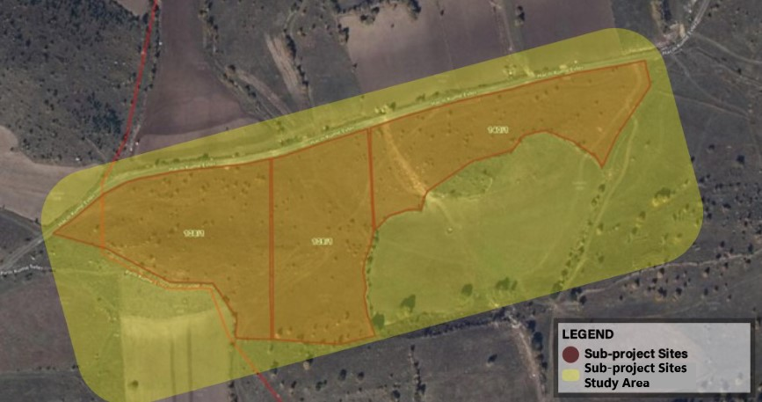
Figure 7. Biodiversty Area of influence plots
Detailed information on flora and fauna inventories based on the field work carried out within the scope of the sub-projects are given below.

Flora

The sub-project areas are located in the A7 grid according to Davis's grid system and, according to Güner (2012), falls within the Euxine subregion of the Euro-Siberian Floristic Region in the Eastern Black Sea Region. This region is rich in plant diversity and is concentrated in the cone-bearing sector.
Assoc. Prof. Dr. Mustafa Karaköse (Giresun University)
Based on the literature review and field investigations conducted in the sub-project area on 19.06.2025 by Assoc. Prof. Dr. Mustafa Karaköse (Giresun University), no endemic, rare, or threatened plant species were identified. All identified plant species are widespread and have large populations and are classified as "Least Concern" (LC) according to IUCN criteria. The fact that these species are widespread in nature and their populations are not threatened indicates that the subproject implementation will not have a negative impact on biodiversity.
Furthermore, no plant species protected under the Bern Convention were encountered in the subproject area. The conservation status of plant species was assessed using sources from Davis (1965-1985), Güner (2000, 2012), IUCN (2001), TUBIVES (2025), and POWO (2025).
Consequently, due to the absence of endemic or rare plant species in the subproject area and the prevalence of the identified species, the subproject is not expected to have a negative impact on vegetation and floristic diversity.
The flora species identified in the subproject area are listed in Table 10.
The flora inventories based on field studies conducted within the scope of the sub-project
Table 10. Flora of Area of influence
Taxon Name | Endemism | IUCN | Bern
Prangos ferulacea Lindl. | - | - | -
Astrodaucus orientalis (L.) Drude | - | - | -
Asplenium septentrionale (L.) Hoffm | - | LC | -
Artemisia fragrans Willd. | - | - | -
Cota tinctoria subsp. parnassica (Boiss. &Heldr.) Oberpr. & Greuter (Sin.: Anthemis tinctoria L. var. pallide DC.) | - | - | -
Phonus lanatus (L.) Hill (Sin.: Carthamus lanatus L.) | - | - | -
Pilosella auriculoides (Láng) Arv.- Touv. | - | - | -
Berteroa mutabilis (Vent.) DC. | - | - | -
Alyssum trichostachyum Rupr. (Sin.: Alyssum repens subsp. Trichostachyum (Rupr.) Hayek) | - | - | -
Draba bruniifolia subsp. bruniifolia Steven | - | - | -
Draba polytricha Ledeb. | - | - | -
Draba hispida Willd. | - | - | -
Erysimum pulchellum subsp. pulchellum (Willd.) J. Gay | - | - | -
Sabulina juniperina (L.) Dillenb. & Kadere it (Sin.: Minuartia juniperina (L.) Marie & Petitm.) | - | - | -
Dianthus polycladus Boiss. (Sin.: Dianthus strictus Banks & Sol. var. gracilior (Boiss.) Reeve) | - | - | -
Silene noctiflora L. (Sin.: Silene dichotoma subsp. dichotoma Ehrh.) | - | - | -
Polystichum lonchitis (L.) Roth | - | LC | -
Euphorbia macroclada Boiss. | - | - | -
Colutea cilicica Boiss. & Balansa | - | - | -
Trifolium campestre Schreb. | - | - | -
Crocus suworowianus K. Koch (Sin.: Crocus kotschyanus K. Koch subsp. suworowianus (K. Koch) B. Mathew) | - | - | -
Ziziphora capitata L. | - | - | -
Ziziphora clinopodioides Lam. | - | - | -
Thymus sipyles Boiss. | - | - | -
Thymus fallax Fisch. & C. A. Mey. | - | - | -
Thymus praecox Opiz subsp. grossheimii (Ronniger) Jalas | - | - | -
Thymus nummularius M. Bieb. | - | - | -
Thymus leucotrichus subsp. leucotrichus Hal. | - | - | -
Linaria grandiflora Desf. | - | - | -
Thinopyrum elongatum (Host) D.R. Dewey (Sin.: Agropyron elongatum (Host) P.Beauv.) | - | LC | -
Trisetum flavescens (L.) P.Beauv. | - | LC | -
Rumex acetosella L. | - | LC | -
Rhamnus macrocarpa Boiss. | - | - | -
Rosa canina L. | - | LC | -
Galium incanum subsp. incanum Sm. | - | - | -
Cruciata Taurica (Pall. ex Willd.) Ehrend. | - | - | -
Verbascum flavidum (Boiss.) Freyn & Bornm | - | - | -
Verbena officinalis var. officinalis L. | - | - | -
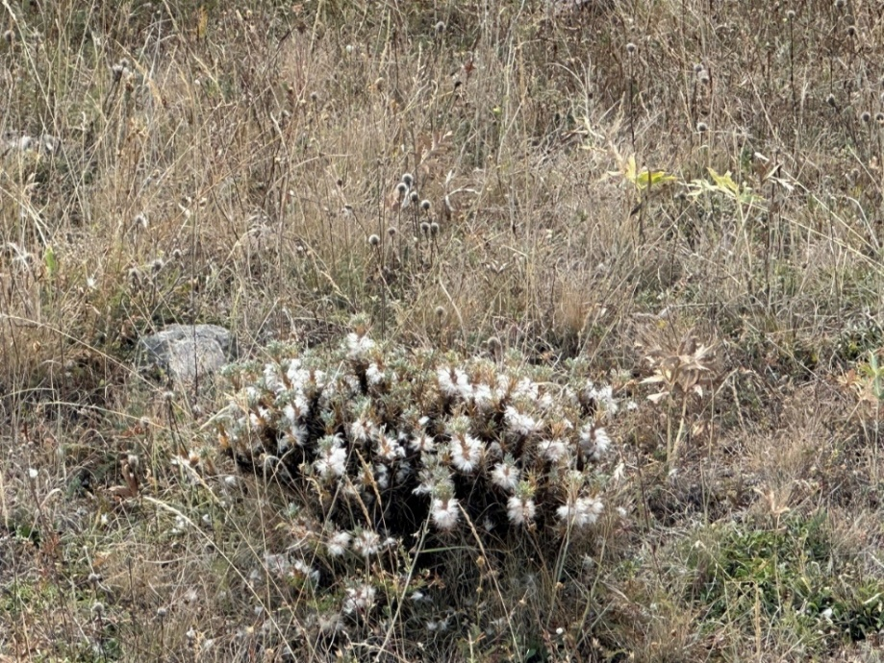
Figure 8. Carthamus lanatus
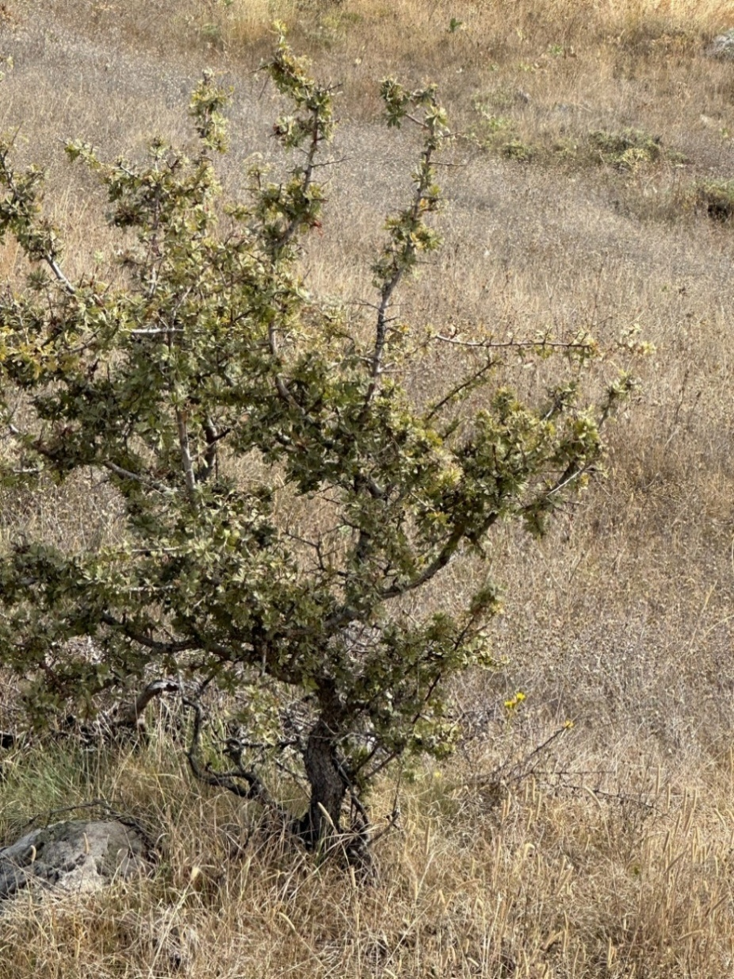
Figure 9. Rhamnus microcarpa Boiss

Possible Impacts of Project on Flora and Precautions to be taken:
Dust emission may accumulate in the leaf blades, flowers, etc. organs of flora taxa, affecting both photosynthesis and respiration of the plant and causing slowdowns in the normal development process. Therefore, in order to prevent dust emission, the work area will be regularly irrigated with a water truck. After the sub-projects activities, the disturbed areas can be easily rehabilitated with plants from the natural flora of the region. For this reason, it is extremely important for the balance of the ecosystem that the natural plants of the region are preferred when selecting plants for landscaping purposes.
In addition to the general impacts of dust on leaf surfaces, the specific flora of the region includes xerophytic and small-statured plants such as Thymus leucotrichus var. leucotrichus, Draba bruniifolia subsp. bruniifolia, and Alyssum repens subsp. trichostachyum, which are ecologically adapted to dry and shallow soils.
To mitigate adverse effects, regular irrigation of the work area with water trucks shall be conducted to reduce dust accumulation on sensitive plant surfaces. Disturbances in microhabitats such as rock crevices and shallow slopes shall be strictly avoided to protect vulnerable taxa. In this direction; the top soil resulting from the vegetative soil stripping process will be used for landscaping purposes in and around the field.

Fauna
Necessary studies were carried out by Biologist Kübra GÖZ to determine the terrestrial fauna components that are and are likely to be present in the area of influence and its surroundings. The wildlife groups that are likely to live and have been identified to live in the region where the area of influence is located are given in Table 11.
Table 11 Area of influence and The Surroundings Fauna List
Amphibian Types List of
Type Ordinary | Endemism | IUCN | BERN | MAK | CITES
ANUR
Bufonidae
Bufotes Variable | - | LC | ANNEX- II | - | -

Reptile Types List of
Scientific Ordinary | Habitat | Endemism | IUCN | BERN | MAK | CITES
SQUAMATA
Lacertidae
Darevskia Valentine | Rocky, stony and  step | - | LC | ANNEX III | - | -
Colubridae
Eirennis modestus | Gizzard and sparsely vegetated areas | - | LC | ANNEX III | - | -
Typholophidae
Xerotyphlops vermicularis | Open land, moist soil intra- | - | LC | ANNEX III | - | -

Bird Types List of
Scientific Ordinary | Rejection Data | IUCN | MAK | Bern | CITES | Endemism
ACCIPITRIFORMES
Accipitridae
Buteo rufinus | A.3 | LC | - | ANNEX III | ANNEX II | -
COLUMBIFORMES
Columbidae
Columba livia | A.5 | LC | ANNEX- 1 | ANNEX III | - | -
Columba Palumbus | A.4 | LC | ANNEX- 1 | - | - | -
STRIGIFORMES
Strigidae
Athena noctua | A.2 | LC | - | ANNEX II | ANNEX II | -
FALCONIFORMES
Falconidae
Falco peregrine | A.1.2 | LC | - | ANNEX II | ANNEX I | -
Falco tinnunculus | A.2 | LC | - | ANNEX II | ANNEX II | -
PASSERIFORMES
Corvidae
Corvus corax | A.5 | LC | ANNEX- 2 | ANNEX III | - | -
Corvus corona ( cornix ) | A.5 | LC | ANNEX- 1 | - | - | -
Pica pica | A.5 | LC | ANNEX- 1 | - | - | -
Alaudidae
In the gallery cristata | A.3 | LC | ANNEX- 2 | ANNEX III | - | -
Alauda arvensis | A.4 | LC | ANNEX- 2 | ANNEX III | - | -
Melanocorypha Calandra | A.5 | LC | - | ANNEX II | - | -
Sturnidae
Sturnus vulgaris | A.5 | LC | ANNEX- 2 | - | - | -
Muscicapidae
Saxicola Rubicola | A.3 | LC | - | ANNEX II | - | -
Passeridae

Scientific Ordinary | Rejection Data | IUCN | MAK | Bern | CITES | Endemism
Passer montanus | A.3 | LC | ANNEX- 2 | ANNEX III | - | -
Fringillidae
Fringilla coelebs | A.4 | LC | ANNEX- 2 | ANNEX III | - | -
Carduelis carduelis | A.3.1 | LC | - | ANNEX II | - | -
Linaria Cannabina | A.3 | LC | - | ANNEX II | - | -
Emberizidae
Emberiza Cirlus | A.2 | LC | - | ANNEX II | - | -
Emberiza ( Miliaria ) calandra | A.4 | LC | ANNEX- 2 | ANNEX III | - | -
List of Mammal Species
Scientific Ordinary | Endemism | IUCN | BERN | MAK | CITES
EULIPOTYPHLA
Erinaceidae
Erinaceus Concolor | - | LC | - | - | -
Soricidae
Sorex satunini | - | LC | ANNEX III | - | -
Talpida
Talpa Levantis | - | LC | - | - | -
RODENTIA
Cricetidae
Microtus mystacinus | - | LC | - | - | -
CHIROPTERA
Vespertilionidae
Myotis mystacinus | - | LC | ANNEX II | - | -
Myotis blythi | - | LC | ANNEX II | - | -
LAGOMORPHA
Leporidae
Lepus europaeus | - | LC | ANNEX III | ANNEX- 1 | -
CARNIVORA
Mustelidae
Mustela Nivalis | - | LC | ANNEX III | ANNEX- 2 | -
There is no permanent water source or wetland such as a lake, pond, stream, or river within the sub-project area of influence, but amphibian species that may be found in the area due to water accumulations that may occur with seasonal rainfall have been added to the list.
In order to determine the species under protection from the fauna species, the Turkish Environmental Legislation 'Convention on the Protection of European Wildlife and Habitats' and its annexes were examined. The species under protection according to the Bern Convention are shown in the fauna lists in Table 11.
The protection statuses of bird species were evaluated according to the Red Data Book (Kiziroğlu, İ.) and included in the relevant tables.
As a result of the evaluation of the faunistic list of the sub-project area of influence and its surroundings, it was determined that 4 species are protected under the CITES (Convention on International Trade in Endangered Species of Wild Fauna and Flora), signed in Washington in 1978. Among the bird species, 1 species (Falco peregrinus) is included in CITES Appendix I. Three bird species (Buteo rufinus, Athene noctua, Falco tinnunculus) are included in CITES Appendix II.
These species were identified through literature review. During the implementation phase of the project, the provisions of Articles 6 and 7 of the Bern Convention will be strictly followed (Annex J).

Socio-economic Environment
The main purpose of an ESMP is to identify and assess the potential positive and adverse impacts that may be caused by the sub-project activities on the socio-economic wellbeing and conditions of the population (community and workforce) at local and regional level. This following assessment is based on the sub-project characteristics and activities and the socio-economic baseline conditions in the sub-project areas.
Uslu Teknology will prepare a Stakeholder Engagement Plan (SEP) to correctly define sub-project components and identify stakeholders related to these components, take into account stakeholders' views, and increase awareness of the sub-projects.

Demography and Population
The official population data of Alucra District, taken from the website of the Turkish Statistical Institute (TurkStat, 2025), is given in Table 12. Hacılı Neighborhood, which is within the scope of the sub-project activities, consists of 22 females and 23 males, a total of 45 people. There are a total of 35 households in the neighborhood. In addition to the demography of Hacılı Neighborhood, the demographic structure of residential areas adjacent to the SPP lands was assessed, including household sizes, age distribution, gender composition, and any vulnerable groups. This information was collected through field observations and consultations with local stakeholders.In Hacılı Neighborhood, there are a total of 35 households. Considering the total population (45 people), the average household size is approximately 1.3 persons. This figure is well below the Turkish average household size of about 3.1 persons. The low household size indicates that the neighborhood is predominantly composed of individuals living alone or small households without children. It also suggests that a significant portion of the young population (aged 18–29) has migrated outside the district, leaving mostly elderly residents behind.
According to the information received from the mukhtar of Hacılı neighborhood during the consultations held within the scope of the sub-project sites visit, there are no refugees and households with children residing in the sub-project AoI.
Table 12 Population data of Alucra District
Year | Alucra Population | Male Population | Female
2024 | 9,025 | 4,581 | 4,444
2023 | 10,514 | 5,384 | 5,130
2022 | 8,574 | 4,317 | 4,257
2021 | 8,892 | 4,498 | 4,394
2020 | 9,405 | 4,776 | 4,629
2019 | 10,253 | 5,250 | 5,003
2018 | 12,250 | 6,259 | 5,991
2017 | 9,119 | 4,573 | 4,546
2016 | 13,753 | 6,911 | 6,842
2015 | 9,104 | 4,587 | 4,517
2014 | 12,948 | 6,555 | 6,393
2013 | 9,170 | 4,594 | 4,576
Turkish Statistical Institute (TurkStat), ADNKS 2025 Results
22% of Alucra's population consists of young people (18-29 years), 42% of middle-aged people, and 36% of elderly people. The population data obtained from Turkstat, 2025 was cross-checked with qualitative information gathered during consultations with the mukhtar of Hacılı Neighborhood. The numbers were found to be largely consistent, confirming the reliability of the demographic data. Any discrepancies or additional insights provided by the mukhtar are also noted and taken into account in the socio-economic baseline.
Table 13. Population data of Hacılı Neighborhood
Population | Hacılı Neighborhood
Female | 22 people
Male | 23 people
Total | 45 people

Land Ownership Status and Land Use by Affected People
The properties of lot 1 of block 138, lot 1 of block 139, lot 1 of block 140 where the sub-project will be established belongs to the legal entity of Hacılı Neighborhood and has been leased by Giresun Municipality for 35 years. The lease agreement is shared in Annex B.
The ETL mainly passes through cadastral roads, the last 28 meters of the ETL are in lot 1 of block 133 belonging to the Hacılı Neighborhood Legal Entity. It was rented by Giresun Municipality for 35 years.
There are no official or unofficial users on the lands where sub-project activities will be carried out. There are 1-year-old wild grasses and sparse long-year bushes on the land.

Employment and Means of Livelihood
The Hacılı neighborhood’s economy is largely based on agriculture and animal husbandry. Households residing within the Area of Influence (AoI) of the sub-project primarily sustain their livelihoods through agriculture and animal husbandry. These activities constitute the main sources of income for the local population and play a significant role in the socio-economic fabric of the region. Individual vegetable and fruit cultivation is also available. The pasture and grazing area used by local residents is located approximately 150–200 meters east of the Hacılı neighborhood, and is about 900-950 meters away from the nearest boundary of the sub-project areas.
In the Hacılı neighborhood, which is home to approximately 35 households, agricultural activities are quite limited. Livestock farming, however, is prominent, with around 1,500 head of livestock raised. This corresponds to an average of about 40–45 animals per household. Consultations with knowledgeable local residents indicate that the region’s economic activities and livelihoods are largely based on livestock farming.

Education and Health Services
There is no health center in the Hacılı neighborhood. Education and health needs are met by schools and health centers located in the Alucra district, approximately 4 km away. There are no educational facilities within the sub-project AoI.

Infrastructure Services
Due to the rugged structure of the neighborhood, road use becomes difficult in the winter months. Road cleaning and maintenance services are provided by the Alucra Municipality. There are also mains water and wastewater collection systems in the settlement.
Electrical infrastructure is largely available, but there are interruptions. There are also individual solar energy systems, within the borders of Alucra district, one of which is located 1.5 km from the sub-project sites.
There is a local telephone line in Hacılı neighborhood. Mobile lines are also available locally.

Transportation and Traffic
Hacılı neighborhood is 154 km away from Giresun city center and 4 km away from Alucra district center. Hacılı neighborhood is located in the east of Alucra District and is connected to the Alucra-Şiran-Bayburt state road numbered D.040 by a 3.6 km stabilized road. The access road route to the sub-project sites passes in front of Alucra district. The access road is an asphalt road. The fields are located on the highway. No additional access road opening will be done. Sub-project access route given Figure 10

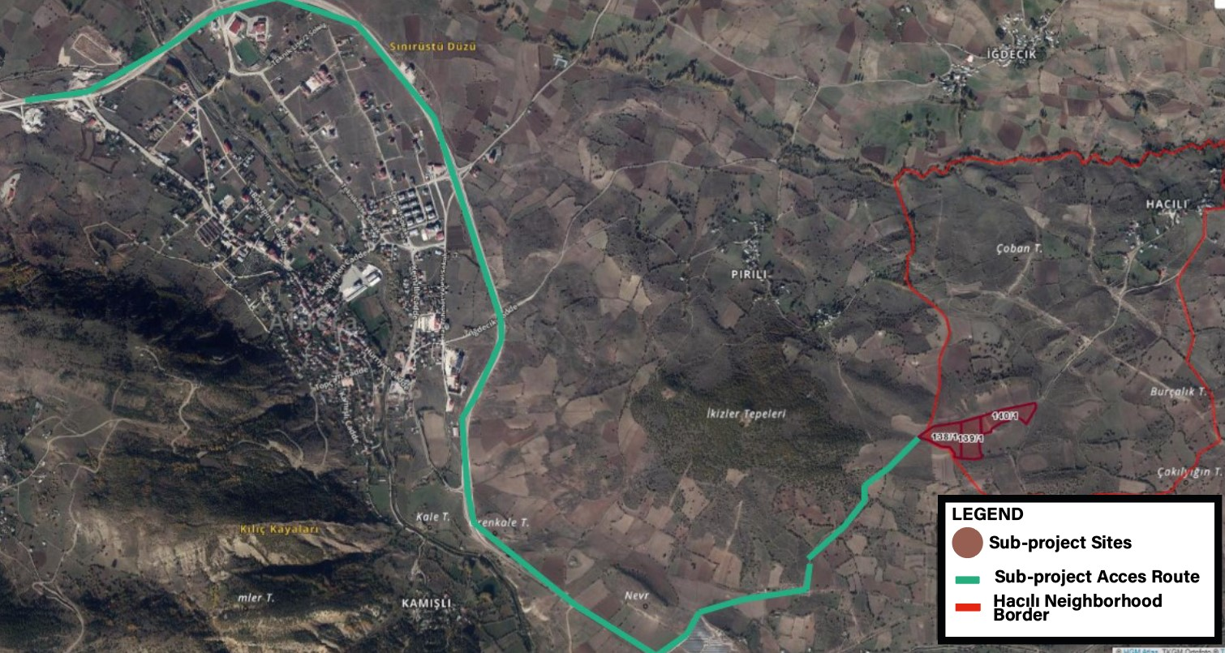
Figure 10. Sub-project sites access route

Cultural Heritage (Tangible and Intangible)
Information regarding the absence of any tangible or intangible cultural heritage that may be negatively affected by the sub-projects was received verbally from Giresun Municipality. The closest cultural heritage to the sub-project areas are the İkiztepe (Twins) Tumulus. It consists of two side-by-side mounds in Pirili neighborhood, Alucra district. The two hills, 50 meters apart, are located on a flat land. The height and width of the tumuli are approximately 40 meters. In the past years, excavations were carried out by the Trabzon Museum Directorate, but since no results could be obtained over time, the excavations were left unfinished. The tumulus, which was registered as a cultural asset with the decision numbered 610 on 19.01.1990, is one of the most striking cultural assets in the district. The tumuli in question are known as "İkizlerTumulus". The distance of İkizler Tumulus to the sub-project sites are 700 meters as the crow flies. The closest cultural heritage to the sub-project sites is given in Figure 11.
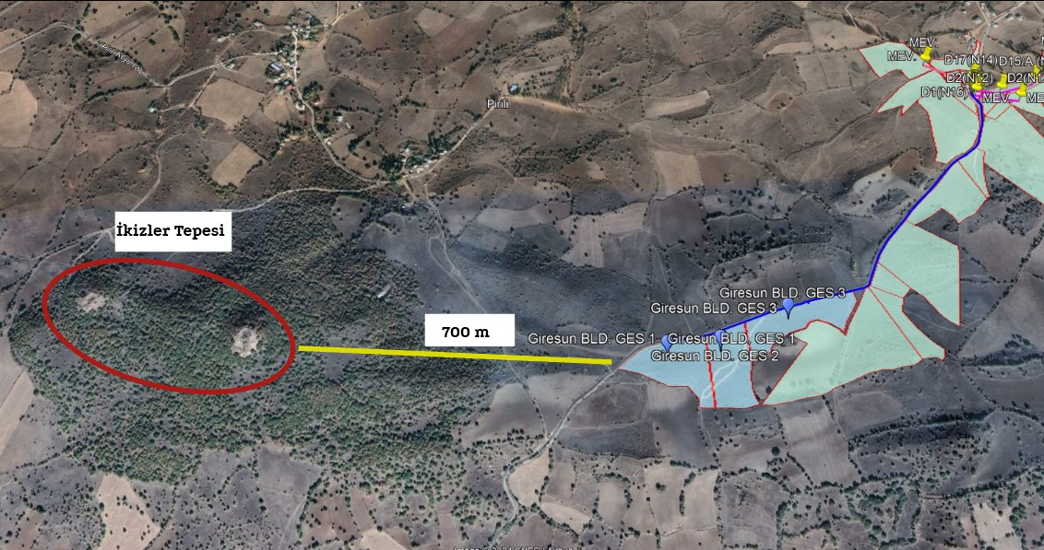
Figure 11. The closest cultural heritage to the sub-project sites.

Vulnerable and Disadvantage Individuals/Groups
According to the Environmental and Social Standards (ESSs) of the World Bank’s Environmental and Social Framework (ESF), vulnerable individuals/groups are those who, due to their specific circumstances, may be disproportionately affected by sub-project impacts or have limited ability to participate in and benefit from development projects. These individuals or groups often experience barriers to accessing sub project benefits, decision-making processes, or grievance mechanisms. These groups may face challenges in accessing equal rights and opportunities and are often subject to discrimination, exclusion, or marginalization. Since there are no refugees in the sub-project AoI, there is no disadvantage that may arise from language differences.
According to the information obtained from the mukhtar of Hacılı Neighborhood during the site visit conducted by Uslu Technology on 15.05.2025, a total of [16] people living in the Hacılı neighborhood, which falls within the (AoI) of the sub-projects, were identified as members of vulnerable or disadvantaged groups. These groups are described below in terms of their vulnerabilities and the implications for participation and access within the framework of the ESMP:
- Disabled Individuals (1 person)
These individuals may face physical and logistical challenges in accessing participation activities or project-related information due to mobility restrictions or sensory impairments.
- People Over 70 Years of Age (4 persons needing care)
Older adults may experience reduced mobility, cognitive limitations, or dependency on caregivers, which can restrict their active participation. They may also be less familiar with digital technologies or formal engagement procedures.
- People with Chronic Illnesses or in Need of Special Care (3 persons)
This group may have fluctuating health conditions or require regular medical care, limiting their ability to attend consultations or meetings. Fatigue and limited mobility may also be barriers.
- Female Heads of Households (2 persons)
These women may have increased domestic responsibilities and limited time and financial resources, which can restrict their availability and ability to participate in sub-project consultations. They may also experience social or cultural barriers.
- Low-Income or No-Income Households (3 persons)
Economic hardship can result in limited access to communication tools, transportation, and time resources. These individuals may prioritize daily survival needs over participation in sub-project processes.
- Women with Low Literacy Levels (3 persons)
These individuals are at heightened risk of exclusion due to difficulty reading or understanding written materials and technical documents. Their participation may be limited by lack of confidence or fear of misinterpretation. Verbal reliance may increase exposure to misinformation or social stigma.

SUBPROJECT ACTIVITIES

Construction Phase

Construction Activities
Construction activities will be completed in 12 months. Detailed implementation schedule envisaged for the construction phase activities (including provisional acceptance) is presented in Chapter 6.
- Pre-construction activities:
Land leveling will be conducted before starting the solar power plant construction and installation. Approximately 10 cm of topsoil and stones on the land will be cleared and the land should be prepared flat.
Before the construction, the survey engineer will determine the points where the columns and the wire fence for land security will be installed. The determined points should be marked appropriately and deviations in the column assembly will be prevented. The stripped topsoil will be used in landscaping of sub-project areas.
Construction/ installation activities:
In order to ensure correct setup and operation of the project, a variety of tasks will be included in the construction and installation phases. The panel feet will be firmly installed using pile driving techniques. In order to successfully integrate the panels into the system, cable connections will be set up. A security cabin will be built, offering a safe and regulated space. A container will also be positioned to act as a facility where staff may fulfill their needs and store items. Additionally, a space will be set aside for the administration and collection of waste panels, guaranteeing appropriate disposal and adherence to environmental regulations. Until the panels are delivered, they will be kept under cover in case they need to be kept on site.
- Construction machinery and equipment:
1 truck, 1 excavator, 1 crane, 1 pile driver and 1 tanker will be used during the construction process.
- Water use and waste water management:
Drinking water needs for personnel working during the construction phase will be provided as bottled water. Domestic water will be provided from the mains. The amount of water required for personnel are calculated in Section 4.
There is no risk of flooding the sub-project areas. Therefore, no drainage is required.
- Waste and hazardous materials management:
During the construction phase of the sub-projects, activities such as vegetation clearance, leveling, construction and assembly of main operating and auxiliary units, supply, transportation and assembly of units and equipment will be carried out. The types of solid waste expected to be generated within the scope of these activities are municipal waste, packaging waste of system equipment (e.g. wood, cardboard, plastic, etc.), hazardous waste, excavation and construction waste (e.g. scrap metal, wood, concrete waste, etc.) and waste system equipment (PV monocrystalline panels, cables, electronic components). Panel waste generated during maintenance and repair on sites will be delivered to licensed companies. The points where the disposal of cells containing crystalline silicon is included in the legislation are limited and are in the form of conventional waste disposal. This includes recycling the reusable parts of the waste from PV panels and then disposing of them in regular landfills or removing them through general waste processing. In addition, hazardous and other wastes may include packaging materials and cloths contaminated with chemicals (e.g. paint, solvents) or oils, waste oils resulting from the operation and maintenance of machines and vehicles, solvents, accumulators, batteries, filters, machine parts. The food needs of the personnel working within the scope of the sub-projects will be met by the subcontractor company and there will be no generation of vegetable waste oil. If no subcontractor company is used, vegetable waste oils will be collected separately from other wastes and stored in the temporary waste storage area to be located in the sub-project areas and sent to licensed facilities in accordance with the provisions of the "Vegetable Waste Oil Control Regulation" published in the Official Gazette dated 06.06.2015 and numbered 29378. In addition, personal protective equipment, clothing and cloths used during maintenance and repair activities may also cause limited waste generation. The impact from waste generation is assessed as direct and negative, short-term, local and of low importance.
- Use of other resources and materials:
Material, energy, water and land use have been and will be optimized throughout the life cycle of the Giresun Municipality 832 kWe/837 kWp, 989 kWe/999 kWp and 990 kWe/999 kWp, Solar Power Plant Project. Key measures for implementing resource efficiency that can help minimize negative environmental impacts, reduce costs and maintain the environmental, social and economic sustainability of solar energy production are as follows:
Optimized Design and Layout: Site selection and design optimization have been carried out to maximize solar energy capture while minimizing land use and environmental impacts. This includes consideration of factors such as availability of solar resources, terrain structure, land use patterns and potential environmental constraints.
Within the scope of the sub-projects, concrete will be used during the construction of the foundations of the panels. Within the scope of the projects, the SPP sites fields will be covered with gravel. The ready-mixed concrete needed at this stage will be purchased from the market. In this way, it will contribute to the regional economy. The field coating is the responsibility of the contractor company.
In addition, it is planned to pour concrete to ensure sealing within the waste panel storage area.
Fuel usage: diesel fuel type will be used for the machines that will operate during the construction phase.
Advanced Solar Panel Technologies: Investments are planned for high-efficiency solar panels that increase energy output per unit area, reduce the ecological footprint and material requirements for a given power output.
Energy Efficiency: Use of energy-efficient equipment and adoption of low-energy construction techniques will be ensured. Optimizing energy use during transportation, installation and operation of the proposed PV power plant will reduce overall energy consumption and associated greenhouse gas emissions.
Community Participation and Social Sustainability: Engaging with local communities and stakeholders throughout the sub project life cycle will help identify opportunities to enhance social sustainability, address community concerns and maximize local benefits, and contribute to the overall efficiency and acceptance of the proposed PV power plant.
- Supply of materials and equipment:
Local companies will be given priority in the procurement of panels, steel construction, inverters and other electrical equipment to be used in the sub-projects.
- Test and commissioning
The contractor, selected through an open and competitive bidding process in accordance with national procurement regulations, is responsible for is responsible for the design, construction, logistics, testing, and commissioning of the solar plant, and for preparing the sub project for provisional acceptance.
There are no activities related to the sub-projects that are outside the scope of the proposed financing.

Construction Facilities
Within the scope of the sub-projects, a total of 4 facilities will be established, temporary and permanent. Two of these are planned to be permanent while the other two are temporary. The facilities planned to be established are listed below additionally (See Figure 13);
- Security cabin (Permanent)
- Hazardous waste and waste panel storage area (Permanent)
- Area where personnel can leave their materials (Temporary)
- Secure area where panels will be placed during the installation phase (Temporary)

Operation Phase

Operation Activities
The sub-project areas will be surrounded by wire fencing and illuminated with lighting poles. There will be security cameras and motion sensors on the lighting poles. There will be a club with security personnel and a monitoring room in the sub-project areas. It is planned to employ 3 security personnel during the operation phase of the sub-projects. The security personnel will work in shifts.
Dirt, dust, bird droppings, etc. that may form on solar panels reduce panel efficiency. Therefore, in order to avoid any loss of efficiency in the power plant, the panels will be cleaned by washing them with pure water. During the operation phase, panel cleaning will be done twice a year and deionized pure water will be used. Pure water will be supplied by purchase.

Operation Facilities
Operation facilities are described in Table 14.
Table 14. Operation Facilities
Component | Characteristics
Solar panels | Photovoltaic  CW Solar Monoperc 144PM10
Mounting structures | Inverter, transformers, panel stand
Inverters, transformers, etc. | Transformers:  SPP-1: 1 piece  SPP-2: 1 piece  SPP-3: 1 piece  Inverter:  SPP-1: 10 piece  SPP-2: 10 piece  SPP-3: 10 piece
Control room, building, system, etc. | Monitoring Room
Energy monitoring system | SCADA System
Grounding system | 30x3,5 mm² Galvanized strip
Lightning protection system | The system that complies with the TS EN 62305-1 Standard Containing General Rules for Lightning Protection Systems will be used.
Fire preparedness and firefighting facilities | Fire extinguisher 6 kg (20 pieces)
Security facilities | Security hut, CCTV and motion sensors

Labor Requirements
It is expected that 15 peoples will work during the construction phase of the sub-projects, and 3 people will work during the operation phase (See Table 14).
During the construction phase, workers are expected to be accommodated in rented facilities within the city center. The responsibility for providing suitable accommodation for the workforce lies with the contractor. All accommodation arrangements will be made in compliance with relevant labor and occupational health and safety regulations.
It is the responsibility of the contractor company to meet the needs of the personnel to be employed within the scope of the sub-projects and to ensure their transportation to the site. During the construction process, a container will be provided within the boundaries of lot 1 of block 140 where the personnel will store their clothes, meet their food, beverage and toilet needs and where sub-project activities will be carried out in Figure 12.
During the operation phase, a hut with security guards will be built at the point shown in Figure 12.
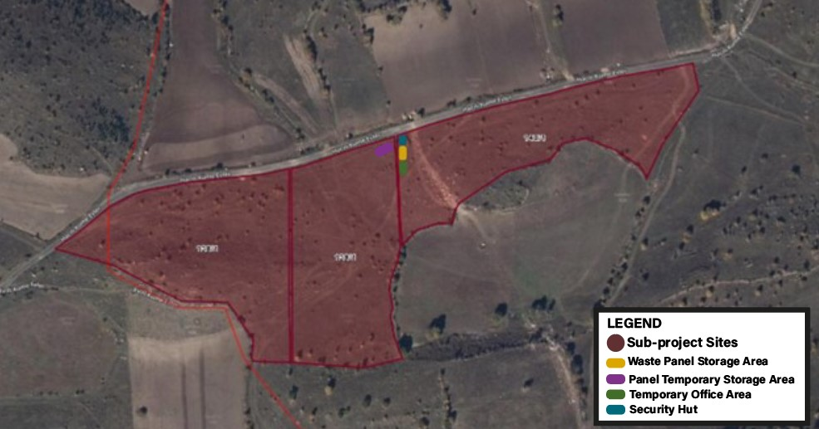
Figure 12. Sub-projects campsites

Number of workers (at peak) that will work on site during the construction and operation phases of the sub-projects are provided in Table 15.
Table 15. Labor Requirements of the Subproject
Phase | Number of Workers  (including contractors and subcontractors) | Planned Accommodation Arrangement
Construction Workers (at peak) | 15 | Off-site accommodation
Operation Workers (at peak) | 3 | On-site accommodation

Land Acquisition Status
Lot 1 of block 138, lot 1 of block 139, and lot 1 of block 140 parcels where sub-project activities will be carried out belong to the legal entity of Hacılı Neighborhood. Giresun Municipality leased 1 of these parcels (lot 1 of block 133) for sub-project use. The lease document is given in Annex B.
Most of the ETL passes through cadastral roads. Only the last 28 meters of the ETL, including lot 1 of block 133 where the transformer center will be located, will require additional land use. This parcel is leased by Giresun Municipality, and the lease agreement is shared in Annex B.
There are 3 connection points between the transformer center and the existing power line. Since two of the connection lines will be made within existing cadastral roads and public land, no land acquisition will be required for those segments. However, in order to complete the 3rd connection line, lot 1 of block 133 — which is privately owned by the Hacılı Neighborhood Legal Entity and currently leased by Giresun Municipality — will continue to be used under the existing lease agreement. The lease will be renewed upon expiration; ; therefore, no easement rights will be required.
Within the scope of the sub-projects, panel layout plans have been prepared. Approximately 10,000 m² of lot 1 of block 138 (15,532 m²), 11,150 m² of lot 1 of block 139 (15,254 m²), and 11,150 m² of lot 1 of block 140 (16,702 m²) have been designated as panel installation areas. Detailed layouts are presented in Annex İ.
Temporary structures such as offices, security cabins, waste panel storage areas, and temporary panel storage areas will be located in the spaces between panel rows. These areas have been carefully selected to ensure easy access and operational convenience without affecting the functionality or efficiency of the solar panels..
Table 16. Land Acquisition Status for the Subproject
Subproject Component&AF | Lot/ Parcel No. | Current Land Ownership | Type of Parcel  (according to Title Deed) | Land Acquisition Method | Title Deed Area of the Parcel (m²) | Area to be Used by the Subproject (m²) | Solar Panel Site(m²)
SPP-1 | 138/1 | Legal Entity of Hacılı Neigborhood | Land | Leasement | 16,702 | 15,532 | 10,000
SPP-2 | 139/1 | Legal Entity of Hacılı Neigborhood | Land | Leasement | 15,254 | 15,254 | 11,500
SPP-3 | 140/1 | Legal Entity of Hacılı Neigborhood | Land | Leasement | 15,532 | 16,702 | 11,500
ETL (The last 28 meters) | 133/1 ( | Legal Entity of Hacılı Neighborhood | Land | Leasement | 1,711.32 | 890

The land acquisition method and the status of land acquisition are the same for all components, and the process of leasing parcels has been completed.

Permitting Status
Status of permits, licenses, approvals required to be in place before start construction is presented in Table 17. Within the scope of the sub-projects, there is a decision of 'EIA Not Required' taken from the Giresun Governorship Environment, Urbanization and Climate Change Provincial Directorate.A letter of opinion was received from the Giresun Governorship Culture and Tourism Provincial Directorate regarding the nearest cultural heritages. The opinion letters was shared in Annex A.
Table 17. Status of Permits for the Construction Phase
Permit, License, Approval | Status  (In place, Not in place) | Remarks/ Notes
EIA Decision for the Power Plant | In place | Since the Giresun Municipality SPP-1, SPP-2, SPP-3 solar energy project is an on-land installation, an EIA assessment has been made according to the EIA regulation dated July 29, 2022 and the decision that EIA is not required is available with the decision number 85645151 220-02-E.2024489 dated 06.11.2024 by the Giresun Governorship Provincial Directorate of Environment and Urbanization.
Permission Letter from the Provincial Directorate of Culture and Tourism | In place | In the letter received from Giresun Governorship Provincial Directorate of Culture and Tourism with the number E-95696070-169.99-5743992 and dated 30.09.2024, it was stated that the subproject area;  Within the scope of the Tourism Incentive Law dated 12/03/1982 and numbered 2634, it is not among the places declared as “Tourism Center” by the Presidential Decree, and there is no zoning plan prepared for the areas outside the “Tourism Center” area in accordance with the relevant articles of the same law, showing the places allocated for tourism,  In the examination carried out by the relevant Institution; within the scope of the Law on the Protection of Cultural and Natural Assets dated 21/07/1983 and numbered 2863, amended by Law No. 3386; it was determined that the subproject area is not within the protected area that needs to be protected, and no cultural assets were found on the area. (See Annex A)

ESMP MATRIX: RISK AND IMPACTS, MITIGATION AND MONITORING
As the sub-project involves both construction and operation activities, the ESMP consist of two components applicable to respective sub-project phases, as follows:
- Pre-construction Phase
- Construction Phase ESMP Matrix
- Operation Phase ESMP Matrix
Roles and responsibilities related to implementation of this ESMP is defined in Section 5.2.
Implementation arrangements for ESMP implementation are described in Section 1.5.
Contractor’s E&S management plans and procedures that will support implementation of the E&S assessment documents are listed in Section 4.5.
A stand-alone sub-project specific Stakeholder Engagement Plan (SEP), including Grievance Mechanism, has also been developed and will be implemented for the sub-project throughout the sub-financing agreement lifecycles.
The installation process is planned to take 12 months. Excavation and driving machines will be used intermittently only for a maximum of 2 months of this process. As the owner of the sub-projects Giresun Municipality is responsibility to manage their environmental and social issues of the sub-projects and ensure that the necessary mechanisms are developed and implemented by the Contractor and/or Sub-Contractor.
It is anticipated that some environmental and social impacts may occur during the pre-construction, land preparation, construction and operation phases of the Giresun Municipality SPP-1: 837 kWp / 832 kWe, SPP-2: 999 kWp / 989 kWe, SPP-3: 999 kWp / 990 kWe Solar Power Plant Projects planned within the scope of the sub-projects.
The management of the risks and impacts that may occur on the environmental and social components during the pre-construction, land preparation, construction and operation phases and the relevant mitigation measures defined for these impacts are given in Section 4.2 and 4.3.
It should be noted that for the implementation of the mitigation plans, the strictest national legislation and WB standards will be followed and the most up-to-date legislation will also be taken into account. Monitoring plays a key role in ensuring the continuity and effectiveness of the implementation of the determined mitigation management strategies. The main purpose of the Monitoring Plan is to provide a basis for evaluating the implementation of the measures and requirements envisaged in this ESMP. Information collected through monitoring can be used to improve management plans at all stages of the sub-projects. Therefore, monitoring will ensure successful implementation of mitigation/management plans and optimize environmental protection through good practices at all stages of the sub-projects.

E&S Risk and Impacts of the Subproject
This section identifies the potential environmental and social impacts and risks that could arise from the activities of the sub-projects either during the construction phase or the operational phase.
The highlighted impacts listed in below are broad and envisaged as cutting across most of the sub-projects. The specific potential impacts and risks for each sub-projects will be provided in E&S assessment section of its feasibility report.
Typical Sub-projects activities to be implemented are broadly categorized into:
- Pre-construction phase
- Construction phase,
- Operation phase,
General, cross-cutting potential environmental impacts, which could be expected for all sub-projects, are presented below.

Pre-construction phase
During the preparation phase of the sub-project sites, two primary environmental impacts may occur. The first is related to the fertile topsoil that will be stripped. If the topsoil is not utilized effectively and efficiently, a loss of soil fertility may be observed. Within the scope of the sub-projects, the stripped topsoil will be reused for landscaping purposes at the sub-project sites. Detailed studies regarding biodiversity are explained in Section 2.1.6. Inspections conducted in the sub-project sites have not identified any endemic flora or protected fauna species. Before starting sub-project activities, the sites will be enclosed with wire fencing to prevent unauthorized access.
From a social impact perspective, potential dust emissions and environmental noise during the preparation phase of the sub-projects may affect nearby residents. However, dust and noise assessments indicate that their levels remain below regulatory limits, and no significant negative impacts on the local population are expected. Nevertheless, Giresun Municipality will implement dust suppression activities by spraying water using municipal tankers. Furthermore, the work will be carried out only during daytime hours, and no nighttime operations will take place.
In addition to these environmental aspects, various social risk areas must be continuously addressed throughout the sub-projects. Although no major issues have been identified to date, potential risks remain related to missing documentation, inadequate information disclosure to affected communities, and labor and working conditions.
For instance, incomplete or non-standard employment contracts may lead to wage disputes and legal risks, while unclear provisions regarding working hours and overtime could result in worker grievances and union complaints. The absence of a clearly defined code of conduct for workers, as well as inadequate OHS measures, may generate significant challenges during implementation. Weak OHS practices in particular carry the risk of workplace accidents and work stoppages.
The lack of comprehensive E&S plans may also cause multiple adverse outcomes. Insufficient safety protocols can increase the likelihood of occupational accidents, the absence of emergency response plans may lead to inadequate or improper interventions in the event of fire, accidents, or natural disasters, and shortcomings in waste management plans may result in both environmental damage and non-compliance with regulations.
Furthermore, inadequate information disclosure to local communities may undermine social acceptance, trust, and transparency, potentially triggering resistance to the project, complaints, and narratives that contribute to social unrest. Interactions between incoming workers and local residents may also cause integration challenges and cultural conflicts, while unmet expectations regarding local employment can generate dissatisfaction.
Finally, the absence of regular monitoring and reporting mechanisms may prevent timely identification of non-compliance, thereby increasing the likelihood of legal sanctions and sub-project delays.

Construction Phase

Environmental Impacts and Risks

Waste
Domestic Solid Waste
Assuming that the amount of domestic solid waste generated by personnel during the construction and operation phase of the sub projects are 1.02 kg/day per person (average waste amount per person (kg/person-day), TURKSTAT, 2023);
A total of 15 personnel will work during the sub-projects construction phase. Accordingly, the amount of waste to be generated daily is;
15 person * 1.02 kg/person = 15.3 kg
Domestic solid waste will be collected in closed and leak-proof garbage bins that will not emit odors. Domestic solid waste will be transported daily to the nearest municipal garbage collection center. During the activity; the provisions of the "Waste Management Regulation" and its amendments, which came into force after being published in the Official Gazette dated 21.06.2021 and numbered 31523, will be complied with.
Packaging Waste
It has been accepted that approximately 13.5% of recyclable packaging waste will be generated among domestic solid waste (TurkStat, 2023). Any packaging waste that may be generated will be collected separately from solid waste and will be recycled by giving it to packaging waste collection-sorting facilities that have an environmental license.
When the rate given above is compared to the daily waste amount;
15.3 kg * 0.135 = 2.0655 kg
The "Packaging Waste Control Regulation", which came into force by being published in the Official Gazette dated 21.06.2021 and numbered 31523, and the "Waste Management Regulation" and its amendments, which came into force by being published in the Official Gazette dated 12.07.2019 and numbered 30829. “Zero Waste Regulation” and its relevant provisions will be complied with.
Hazardous Waste
Since the maintenance of the equipment to be used during the construction phase of the activity will be carried out by the authorized service, there will be hazardous waste generation originating from the machinery and equipment in the activity area. In case of generation, in a safe place will be established at a designated point in the activity area and the hazardous waste will be stored there. The waste in question will be classified according to their characteristics according to the “Waste Management Regulation” and the label “hazardous or non-hazardous waste” will be written on the temporarily stored waste, the waste code will be written and the waste will be accumulated in the temporary waste storage area in a way that it will not react with each other. These accumulated wastes will be delivered to companies licensed by the Ministry of Environment and Urbanization. The provisions of the Waste Management Regulation (Amended: Regulation on Amendments to the Waste Management Regulation, Official Gazette, dated 02.04.2015 and numbered 29314) which entered into force upon publication in the Official Gazette dated 23.06.2021 and numbered 31523 will be complied with.
The area where hazardous waste will be temporarily stored will be equipped with appropriate engineering measures to minimize possible risks to the environment and human health. This area will be constructed with a waterproof and impermeable floor covering and will be covered to prevent rain and surface water from entering. The area will be surrounded by wire fencing and entrances and exits will be controlled to prevent waste from spreading to the outside environment. The area will be secured with a locked system to prevent unauthorized access. Fire extinguishing equipment and emergency response kits will be kept in the area, and regular inspection and maintenance activities will be carried out. In addition, hazardous waste will be labeled, recorded and managed in accordance with the legislation until they are sent to licensed disposal facilities during the temporary storage period. These conditions will be designed in accordance with both national legislation and the World Bank Environmental, Health and Safety Guidelines. Panels that become waste will be classified as hazardous waste and will be stored safely in a designated area (See Figure 13)at the sub-project sites until they are delivered to a licensed recycling/disposal facility.
Waste Batteries and Waste Accumulator
Waste batteries that may be removed from vehicles in the sub project areas will be returned to the vendors and replaced with new batteries. Batteries used in the field will be reused by ensuring that they are rechargeable. Used batteries will be collected in battery collection boxes and left at collection points belonging to TAP (Portable Battery Manufacturers and Importers Association). The "Regulation on the Control of Waste Batteries and Accumulators" and its relevant provisions, which came into force after being published in the Official Gazette dated 31.08.2004 and numbered 25569, will be complied with.

Water Supply and Wastewater Management
Amount of Domestic Water Required
It is planned that 15 personnel will be employed during the construction phase of the Giresun Municipality Solar Power Plant Projects, and assuming that the drinking and utility water consumption per person is 186 L/day (TurkStat, 2023),
15 people * 186 L/day*person = 2,790 L/day
Within the scope of the sub-projects, the Regulation on Waters for Human Consumption, which came into force after being published in the Official Gazette dated 17.02.2005 and numbered 25730, and the "Regulation on Waters for Human Consumption" published in the Official Gazette dated 31.07.2009 and numbered 27305, will be complied with.
The water requirement for suppressing the dust generated in the sub-project areas due to construction work will be met by using water trucks filled from the municipal infrastructure of Giresun Municipality. Drinking water and water used for suppressing dust during construction will be provided from the district water network.
The total construction area within the scope of the sub-projects will be approximately 47,488 m². 5 liters of water will be used per square meter. Accordingly, water will be used to prevent dust emissions (calculation for one-time irrigation).
47,488 m²*5 liters/m² = 237,440 L
Amount of Wastewater
It is anticipated that a total of 15 people will work. Since the daily amount of drinking and utility water to be used per person is 113 L/person-day, the total amount of water to be used will be (TurkStat, 2023);
Personnel water usage amount = (Water usage amount per person) x (number of personnel)
Personnel water usage amount = (113 L/person-day) x (15 peoples)
≈ 1,695 L/day.
Within the scope of the sub-projects, the Regulation on Waters for Human Consumption, which came into force after being published in the Official Gazette dated 17.02.2005 and numbered 25730, and the "Regulation on Waters for Human Consumption" published in the Official Gazette dated 31.07.2009 and numbered 27305, will be complied with.

Dust and Exhaust Gas Emission
Air pollution will mainly originate from dust emissions and exhaust emissions as well as Greenhouse Gas (GHG) emissions. Considering the location of the sub-project area, sensitive receptors ( are not expected to be affected) . During the construction phase of the sub-project, the impacts on air quality will mainly originate from dust, exhaust and greenhouse gas emissions:
• Dust emissions during site preparation, excavation, filling and compaction works carried out for construction works.
• Dust emissions from vehicle movements for transporting various construction materials to the sub project sites.
• Exhaust emissions from vehicles used in construction activities.
• Greenhouse gas emissions from small amounts of vehicles and machinery.
Since a limited number of equipment and machinery will be operating on the sites, these air quality impacts will be limited to the area and in the short term.
Emission estimates from excavation works are given in Table 24.
Calculation of dust emissions from topsoil stripping
In the calculation of the dust emissions to be generated, the emission factors given in Table 17 of the “Regulation on Control of Industrial Air Pollution” (Amended Table: RG-20.12.2014-29211) published in the Official Gazette dated 03.07.2009 and numbered 27277 were used and the results were evaluated within the framework of the same regulation.
The calculations were made using both “uncontrolled” emission factors, considering that the most adverse conditions could occur during dust formation, and “controlled” emission factors, assuming that the necessary control measures were taken.
The area where the SPP-1 sub project site will be established is 16,702 m². In this area, 10 cm topsoil stripping will be used to strip 1,670.2 m³ of soil.
The area where the SPP-2 sub project site will be established is 15,254 m². In this area, 10 cm topsoil stripping will be used to strip 1,525.4 m³ of soil.
The area where the SPP-3 sub project site will be established is 15,532 m². In this area, 10 cm topsoil stripping will be used to strip 1,553.2 m³ of soil.
A period of 6 weeks is planned to be allocated to 3 sites for excavation work, and the soil formed by surface stripping will be used in landscape areas within the sub-project sites.
The total topsoil formed in SPP-1, SPP-2 and SPP-3 lands is 4,748.8 m³.
(Soil Bulk Density is taken as 1.6 tons/m3)
4,784.8 m³* 1.6 tons/m3=7,655.04 tons
Daily working time is planned as 8 hours. Excavation work is planned as 336 hours in total.
7,655.04 tons/336 hours= 22.78 tons/h
Table 18. Control of Industrial Air Pollution
Sources | Uncontrolled | Controlled | Unit
Removal | 0.025 | 0.0125 | kg/ton
Loading | 0.0100 | 0.005 | kg/ton
Unloading | 0.010 | 0.005 | kg/ton
Transportation (total round trip distance) | 0.7 | 0.35 | kg/km-vehicle
Storage | 5.8 | 2.9 | Dust/ha-day

Mass Flow Rate of Dust Emission to Occur During Removal, Loading and Unloading of Vegetal Soil
Uncontrolled; E1 = 22.78 tons/hour x (0.025+0.01+0.01) kg/ton = 1.03 kg/hour
Controlled; E1 = 22.78 tons/hour x (0.0125+0.005+0.005) kg/ton= 0.51 kg/hour
Mass Flow Rate of Dust Emission to Occur During the Transportation of Topsoil
Topsoil taken from the field during construction work will be temporarily stored in the topsoil storage area that will also be located within the work area; this distance is an average of 0.25 km round trip. Assuming that each truck used during transportation can carry 25 tons of material and therefore will make 1 trip in approximately 1 working day (25 tons/21.36 tons/hour), the mass flow rate of dust emissions that will occur during transportation is;;
Uncontrolled; E2 = (0.7 kg/km) x (0,25 km/1 trip) x (1 trip/1 hour) = 0.175 kg/hour
Controlled; E2 = (0.35 kg/km) x (0,25 km/1 trip) x (1 trip/1 hour) = 0.088 kg/hour
Dust Emission Mass Flow Rate to be Formed During the Storage of Vegetal Soil
If 4,784.8 m³ of topsoil is stored at a height of 3 meters, an area of 1,595 m² is required.
Uncontrolled; E3 = (5.8 kg/ha-day)x(0.16 ha/3 months/ 30 days/month/8 hours/day)= 0.0012 kg/hour
Controlled; E3 = (2.9/ha-day)x(0.16 ha/3 months/30 days/month/8 hours/day)= 0.0006 kg/hour
Accordingly, the total mass flow rate of dust emission to be formed from the stripping operations of the vegetal soil to be carried out;
Uncontrolled; ETOTAL-1 = 1.03 kg/h + 0.175 kg/h + 0.0012 kg/h ≈ 1.2 kg/h
Controlled; ETOTAL-1 = 0.51 kg/h + 0.088 kg/h + 0.0006 kg/h ≈ 0.6 kg/h
The amounts of dust emissions that are likely to occur under uncontrolled and controlled conditions during the activity have been calculated above. As stated in the relevant sections, the sub-projects will be operated under controlled working conditions and the dust emissions that will occur within this scope do not exceed the 1 kg/hour limit value specified in the “Regulation on Control of Industrial Air Pollution”, which was published in the Official Gazette dated 03.07.2009 and numbered 27277 and entered into force.
Considering that all the works to be carried out within the scope of the vegetal soil stripping operations to be carried out at the construction site will be carried out in the same time period (worst case scenario), the dust emission to be generated has been calculated as 1.2 kg/hour for the uncontrolled case and 0.6 kg/hour for the controlled case. Therefore, as stated in “Industrial Air Pollution and Control Regulation”; since the specified pollutant mass flow rates are not exceeded for the vegetal soil stripping operation, it has not been deemed necessary to calculate the “Contribution Value to Air Pollution” using an internationally accepted distribution model in the facility AoI.
The construction equipment and transportation vehicles in question will be used at different times during the day. Therefore, the pollutant values ​​calculated in the Table 24 are expected to be much lower in reality.
Emission calculation from vehicles
The provisions of the Exhaust Gas Emission Control and Gasoline and Diesel Quality Regulation, which was published in the Official Gazette dated 30.11.2013 and numbered 28837 and entered into force, and the Exhaust Gas Emission Control Regulation, which was published in the Official Gazette dated 11.03.2017 and numbered 30004, shall be complied with.
During construction, the fuel to be spent is only necessary for the work machines to be used, there will be no fuel consumption for heating etc. The usage periods and fuel consumptions of the work machines to be used during the construction phase of the business are shared in Table 19. Usage periods of the work machines to be used in the facility.
Table 19. Working hours
Machine type | Number | Power (hp/h) | Working Time (h/day)
Crane | 1 | 200 | 8
Excavator | 1 | 200 | 8
Truck | 1 | 200 | 8
Pile Driver | 1 | 90 | 8
Water Tank | 1 | 120 | 8

The fuels to be used in the land preparation and construction phase of the sub-projects will be diesel fuel to be used during the work of the construction equipment. Apart from this, there is no other type of fuel to be used in the sub-projects. Diesel fuel will be preferred as fuel for the construction equipment to be used within the scope of the sub-projects. There will be no fuel storage in the sub-project areas and their fuel supply to the construction equipment will be made with fuels supplied from authorized stations. The characteristics of diesel fuel are given below:
Table 20. Diesel Properties
Properties | Diesel | Properties | Diesel
Consistency | Very fluid | Carbon Wastes (%) | Trace
Type | Distilled | Sulfur (%) | 0.4-0.7
Color | Amber | Oxygen-Nitrogen (%) | 0.2
Density (150c-gr/cm3) | 0.8654 | Hydrojen (%) | 12.7
Viscosity (380 ^{oC}) | 2.68 | Carbon (%) | 86.4
Pour Point (0oC) | -18 | Water and Sediment (%) | Trace
Atomization Temperature (0oC) | Atmospheric | Ash (%) | Trace
Pumping Temperature (0oC) | Atmospheric | Heat Value | 9.387
Source: Air Pollution Control and Supervision, Chamber of Chemical Engineering, May, 1999
The emission factors table determined by the EPA (Environment Protection Agency) was used for the construction equipment to be used within the scope of the sub-projects.
Table 21. Emission Factors Used in Calculations
Power | Year | CO (g/kWh) | HC (g/kWh) | NOx (g/kWh) | PM (g/kWh)
56 ≤ kW < 130  (75 ≤ kW <175) | 2012 and above | 5,0 | 0,19 | 0,40 | 0,02
130 ≤ kW < 560  (175 ≤ kW <560 | 2011 and above | 3,5 | 0,19 | 0,40 | 0,02
Source: USEPA Standards
Using the data in the table above, exhaust gas emissions that will occur during the construction and operation phases are calculated with the formula below and entered into the tables.
Emission Value (kg/h) = Emission Factor x Engine Power (kW) x Number x kg/1000 gr
Table 22. Emission calculations
Equipment to be used | Piece | Hp | kW | Emission Factor (g/kWh) |  | Emission Value (kg/h)
Excavator | 1 | 200 | 149 | CO | 3,5 | 0,52
 |  |  |  | HC | 0,19 | 0,03
 |  |  |  | NOx | 0,4 | 0,06
 |  |  |  | PM | 0,02 | 0,003
Crane | 1 | 200 | 149 | CO | 3,5 | 0,52
 |  |  |  | HC | 0,19 | 0,03
 |  |  |  | NOx | 0,4 | 0,06
 |  |  |  | PM | 0,02 | 0,003
Pile Driver | 1 | 90 | 67.05 | CO | 5 | 0,34
 |  |  |  | HC | 0,19 | 0,013
 |  |  |  | NOx | 0,4 | 0,026
 |  |  |  | PM | 0,02 | 0,0013
Truck | 1 | 200 | 149 | CO | 3,5 | 0,52
 |  |  |  | HC | 0,19 | 0,03
 |  |  |  | NOx | 0,4 | 0,06
 |  |  |  | PM | 0,02 | 0,003
Water Tanker | 1 | 120 | 89.5 | CO | 5 | 0,4475
 |  |  |  | HC | 0,19 | 0,017
 |  |  |  | NOx | 0,4 | 0,036
 |  |  |  | PM | 0,02 | 0,002
1 Hp = 0.745 kW.
When emissions from all vehicles are added together;
Table 23. Amount of Emission
Pollutant | Amount (kg/h) | Working Time (h) | Total Amount (kg)
CO | 2.3475 | 8 | 18.78 kg
HC | 0.12 | 8 | 0.96 kg
NOx | 0.242 | 8 | 1.936 kg
PM | 0.0123 | 8 | 0.0984 kg

The calculation was made assuming that all vehicles were operating at maximum operating time and in the same month.
Table 24. Comparison of amount of emissions with limit values
Pollutant | Amount (kg/h) | Mass flow rate (kg/hour) given in Annex-2 Table 2.1 of the “Regulation on Control of Air Pollution from Industrial Sources” | Evaluation
CO | 2.3475 | 50 | Below the limit value
HC | 0.12 | 2 | Below the limit value
NOx | 0.242 | 4 | Below the limit value
PM | 0.0123 | 1 | Below the limit value

The calculated exhaust gas emission amounts were calculated cumulatively assuming that all machinery and equipment operate at the same time and are entered in the table above. When the calculated hourly mass flow rate (kg/hour) value was compared with the mass flow rate (kg/hour) values given in Annex-2 Table 2.1 of the “Regulation on Control of Industrial Air Pollution”, it was seen that the emission mass flow rates were below the limit values given in the regulation. The calculations were made based on the assumption that all work machines operate simultaneously and continuously in their areas of use, and in reality, such an application is not very possible. Therefore, the emission levels that will occur in reality will be lower than the emission levels found in the calculations.
Where the requirements in Türkiye differ from the levels and measures presented in the EHS Guidelines, the more stringent (such as the most stringent discharge and emission standards) will be applied in the subproject specification.
There are no sensitive structures such as schools or health centers within the AoI. The closest sensitive receptor to the sub-project sites are a household located approximately 620 m northwest of the SPP-1 area, and a single residence located 653 and 756 m south of the SPP-2 and SPP-3 areas, respectively. Air pollution will mainly originate from dust emissions and exhaust emissions as well as Greenhouse Gas (GHG) emissions. These receptors may be temporarily affected by dust emissions from excavation operations and vehicle movements, and exhaust gases from construction machinery. During the construction phase of the sub-projects, the impacts on air quality will mainly originate from dust, exhaust and greenhouse gas emissions:
- Dust emissions during site preparation, excavation, filling and compaction works carried out for construction works.
- Dust emissions from vehicle movements for transporting various construction materials to the sub-project sites.
- Exhaust emissions from vehicles used in construction activities.
- Greenhouse gas emissions from small amounts of vehicles and machinery.
Since a limited number of equipment and machinery will be operating on the sites, these air quality impacts will be limited to the sub-project AoI and in the short term.

Noise Pollution
Noise emissions will occur during the construction phase of the sub-project activites. The distance of the sub-project sites to the residential areas greatly reduces the impact of the emissions. Noise emissions are at a negligible level.
During the construction phase noise pollution may occur, necessary precautions will be taken and procedures will be followed.
During the construction phase, 3 loaders, 3 trucks, 2 concrete mixers, 1 water tanker and 1 pile driver will be on duty on site. All of these machines will work in an open area. Considering the maximum impact in the noise calculations, it was assumed that all machines would work on the surface, simultaneously and continuously.
The noise values expected to occur within the scope of the sub-projects were calculated using the formula Leq=10 log∑10 LT(i) /10 with equivalent noise levels (Lday = Leq) and the Lday levels were found and the table below was created.
Table 25. Probable Ldaytime Noise Levels During the Construction Phase
Distance L daytime (dBA) | L daytime (dBA)
35 | 73
80 | 65
500 | 47
620 | 45
653 | 45
756 | 43
2500 | 30
3000 | 28

It is expected that the noise intensity reaching the receptors will decrease further due to some effects such as the fact that the sub-project areas where the activity will be carried out is spread over an open and wide area, the noise will not be continuous and will be variable at certain intervals, and the terrain conditions are rugged. As is known, on many highways, vegetation creates noise barriers and, in some sections, the road level is lowered and the noise level that will reach the receptors is reduced using topography. These two applications are naturally present between the sub-project areas and the receptors. Therefore, the value obtained in the calculation will be much lower than the level that will be felt at the receptor and will not cause a negative effect.
However, in case of a complaint or if the authorized institutions request it, noise will be measured, noise barriers will be created at the border points facing the nearest residence or other measures will be taken as requested by the authorized institutions. Accordingly, the residence located here will not be negatively affected during the works.

Soil erosion, loss and contamination
The major impact on soil could be the potential topsoil loss at the footprints of the sub-projects where excavation will be carried out. Excavated soil may be exposed to agents of erosion, mostly water and wind. Due to the involvement of heavy machinery during the construction phase, soil contamination may be seen due to accidental oil leakages in the areas. The impacts on soil will be minimal and localized in the areas where construction will take place only. The potential impacts of the sub-projects on soil environment are summarized below:
- Soil compaction as a result of topsoil stripping, levelling, excavation and filling activities, work of construction machinery,
- Mixing of soil layers as a result of excavation and filling activities,
- Soil contamination as a result of oil or fuel leaks or spillage that may result from incidents and unexpected events,
- Soil pollution which may occur in case of uncontrolled storage or disposal of solid and/or liquid wastes to be generated within the scope of the sub-projects, and
- Erosion potential due to earthworks.

Possible Impacts on Fauna and Measures to be taken:
It is expected that fauna species will be affected by the works carried out in the area within the scope of the sub-projects. In particular, effects such as spontaneous departure of species showing mobility, search for alternative habitats and regional carrying capacity have been taken into consideration. However, as a result of the observations made, no dense fauna population or habitat requiring special protection was detected in the area. In this context, visual checks will be carried out during the pre-construction preparation phase, nest areas will be determined and necessary markings will be made to ensure that the creatures move away from the area without intervention.

Social Impacts and Risks

Occupational Health and Safety and Labor Risks
During electrical installations, standard risk elements such as using gloves used in electrical work instead of gloves used in mechanical operations, ensuring electrical insulation, and implementing logo lock applications should be applied in every work area. In addition to these simple applications that should be applied in every work area, risk assessments should definitely be carried out by an expert in the work areas and the most necessary precautions should definitely be taken if there are any.
Construction works can cause incidents and accidents that may threaten the health and safety of workers if measures are not taken proactively.
Potential health and safety risks during the construction have been listed below.
- Working at height,
- Moving objects,
- Slips and trips,
- Noise vibration and exposure to dust,
- Materials handlings,
- Unintended collapse,
- Chemicals
- Machinery and equipmentElectricity,
- Traffic related risks due to increased traffic,
- Associated risk of occupational accidents, injuries and diseases,
- Hazards to workers due to unhygienic or unsanitary living conditions, etc.
Details and area specific risks will be obtained during site studies and will be assessed under social impact and risks sections of respective ESA documents. Mitigation measures and occupational health and safety issues are managed in line with the Labor Management Procedure of the sub-projects which is in compliance with the national legislation, Occupational Health and Safety Law (Law No: 6331, Date of Enactment: 20/06/2012), World Bank ESS2 and World Bank Group General Environmental Health and Safety Guidelines.
Depending on the sub-project activities, an appropriate number of OHS experts will be assigned. A comprehensive risk assessment including sub-project specific risks will be conducted. Personnel will be required to obtain health reports before starting work and declare them to the employer. Personnel training will be completed before starting work. During construction activities, work will be monitored and evaluated in terms of OHS and any non-compliance will be reported.

Community Health and Safety
The sub-projects are expected to bring benefits to the community by improving access to municipal services, which in turn may enhance local business opportunities and stimulate infrastructure development in the region. However, potential adverse Community Health and Safety (CHS) impacts may arise during the construction phase. These impacts include, but are not limited to:
- Damage to roads and increased traffic congestion, resulting in a higher risk of traffic accidents and injuries,
- Emergency situations related to contextual risks (e.g., earthquakes),
- Increased noise levels from construction activities,
- Risks to community culture, safety, and security due to the presence of construction workers and opportunistic external actors,
These CHS-related risks have been identified within the scope of the Environmental and Social Management Plan (ESMP), and corresponding mitigation measures will be developed and implemented accordingly.

Traffic
Access to the highway from the sub-project areas will be provided through existing intersections and no connection will be made to the highway.
The existing access road shared in Figure 2 passes in front of Alucra district. As the sub-projects will utilize existing roads and the route passes in front of Alucra district, no permanent or significant impacts are expected. Nevertheless, the current condition of the road with its limited capacity, combined with increased vehicle movements during the construction phase, may cause temporary congestion and safety risks.

Loss of Land and Livelihoods
The existing land use of the sub-project areas will be affected by the construction camps and ETL. In the parcels where the sub-project areas are located; no institution or organization and local people carry out any pasture use, agriculture or animal husbandry activities. In this direction; no loss of land or livelihood risks are expected within the scope of sub-project activities.

Vulnerable and Disadvantaged Individuals/Groups
Certain vulnerable and disadvantaged individuals and/or groups such as persons with disabilities, individuals over 70 years of age, those with chronic illnesses or in need of special care, female-headed households, low- or no-income households, and women with low literacy levels may be more affected by sub-project activities compared to others. Potential impacts include exposure to dust emissions and environmental noise, as well as possible reluctance among women with lower education levels to express their opinions, suggestions, and concerns about the sub-projects. Although the construction activities will not take place directly on main access road, the movement of heavy vehicles in nearby areas may still pose a risk by potentially damaging secondary roads, which could restrict the mobility of persons with disabilities and other vulnerable and disadvantaged individuals.
The sub-projects specific ESMP will consider any impacts in association with the daily living patterns of potential vulnerable and disadvantaged groups that may be generated due to civil works.
Although no direct adverse impacts on vulnerable groups are anticipated, secondary risks such as noise, dust, and increased vehicle movement may occur during construction activities. To mitigate these risks, accessibility, information disclosure, and safety measures will be implemented with particular consideration for the vulnerabale and disadvantaged groups which are determined under the section 2.1.7.8.

Cultural Heritage
There is no tangible or intangible cultural heritage found within the sub-project sites. In this case of any detection of chance finds during the construction activities, Chance Find Procedure (Annex F) will be implemented. As the initial stage of baseline studies, literature and surficial studies have been conducted for land. In the second stage, a field visit was carried out on 15.05.2025. However, due to the nature of physical cultural resources, buried assets (i.e., graves or mounds) may not be determined during baseline studies. The principal issue is twofold: (i) “chance finds” identification of during construction, and (ii) potential impact of the subproject on known cultural values. Giresun Municipality is responsible for the application of the relevant law and regulation given in Annex H. Moreover, during the site studies, mukhtar of Hacılı Neighborhood, local authorities of Giresun District and residents were questioned about the presence of cultural heritage in sub-project AoI. No tangible or intangible cultural heritage assets that may be adversely affected by the sub-projects were identified.

Operation Phase

Environmental Impacts and Risks

Waste
Domestic Solid Waste
Assuming that the amount of domestic solid waste generated by personnel during the operation phase of the sub-projects is 1.02 kg/day per person (average waste amount per person (kg/person-day), (TURKSTAT, 2023);
A total of 3 personnel will work during the sub-projects operation phase. Accordingly, the amount of waste to be generated daily is;
3 persons * 1.02 kg/person = 3,06 kg/gün
Domestic solid waste will be collected in closed and leak-proof garbage bins that will not emit odors. Domestic solid waste will be transported daily to the nearest municipal garbage collection center. During the activity; The provisions of the "Waste Management Regulation" and its amendments, which came into force after being published in the Official Gazette dated 02.04.2015 and numbered 29314, will be complied with.
Packaging Waste
It has been accepted that approximately 13.5% of recyclable packaging waste will be generated among domestic solid waste (TURKSTAT, 2023). Any packaging waste that may be generated will be collected separately from solid waste and will be recycled by giving it to packaging waste collection-sorting facilities that have an environmental license.
When the rate given above is compared to the daily waste amount;
3,06 kg * 0.135 = 0.41 kg/day.person
3 persons* 0,41 kg= 1.23 kg
The "Packaging Waste Control Regulation", which entered into force upon publication in the Official Gazette dated 21.06.2021 and numbered 31523, and the "Zero Waste Regulation" and its amendments, which entered into force upon publication in the Official Gazette dated 12.07.2019 and numbered 30829, and the relevant provisions will be complied with.
Hazardous Waste
At the end of their service life, the equipment used in the facility will generate waste that must be managed in accordance with applicable regulations. Photovoltaic (PV) panels to be used have an estimated product lifespan of 10 years and a performance warranty of 25 years. After 25 years, they may remain operational with up to a 20% efficiency loss. When the panels reach the end of their operational life or require replacement, they will be either refurbished for reuse or replaced with new units.
In line with the Waste Management Regulation (Official Gazette No. 29314, dated 02.04.2015), waste management procedures will be implemented for hazardous and non-hazardous materials. PV panels are classified as hazardous waste, and their dismantling, transportation, and final disposal will be carried out through licensed hazardous waste treatment facilities.
Inverters and fuses, classified as electronic equipment with an average economic life exceeding 20 years, will be disposed of by authorized firms. Their waste classification will be made in accordance with the Waste List Communiqué published by the Ministry of Environment, Urbanization and Climate Change. Waste inverters and similar electronic components will be disposed of under waste code 20 01 36 (Discarded electrical and electronic equipment other than 20 01 21, 20 01 23, and 20 01 35).
The structural support systems for the solar panels are designed to last at least 40 years. Upon decommissioning, these metallic structures will be considered non-hazardous waste and will be managed under waste code 20 01 40 (Metals) through licensed recycling facilities.
Cables to be used in the system will be selected for their resistance to ultraviolet radiation and high temperatures, with a minimum service life of 20 years. Upon reaching end-of-life, cables will be collected and sent to licensed facilities for disposal under waste code 17 04 11 (Cables other than 17 04 10).
All waste handling processes will adhere strictly to national environmental legislation to ensure safe and compliant disposal and minimize potential environmental impacts.
Waste Batteries and Waste Batteries
Waste batteries that may be removed from vehicles in the sub project areas will be returned to the vendors and replaced with new batteries. Batteries used in the field will be reused by ensuring that they are rechargeable. Used batteries will be collected in battery collection boxes and left at collection points belonging to TAP (Portable Battery Manufacturers and Importers Association). The "Regulation on the Control of Waste Batteries and Accumulators" and its relevant provisions, which came into force after being published in the Official Gazette dated 31.08.2004 and numbered 25569, will be complied with.

Water Supply and Wastewater Management
It is anticipated that a total of 3 persons will work. Since the daily amount of drinking and utility water to be used per person is 186 L/person-day, the total amount of water to be used will be (TURKSTAT, 2023);
Personnel water usage amount = (Water usage amount per person) x (number of personnel)
Personnel water usage amount = (186 L/person-day) x (3 persons
≈ 558 L/day.
Within the scope of the sub-projects, the Regulation on Waters for Human Consumption, which came into force after being published in the Official Gazette dated 17.02.2005 and numbered 25730, and the "Regulation on Waters for Human Consumption" published in the Official Gazette dated 31.07.2009 and numbered 27305, will be complied with.
According to TurkStat, 2023 data, the amount of wastewater per person is calculated as 113 L/day. During the operation phase, 3 people will work at the facility. Daily wastewater amount:
113 L/day-person*3 person= 339 L/day
Within the scope of the sub-projects, a septic tank will be constructed during the operation period.
Periodic cleaning of solar panels is essential to minimize efficiency losses in the solar power plant. Although the frequency of cleaning the panels varies depending on the city and environment where the power plant is located, on average, cleaning the panels twice a year will be sufficient. Cleaning of solar panels is done only with water.
Using chemicals to clean the solar panel may scratch the panel and reduce the absorption power of the solar rays, which will significantly weaken the efficiency of the solar panels. For this reason, no chemicals will be used during cleaning. No chemicals will be used for panel cleaning during the operation phase. The panels will be cleaned with deionized pure water. Deionized water will be purchased from outside. Panel cleaning will be done twice a year and approximately 4 m³/ha water will be used.
The size of the sub-project areas are 4.75 ha. Accordingly, the amount of water to be used in cleaning operations is;
4.75 ha x 4 m³/ ha = 19 m³

Climate Change
There is no activity that may contribute to climate change during the operation phase of the activity subject to the sub-projects, and it is not foreseen that any greenhouse gas formation, greenhouse gas emission and climate change will occur around the sub-project areas. There is no activities that may contribute to climate change during the operation phase of the activity subject to the sub-projects, and it is not foreseen that any greenhouse gas formation, greenhouse gas emission and climate change will occur around the sub-project areas.

Impacts on Natural Habitats and Biodiversity
The sub-project areas and their surroundings are not located within any officially designated protected areas such as Special Environmental Protection Areas (SEPAs), Natura 2000 areas, Wildlife Protection Areas (WPAs) or other ecologically sensitive areas. According to available data, there are no endemic or endangered flora or fauna species within the sub-project areas boundaries.
However, as part of the biodiversity assessment, potential impacts on ecosystem integrity and habitat connectivity will be taken into account. Although there are no endemic habitats in the area where the SPP will be installed, the installation of perimeter wire mesh fences may impede the movement of certain terrestrial species, especially medium and large-sized mammals. This may lead to habitat fragmentation or disruption of temporary movement corridors.
To minimize potential impacts on habitat connectivity:
Layout and fence design will take wildlife movement into account and accommodate wildlife passages or openings (e.g. ground-level gaps or raised fences in selected segments) where necessary.
The SPP areas will be strictly limited to the permitted boundaries and sub-project activities will not extend beyond this footprint. In this regard, the integrity of the surrounding habitats will be preserved and no permanent or significant temporary habitat degradation is anticipated. If any indication of sensitive species or habitats is revealed during construction or operation, a detailed ecological survey will be conducted. In addition, awareness will be created among all field personnel on the conservation of biodiversity and wildlife.

Noise
Photovoltaic (PV) systems used in solar power plants do not produce mechanical noise during operation as they do not contain moving parts. However, auxiliary components such as inverters, transformers and cooling fans may produce low levels of continuous noise.
Although this noise is generally low, it will be technically assessed in accordance with both national regulations (e.g., the Turkish Environmental Noise Control Regulation) and relevant international standards such as the World Bank Group Environmental, Health and Safety (WBG EHS) Guidelines.
As part of the environmental assessment, the distance to the nearest sensitive receptor will be clearly determined and potential noise impacts from the operational phase will be assessed. Where necessary, mitigation measures (e.g., acoustic enclosures, buffer zones) will be taken to ensure compliance with applicable standards and to protect public health and welfare.

Social Impacts and Risks

Community Health and Safety
The solar power plant project may have certain implications for community health and safety. During the operation phases, inadequate waste management or potential chemical leaks could negatively impact local water resources and soil quality. Additionally, unauthorized access to the site may pose safety risks such as falls or contact with electrical components. Effective management of these risks is essential for the safety of the public and the success of the sub-projects.
The solar power plant project may have certain implications for community health and safety during the operation phase. Inadequate waste management or potential chemical leaks could negatively impact local water resources and soil quality. Additionally, unauthorized access to the site may pose safety risks such as falls, physical injuries, or contact with energized components.
In line with the World Bank Environmental and Social Standard 4 (ESS4), community health and safety risks during the operational phase must be carefully assessed and managed. This includes evaluating potential hazards arising from the sub-project's infrastructure, such as electrical installations, access roads, and waste storage areas, as well as ensuring that emergency response procedures and security measures are in place.
In this context, an assessment of risks to community health and safety should be conducted in accordance with ESS4, focusing particularly on their potential impacts on the local population.

Occupational Health and Safety and Working Conditions
Key precautions include electrical safety protocols, such as marking energized equipment, implementing Lockout/Tagout (LOTO) procedures, and inspecting electrical tools and cables. Machine safety is ensured through proper guarding, emergency stops, and controlled maintenance processes. Hot work precautions include fire prevention measures like standby extinguishers and hot work permits. Safe vehicle operation is enforced through driver training, medical supervision. In addition, safe storage, appropriate labeling, minimization of exposure and avoidance of harmful substances wherever possible will be essential for mineral oils and similar substances in order to prevent environmental pollution.
During electrical installations, standard risk elements such as using gloves used in electrical work instead of gloves used in mechanical operations, ensuring electrical insulation, and implementing logo lock applications should be applied in every work area.
In addition to these simple applications that should be applied in every work area, risk assessments should definitely be carried out by an expert in the work areas and the most necessary precautions should definitely be taken if there are any.

Labor and Working Conditions
All needs of the personnel who will work during the operation phase will be met from the administrative building. Kitchen, study rooms, restrooms will be created inside the administrative building. The food needs of the personnel will be met by purchasing services from outside. All services will be provided in accordance with the legislation and the wastes that will occur during or after the services will be collected and disposed of in accordance with the provisions of the legislation.
During the operational phase, three unarmed security guards will be deployed on site. The job description will include night patrols, monitoring remote or open areas, and managing unauthorized access that may involve risks of physical conflict. Inadequate training or lack of knowledge of emergency procedures can increase security risks for both personnel and the surrounding community.
Special attention will be paid to the deployment and conduct of security personnel in accordance with World Bank Environmental and Social Standard 4 (ESS4). The sub-projects will include ensuring that security personnel are appropriately trained in accordance with human rights principles and conflict reduction techniques, interact with community members, that any use of force is strictly proportionate and limited to what is lawful, and that grievance mechanisms are accessible to the community in the event of misuse or abuse.
In this context, effective risk management is essential to protect community members and ensure that the sub-project complies with its ESS4 obligations.

Land Acquisition

All parcels required for the sub-project are accessed through lease agreements; therefore, no expropriation or easement rights are needed. The 35-year lease agreement for parcel 133/1 will be renewed by Giresun Municipality upon expiration. As land access is based on leasing, several low-level subproject-specific risks have been identified. These include the potential for administrative delays in the renewal process that could affect the subproject schedule, procedural inconsistencies between the parties that may result in temporary access limitations or additional review needs, and possible institutional risks arising from changes in public administration that may lead to requests for additional documentation. These risks are considered low in probability and can be effectively managed through the municipality’s commitment to renew the lease and regular monitoring of relevant processes.

Construction ESMP Matrix
No | Impact Description | Receptor | Proposed Mitigation Measure | Relevant Plans/Procedures | Responsibility for 133 of Mitigation Mesaure
ESS2 - Labor and Working Conditions
1 | Management of Working and Labor Conditions | Employees | - All services should be provided in accordance with the relevant legal legislation.  - Weekly on-the-job trainings will be implemented, including the OHS Plan and Working Conditions.  - The Labor Management Plan will be implemented for the recruitment and management processes of all employees.  - In accordance with the Labor Management Plan, child labor, forced labor and unregistered labor will be prohibited.  - Employees will be provided with clear and understandable documentation on their rights under national labor law, such as collective agreements, working hours, wages, overtime, compensation and social rights; this information will be provided at the beginning of the employment relationship and in case of any significant change.  - Workers’ Grievance Mechanism will be implemented for employees. Employees will be informed about this mechanism during recruitment and will be easily accessible.  - All employees will receive the necessary OHS training covering risks and emergency response training.  - On-the-job briefings (toolbox) should be held regularly and current safety procedures, risks and precautions to be taken should be fully conveyed to employees.  - OHS Management Plan and Labor Management Plan (including the Workers’ grievance mechanism) will be prepared by the awarded contractor and sent to ILBANK for approval prior to the site mobilization. | OHS Management Plan,  Workers’ Grievance Mechanism  Labor Management Plan | Giresun Municipality, (performance control and coordination)  Supervision Consultation, (monitoring)  Contractor (implemantation)
2 | OHS - Physical Hazards: Electrical Hazards | Employees | - Ensure that all energized electrical devices and lines are marked with warning signs  - Ensure that the devices are locked (de-charging and leaving open with a controlled locking device) and labeled (warning sign placed on the lock) during service or maintenance.  - Ensure that all electrical cords, cables, and hand power tools are checked for frayed or exposed cords. Also, ensure that the manufacturer's recommendations for the maximum permitted operating voltage of portable hand tools are followed  - Ensure that all electrical equipment used in environments that are or may be wet is double insulated/grounded; use equipment with ground fault interrupter (GFI) protected circuits.  - All panels will be equipped with a residual current relay.  - Ensure that power cords and extension cords are protected against damage from traffic by shielding or suspending above traffic areas  - If extension cords are used, they should be selected based on the required current and length. Extension cords are for temporary use only. Outdoor extension cords should be used.  - Ensure that high-voltage equipment ('electrical hazard') and service rooms where access is controlled or prohibited are properly labeled.  - Ensure that "No Approach" zones are established around or under high voltage lines.  - Ensure that construction vehicles or other vehicles with rubber tires that come into direct contact with or arc across high-voltage cables are taken out of service for 48 hours.  - Ensure that all buried electrical cables are thoroughly identified and marked prior to any excavation work.  - A “Lockout Tagout” (LOTO) Procedure specific to the subproject should be prepared, personnel should be trained and its implementation should be supervised.  - In electrical work, individuals whose professional competence in electricity cannot be documented should not be employed.  - Fire extinguishers containing CO₂ should be provided against possible electrical fires  - Emergency Preparedness and Response Plan will be prepared by the awarded contractor and sent to ILBANK for approval prior to the site mobilization. | - Occupational Health and Safety Management Plan  - Emergency Preparedness and Response Plan  - Labor Management Plan | Giresun Municipality (performance control and coordination),  Supervision Consultant(monitoring),  Contractor(implemantation)
3 | OHS - Physical Hazards: Rotating and Moving Equipment | Employees | - Design machines to eliminate trap hazards and ensure that extremities are kept out of harm’s way under normal operating conditions; i.e. availability of emergency stops dedicated to the machine and placed in strategic locations.  - If a machine or equipment has an exposed moving part or an exposed pinch point that could endanger the safety of any worker, ensure that the machine or equipment is equipped with and protected by a guard or other device that prevents access to the moving part or pinch point. Guards should be designed and installed in conformance with appropriate machine safety standards.  - Ensure that machinery with exposed or protected moving parts or in which energy can be stored (e.g. compressed air, electrical components) is turned-off, disconnected, isolated and de-energized (Locked Out and Tagged Out) during service or maintenance.  - Where possible, ensure that equipment is designed and installed to enable routine servicing, such as lubrication, to be carried out without removing guarding devices or mechanisms  - Routine maintenance, repair and inspection of machinery and equipment | -OHS Plan  -Labor Management Plan | Giresun Municipality (performance control and coordination),  Supervision Consultant(monitoring),  Contractor(implemantation)
4 | OHS - Physical Hazards: Welding and Hot Works | Employees | - Ensure that appropriate heat and spark-resistant gloves, welding apron, steel-toed shoes, and head protection eye protection, such as suitable respiratory protection against welding fumeswelder's goggles and/or a full-face eye shield , is provided for all personnel involved in or assisting with welding operations.  - If welding or hot cutting is performed outside of established welding work stations, ensure that special hot work and fire prevention precautions and Standard Operating Procedures (SOPs) are in place, including "Hot Work Permits, stand-by fire extinguishers, stand-by fire watch and maintaining fire watch for up to one hour after welding or hot cutting is finished".  - Develop specific procedures for hot work on tanks or vessels containing flammable materials.  - There is no need for any other measures other than general measures within the scope of the sub-projects.  - During welding operations, full personal protective equipment, including heat- and spark-resistant gloves, apron, steel-toed shoes, and appropriate head protection, must be provided.  - All welding personnel must hold valid and up-to-date qualification certificates.  - The welding area must be completely cleared of flammable and explosive materials and approved by safety personnel.  - Appropriate ventilation or local exhaust systems must be used during welding in confined spaces.  - A hot work permit must be issued and obtained before welding begins.  - The welding area must be demarcated by a safety tape or barrier, preventing unauthorized access | OHS Plan  Labor Management Plan | Giresun Municipality(performance control and coordination),  Supervision Consultant(monitoring),  Contractor(implemantation)
5 | OHS - Physical Hazards: Industrial Vehicle Driving and Site Traffic | Employees ,  Residents of Hacılı Neigborhood | - Ensure that industrial vehicle operators are trained in the safe use of specialized vehicles such as forklifts, including safe loading/unloading, load limits.  - Make sure drivers undergo medical supervision  - Ensure that mobile equipment with restricted rear visibility is equipped with audible reverse alarms and that large vehicles are manoeuvred by signallers and flaggers. Ensure that rights of way, site speed limits, vehicle inspection requirements, operating rules and procedures (e.g. prohibiting operation of forklifts with forks down), and control of traffic patterns or direction are established.  - Ensure that rights of way, site speed limits, vehicle inspection requirements, operating rules and procedures (e.g. prohibiting operation of forklifts with forks down), and control of traffic patterns or direction are established.  - Ensure that deliveries and movement of private vehicles are restricted to defined routes and areas, with 'one-way' movement preferred where appropriate.  - All sub-projects vehicles should be fitted with GPS location/speed tracking devices.  - There is no need for any other measures other than general measures within the scope of the sub-projects.  - Make sure that they have a certificate of competence (driver's license, operator's license, etc.) obtained from authorized institutions and organizations according to the type of work machine.  - Traffic Management Plan will be prepared by the awarded contractor and sent to ILBANK for approval prior to the site mobilization. | Traffic Management Plan  ESMP  OHS Plan  Labor Management Plan | Giresun Municipality(performance control and coordination),  Supervision Consultant(monitoring),  Contractor(implemantation)
6 | OHS - Physical Hazards: Ergonomics, Repetitive Motion, Manual Handling Lifting | Employees | - Ensure that mechanical assists are used to eliminate or reduce the effort required to lift materials, hold tools and work objects, and that more than one person is lifting if weights exceed thresholds.  - Ensure that tools are selected and designed that reduce force requirements and holding times and improve postures.  - Ensure that user-adjustable workstations are provided.  - Ensure that rest and stretch breaks are incorporated into work processes and job rotation is in place  - Ensure quality control and maintenance programs are in place that reduce unnecessary forces and effort and personnel are trained in manual handling.  - Ensure that additional special circumstances, such as left-handed people, are considered. | OHS Plan  Labor Management Plan | Giresun Municipality (performance control and coordination),  Supervision Consultant(monitoring),  Contractor(implemantation)
7 | OHS - Chemical Hazards | Employees  Water resources | - Ensure that the hazardous substance is replaced with a less hazardous substitute  - Ensure that engineering and administrative control measures are in place to prevent or minimize the release of hazardous substances into the working environment, keeping the exposure level below internationally established or recognized limits  - Ensure that the number of workers exposed or likely to be exposed is minimal.  - All chemicals used during the construction phase (e.g., paints, fuels, adhesives, cleaning agents) will be clearly labeled and stored according to both national regulations and international best practices, such as International Chemical Safety Cards (ICSC) and Safety Data Sheets (SDSs).  - SDSs will be made readily available in a language understood by workers and first-aid personnel.  - All construction workers will receive training on the safe handling of chemicals, reading and understanding SDSs, correct use of PPE, and emergency procedures.  - PPE appropriate for chemical handling (e.g., gloves, goggles, masks) will be provided and enforced.  - Secure storage areas for chemicals will be designated on-site with clear hazard signage. Personal Protective Equipment (PPE) that provides protection appropriate to the chemicals used should be provided free of charge to all employees, delivered against signature, and replaced with a new one when necessary.  - During the construction phase of the sub-projects, mineral oils and chemicals planned to be used for maintenance of equipment (work machines, transformers, heat exchangers, etc.) will be temporarily stored in a sealed area in accordance with the legislation to prevent them from polluting surface and underground water resources.  - In all areas where liquid chemicals are used and stored, leak-proof spill containers or secondary containment containers will be provided to control potential spills. | - ESMP  - OHS Plan  - Labor Management Plan | Giresun Municipality(performance control and coordination),  Supervision Consultant(monitoring),  Contractor(implemantation)
8 | Fire Safety Prevention Measures and Emergency Response | Construction workforce  Flora and fauna  Soil, water resources | - Prepare an Emergency Preparedness and Response Plan before the commencement of works.  - Ensure all employees are trained for their responsibility to report dangers and firefighting measures.  - Ensure that all flammable and hazardous materials are stored in designated, secure areas away from ignition sources.  - Ensure firefighting systems and equipment are available  - Ensure fire and emergency drills are conducted regularly.  - Designate trained fire wardens for each area to lead evacuations and coordinate with emergency responders.  - Keep an up-to-date list of emergency contacts, including local fire departments and hospitals, for quick access in case of fire.  - Make sure that there are enough first aiders in the first aid regulations for the workplace hazard class. | - Emergency Preparedness and Response Plan  - OHS Plan  - Labor Management Plan | Giresun Municipality (performance control and coordination),  Supervision Consultant(monitoring),  Contractor (implemantation)
ESS3 - Resource Efficiency and Pollution Prevention and Management
Air Emissions and Ambient Air Quality
9 | Emissions to air due to construction activities | Employees ,  Residents of Hacılı Neighborhood  Flora and Fauna | - Ensure use of dust control methods, such as covers, water suppression, or increased moisture content for open storage piles, or controls, including air extraction and treatment through a baghouse or cyclone for material handling sources, such as conveyors and bins.  - Ensure use of water suppression for control of loose materials on paved or unpaved road surfaces.  - Within the scope of the sub-projects, no excavation will be carried out other than topsoil stripping. Giresun Municipality tankers will be used to suppress dust emissions that will occur during stripping operations.  - Loading and unloading of trucks will be carried out carefully to prevent the material from being thrown and spread.  - Transport trucks will be covered with tarpaulins on public roads, when arriving and leaving the site,  - Tires of trucks will be cleaned to prevent sludge from being carried to the roads,  - Modern equipment and vehicles will be used to meet the relevant emission standards in construction works,  - Exhaust systems and emission levels of the equipment and vehicles will be checked regularly,  - Good site practices will be implemented by utilizing low-emission construction equipment and vehicles to reduce the release of pollutants into the atmosphere and use of cleaner fuels and technologies during construction to minimize dust and other emissions.  - In order to ensure that agricultural areas, natural vegetation and wild forms are minimally affected by dust during construction and transportation, dust that may arise will be prevented with effective interventions such as irrigation, sedimentation and ventilation. Irrigation works will be carried out to reduce dust emissions on the roads used by vehicles and the bodies of vehicles carrying excavated materials will be closed.  - The construction equipment and transportation vehicles in question will be used at different times during the day. Therefore, the pollutant values calculated in the table above are expected to be much lower in reality. Since the mass flow rates for normal operating conditions and weekly working hours are below the limits specified in Annex-2, Table 2.1 of the Regulation on Control of Industrial Air Pollution published in the Official Gazette dated 03.07.2009 and numbered 27277 (from the chimney), it will not adversely affect the existing air quality. The provisions of the Exhaust Gas Emission Control and Gasoline and Diesel Quality Regulation, which was enacted upon publication in the Official Gazette dated 30.11.2013 and numbered 28837, and the Exhaust Gas Emission Control Regulation, which was enacted upon publication in the Official Gazette dated 11.03.2017 and numbered 30004, shall be complied with.  - Air Quality Management Plan will be prepared by the awarded contractor and sent to ILBANK for approval prior to the site mobilization. | Air Quality Management Plan  ESMP | Giresun Municipality,  Supervision Consultant,  Contractor (implemantation)
Wastewater and Ambient Water Quality
10 | Generation and discharge of wastewater due to construction activities | Surface water resources  Fauna and Flora | - Ensure water is used efficiently to reduce the amount of wastewater generation.  - Ensure that waste minimization and process modification, including reduction of the use of hazardous substances, is carried out to reduce the load of pollutants requiring treatment.  - If septic systems are to be used for wastewater disposal and treatment, ensure that the following requirements are met:  - Properly designed and installed in accordance with local regulations and guidance to prevent any hazard to public health or contamination of land, surface or groundwater.  - Well maintained to allow effective operation.  - Installed in areas with sufficient soil percolation for the design wastewater loading rate.  - Installed in areas of stable soils that are nearly level, well drained, and permeable, with enough separation between the drain field and the groundwater table or other receiving waters.  - Since an area will be established at the sub project site for workers to stay, a septic tank will be constructed. The septic tank will be regularly collected by Giresun Municipality and transferred to the wastewater treatment plant. | ESMP | Giresun Municipality (performance control and coordination),  Supervision Consultant(monitoring),  Contractor (implemantation)
Hazardous Materials Management
11 | Generation of hazardous waste during construction activities | Employees,  Residents of Hacılı Neighborhood  Flora and Fauna | - Ensure that the types and the quantities of hazardous substances present in the sub project should be identified. This information should be recorded and should include a summary table with the following information:  - Name and description (e.g. composition of a mixture) of the hazardous materials  - Classification (e.g. code, class or division) of the hazardous materials  - Internationally accepted regulatory reporting threshold quantity or national equivalent of the hazardous materials  - Quantity of hazardous materials used per month  - Characteristic(s) that make(s) the materials hazardous (e.g. flammability, toxicity)  - Ensure that the potential for uncontrolled reactions such as fire and explosion is analyzed.  - Ensure that operators are trained on release prevention, including drills specific to hazardous materials as part of emergency preparedness response training.  - Ensure a description of response activities in the event of a spill, release or other chemical emergency, including:  - Internal and external notification procedures  - Specific responsibilities of individuals or groups  - Decision process for assessing severity of the release, and determining appropriate actions  - Facility evacuation routes  - Post-event activities such as clean-up and disposal, incident investigation, employee re-entry, and restoration of spill response equipment.  - Ensure that workers are provided with hazard communication and training to prepare them to recognize and respond to chemical hazards in the workplace. Programs should include aspects of hazard identification, safe operating and materials handling procedures, safe work practices, basic emergency procedures, and special hazards unique to their jobs.  - Ensure that permitted maintenance activities such as hot work or confined space entries are defined and implemented.  - Ensure that appropriate PPE (footwear, masks, protective clothing and goggles in appropriate areas), emergency eyewash and shower stations, ventilation systems and sanitary facilities are provided.  - Ensure that monitoring and record-keeping activities and accident and incident investigation reports, including audit procedures designed to verify and record the effectiveness of the prevention and control of exposure to occupational hazards, are kept on file for at least five years.  - A safe storage area will be established within the site for hazardous waste generated in the sub-project areas. Hazardous waste can be stored for a maximum of 6 months, even if the storage area is not full, in accordance with the regulation. When the storage area is full, it will be delivered to the licensed company without waiting for 6 months.  - The provisions of the Waste Management Regulation (Amended: Regulation on Amendments to the Waste Management Regulation, Official Gazette, dated 02.04.2015 and numbered 29314) which entered into force upon publication in the Official Gazette dated 23.06.2021 and numbered 31523 will be complied with.  - Waste panels will be collected in a designated area at the sub project site and delivered to a licensed recycling company.  - In case of a possible spill, chemical spill kits will be used to prevent soil contamination.  - Waste Management Plan will be prepared by the awarded contractor and sent to ILBANK for approval prior to the site mobilization. | - Hazardous Material Management Plan  - Emergency Preparedness and Response Plan  - Waste Management Plan  - ESMP | Giresun Municipality (performance control and coordination),  Supervision Consultant(monitoring),  Contractor (implemantation)
Waste Management
12 | Generation of waste during construction activities | Employees,  Residents of Hacılı Neighborhood | - Establish waste management priorities at the outset of activities based on an understanding of potential Environmental, Health, and Safety (EHS) risks and impacts and considering waste generation and its consequences.  - Ensure that a waste management hierarchy is established that considers prevention, reduction, reuse, recovery, recycling, removal and finally disposal of waste.  - Ensure that waste segregation and storage in temporary waste storage areas is managed according to the standards set out in the GIIP and relevant legislation.  - Ensure that waste is classified and labeled according to waste codes.  - Ensure that data and information is collected on waste streams generated under the project, including characterization of waste streams by type, quantity and potential use/disposal.  - Ensure that raw materials or inputs are substituted with less hazardous or toxic materials or with materials for which processing produces lower waste volumes.  - Ensure that good housekeeping and operational practices, including inventory control, are established to reduce the amount of waste from materials that are outdated, out-of-specification, contaminated, damaged or in excess of facility needs.  - Ensure that the generation of hazardous waste is minimized by implementing strict waste segregation to avoid mixing of non-hazardous and hazardous waste to be managed.  - Topsoil resulting from the surface stripping process will be used for landscaping purposes in SPP fields.  - Containers will be placed for paper-cardboard, plastic, glass, metal waste and will be collected separately from other waste. The evaluation of the said waste will be carried out by Giresun Municipality.  - Separate containers will be placed for non-cycle other wastes and they will be accumulated in these containers. The wastes in question will be collected by Giresun Municipality and transported to the Solid Waste Disposal Facility.  - All waste will be disposed of in a way that will not harm the ecosystem, human or living health, and in accordance with local legislation and the World Bank criteria.  - Reusable soil and other materials will be used in sub-project works.  - Records regarding waste production, storage and disposal will be kept.  - Employees will be provided with training on waste management practices.  - Waste Management Plan will be prepared by the awarded contractor and sent to ILBANK for approval prior to the site mobilization. | Waste Management Plan  ESMP | Giresun Municipality(performance control and coordination),  Supervision Consultant(monitoring),  Contractor (implemantation)
Noise
13 | Noise generation due to construction | - Local community (Residents of Hacılı Neighborhood)  - Sub-project Sites Surroundings  - Fauna  - Employees | - Manage the potential impact of noise, selecting equipment with lower sound power levels  - Noise management measures will not be developed as a stand-alone Noise Management Plan. Instead, noise-related risks and mitigation measures will be addressed comprehensively within the Environmental and Social Management Plan (ESMP). The ESMP includes requirements for contractors to implement appropriate noise control measures during construction, and for training of all project personnel (including direct and contracted workers) on the relevant ESMP provisions.Ensure implementation of sub-project-specific SEP in order to address any noise-related grievance and plan/take corrective actions, where necessary.  - Ensure consultation with PAPs prior to the start of and during the construction activities to be conducted at this location in order to inform stakeholders about the scope and duration of the activities and mitigate the potential impacts for the period of construction  - A time limit (07:00 am-07:00pm) will be imposed for the studies.  - Program and/or other specific limitations for the studies will be determined.  - Residents Pirili and Hacılı Neighborhoods will be informed about the timing of construction activities.  - Complying with the limit values of continuous construction site noise in line with the Environmental Noise Control Regulation. To ensure this, periodic maintenance and lubrication of work machines will be carried out on a timely and regular basis, and parts that may cause excessive noise will be renewed.  - Background noise measurements will be carried out and noise levels will be monitored in sensitive areas. | - ESMP  - Stakeholder Engagement Plan  - Grievance Mechanism | Giresun Municipality(performance control and coordination),  Supervision Consultant(monitoring),  Contractor (implemantation)
 | ESS4 - Community Health and Safety
Structural Safety of Subproject Infrastructure
14 | Injuries suffered as a consequence of falls or contact with electric | - Local communities (Residents of Hacılı Neighborhood) | - Ensure use of buffer strips or methods such as frencing and security gate of of physical separation around sub-project sites to protect the public from major hazards associated with hazardous materials incidents or process failure, as well as nuisance issues related to noise, odors, or other emissions.  - Develop sub-project specific hazard analysis that is required to include management actions applicable to hazardous materials storage and use.  - Manage the potential impacts of off-site impacts of releases through measures intended to contain explosions and fires, alert the public, provide for evacuation of surrounding areas, establish safety zones around a site, and ensure the provision of emergency medical services to the public.  - To eliminate hazardous substance incidents, process malfunctions, and other risks, physical access to sub-project sites should be restricted by fences, security gates, or similar structures, and continuous security surveillance should be maintained.  - Warning and informational signs should be installed throughout the sub-project sites and in all risky areas, including operational areas, in accordance with the Occupational Health and Safety Signs Regulation.  - Community Health and Safety Management Plan will be prepared by the awarded contractor and sent to ILBANK for approval prior to the site mobilization. | - Community Health and Safety Management Plan  - Emergency Preparedness and Response Plan  - Grievance Mechanism | Giresun Municipality(performance control and coordination),  Supervision Consultant(monitoring),  Contractor (implemantation)
15 | Burns and smoke inhalation from fires | - Local communities (Residents of Hacılı Neighborhood) | - Ensure use of buffer strips or other methods of physical separation around sub project sites to protect the public from major hazards associated with hazardous materials incidents or process failure, as well as nuisance issues related to noise, odors, or other emissions.  - Develop sub-project specific hazard analysis that is required to include management actions applicable to hazardous materials storage and use.  - Manage the potential impacts of off-site impacts of releases through measures intended to contain explosions and fires, alert the public, provide for evacuation of surrounding areas, establish safety zones around a site, and ensure the provision of emergency medical services to the public. | - Emergency Preparedness and Response Plan  - Grievance Mechanism | Giresun Municipality(performance control and coordination),  Supervision Consultant(monitoring),  Contractor (implemantation)
Traffic Safety
16 | Road safety | - Local Communities (Residents of Hacılı Neighborhood)  - Road Users | - Emphasizing safety aspects among drivers.  - Improving driving skills and requiring licensing of drivers.  - Adopting limits for trip duration and arranging driver rosters to avoid overtiredness.  - Avoiding dangerous routes and times of day to reduce the risk of accidents.  - Ensure use of speed control devices (governors) on trucks, and remote monitoring of driver actions.  - Roads passing through settlements will be avoided whenever alternative routes are available. If sub-project traffic routing through the settlements is not avoidable, all necessary traffic management measures will be taken. The local communities and if necessary local authorities will be informed about the access routes and schedule.  - Scheduling of traffic will be undertaken to avoid the peak hours on the local road network wherever practicable (e.g. early in the morning with the daylight). Scheduling information and planned traffic disruptions will be communicated well in advance to all related parties including authorities, local communities and nearby businesses.  - Traffic flow in accordance with approved traffic circulation projects on the entrance and exit roads to SPP sites; It will be provided with security measures and warning signs.  - Damages on the roads will be repaired by contractor.  - Traffic Management Plan will be prepared by the awarded contractor and sent to ILBANK for approval prior to the site mobilization. | - Traffic Management Plan  - ESMP  - Grievance Mechanism | Giresun Municipality(performance control and coordination),  Supervision Consultant(monitoring),  Contractor (implemantation)
17 | Increase in traffic | - Local Communities (Residents of Hacılı Neighborhood)  - Road Users | - Ensure minimizing pedestrian interaction with construction vehicles.  - Manage the potential impact of increase in traffic, coordination with emergency responders to ensure that appropriate first aid is provided in the event of accidents.  - Ensure use of locally sourced materials, whenever possible, to minimize transport distances. Locating associated facilities such as worker camps close to sub-project sites and arranging worker bus transport to minimizing external traffic.  - Ensure employing safe traffic control measures, including road signs and flag persons to warn of dangerous conditions.  - Develop sub-project-specific SEP will be implemented to address any construction transport/traffic related grievance and plan/take corrective actions in line with the Grievance Mechanisms, where necessary. As part of SEP, local communities will be informed about the construction sites, traffic restrictions to be applied for health and safety purposes and duration of such restrictions.  - Community Health and Safety Plan will be prepared, including traffic safety risks, accident prevention, training programs, relevant stakeholder engagement activities and site safety awareness raising activities and access restrictions.  - Traffic Management Plan will be prepared by the awarded contractor and sent to ILBANK for approval prior to the site mobilization. | - Traffic Management Plan  - ESMP  - Stakeholder Engagement Plan  - Community Health and Safety Plan  - Grievance Mechanism | Giresun Municipality(performance control and coordination),  Supervision Consultant(monitoring),  Contractor (implemantation)
Transport of Hazardous Materials
18 | Release of hazardous materials | - Local Communities (Residents of Hacılı Neighborhood) | - Develop sub-project specific “Hazard Assessment and Management Actions” in order to identify the potential hazard involved in the transportation of hazardous materials and actions/ preventive measures and emergency response procedures by reviewing:  - The hazard characteristics of the substances identified,  - The history of accidents, both by the company and its contractors, involving hazardous materials transportation  - The existing criteria for the safe transportation of hazardous materials, including environmental management systems used by the company and its contractors  - Develop sub-project specific Emergency Preparedness and Response Plan that is required to cover:  - Planning coordination  - Emergency equipment  - Training  - Ensure that compliance with local laws and international requirements applicable to the transport of hazardous materials.  - Ensuring adequate transport vehicle specifications.  - Ensure that training employees involved in the transportation of hazardous materials regarding proper shipping procedures and emergency procedures.  - Ensure use of labeling and placarding (external signs on transport vehicles), as required.  - Providing the necessary means for emergency response on call 24 hours/day.  - Mineral oils planned for the maintenance of equipment (work machines, transformers, heat exchangers, etc.) will be temporarily stored in sealed areas in accordance with relevant legislation to prevent contamination of surface and groundwater resources. No other chemicals will be used in the operation phase. Hazardous substances will be managed through exposure minimization, proper labeling, and secure storage to avoid environmental pollution. | - Emergency Preparedness and Response Plan  - Grievance Mechanism | Giresun Municipality(performance control and coordination),  Supervision Consultant(monitoring),  Contractor (implemantation)
ESS5 - Land Acquisition, Restrictions on Land Use and Involuntary Resettlement
 | Temporary and/or permanent land use restrictions due to SPP installation, transformer station construction, and ETL connection works (including 28 m of additional ETL corridor on private land 133/1) | - Users of Lot 1 of Block 138, Lot 1 of Block 139, Lot 1 of Block 140, Lot 1 of Block 133 (leased from Hacılı Neighborhood) | - Use existing cadastral roads to minimize additional land disturbance  - Ensure the sustainable effectiveness of the lease arrangements | - WB ESS5  - Grievance Mechanism | Giresun Municipality(performance control and coordination),  Supervision Consultant(monitoring),  Contractor (implemantation)
ESS6 - Biodiversity Conservation and Sustainable Management of Living Natural Resources
19 | Disturbance on flora and fauna species | Flora and fauna | - To prevent the risk of pest/invasive species establishing themselves in the sub-project areas, sub-project workers will not be allowed to bring live animals or plants to the construction site.  - Construction work will be phased so that there is sufficient time for potential fauna species to be found or for species to be relocated to suitable habitats.  - When seeds are present, activities will be minimized (e.g. avoiding stepping on grass or green vegetation, washing cars, activities outside the work area).  - Efforts will be made to mitigate or reduce the effects of disturbance.  - A Site Closure/Rehabilitation Plan for the post-operation phase will be prepared before the post-operation phase begins. This plan will include procedures for how equipment will be dismantled and the rehabilitation of the site.  - Barriers will be installed around known burrows or nesting sites to protect them from disruption during construction. These barriers can be temporary or permanent, depending on the duration of construction activities.  - Sub-project construction sites and access roads will be separated from other areas with appropriate signboards, signs, and fences. personnel and vehicle access to this area will be limited with the construction site.  - The stripping depth will be defined so as not to exceed 10 cm to preserve the biological fertility of the soil, and the implementation will be monitored and controlled accordingly.  - Stripped topsoil should be stored separately in a manner that preserves its fertility and protects it from erosion, compaction, and leaching.  - Stored topsoil should be reused during post-construction landscaping and rehabilitation works, especially in erosion-prone or revegetation areas. | ESMP, Site Closure /Rehabilitation Plan | Giresun Municipality(performance control and coordination),  Supervision Consultant(monitoring),  Contractor (implemantation)
ESS8 - Cultural Heritage
20 | Encountering cultural heritage in topsoil stripping operations  Destruction or deliberate damage to cultural heritage | Cultural Herigate | - If any chance finds falling within the scope of Law No. 2863 is encountered during the underground applications, the work will be stopped immediately and the Trabzon Cultural Heritage Conservation Regional Board Directorate and the relevant Museum Directorate will be notified and the “Chance Find Procedure” (Annex F) will be applied.  - As part of the regular reporting, Giresun Municipality will inform İLBANK and relative Trabzon Cultural Heritage Conservation Regional Board Directorat immediately of the historical and cultural findings, if any, construction work will be stopped immediately. | Chance Find Procedure  Grievance Mechanism | Giresun Municipality(performance control and coordination),  Supervision Consultant(monitoring),  Contractor (implemantation)
ESS10 - Stakeholder Engagement and Information Disclosure
 | Providing information about the sub-projects | Local Communities (Residents of Hacılı Neigborhood)  PAPs  OIPs | - Information about the sub-projects should be provided to communities regularly and transparent manner through regular public meetings and consultation meetings, adequate information boards and signage, publication of sub-projects information through digital communication channels, printed and visual materials, active and effective use of the grievance mechanism, and cooperation with local leaders and NGOs.  - A special consultation meeting will be held for women with low literacy levels, sub-project details will be conveyed, and printed materials will be provided to provide visual explanation instead of written printed materials. | Stakeholder Engagement Plan  Grievance Mechanism | Giresun Municipality (performance control and coordination)  Supervision consultant(monitoring)  Contractor (implemantation)
22 | Dysfunction of the Grievance Mechanism | Local Communities (Residents of Hacılı Neigborhood)  PAPs  OIPs  Vulnerable and disadvantaged individuals/groups | - A grievance mechanism will be established and properly operated, and information about this mechanism will be disseminated to the public.  - All stakeholders' concerns will be addressed. In this context; comprehensive stakeholder grouping will be made, the information process will be transparent and inclusive (bulk SMS, WhatsApp messages, brochures, posters, announcements, meetings, etc.), effective consultation and participation mechanisms will be established, a grievance mechanism will be established and carried out effectively, and support will be provided to vulnerable and disadvantaged groups depending on their needs for their participation in meetings. The needs of vulnerable and disadvantaged groups are given in the SEP prepared specifically for the sub-projects. In order to ensure that these groups can express their complaints easily, verbal applications will be accepted, applications or feedback will be provided by phone or through the mukhtar.  - An easily accessible grievance mechanism should be established, and complaints should be resolved promptly in according to the SEP.  - Providing sufficient information to both local people and employees on the use of the Grievance mechanism,  - Providing the necessary training to the Grievance Mechanism Contact Person (GMCP) who will follow up on the receipt, recording, evaluation and reaching a convincing solution for both parties,  - Grievances will be logged, resolved, and closed within a short period of time to the satisfaction of the complainants.  - Providing widespread distribution of translators, social counselors or support personnel to vulnerable and disadvantaged individuals and/or groups in order to support their participation in sub-project activities.  - All details of Gender Based Violence (GBV) and Sexual Exploitation and Abuse/Sexual Harassment (SEA/SH) victims will be kept strictly confidential in the Grievance Registration Database. | Stakeholder Engagement Plan  Grievance Mechanism | Giresun Municipality(performance control and coordination)  Supervision consultant(monitoring)  Contractor (implemantation)
23 | Insufficient stakeholder engagement activities and public consultation | Local Communities (Residents of Hacılı Neigborhood)  OIPs  Vulnerable and disadvantaged individuals/groups | - An adequate timing will be planned for interaction / communication with communities and for engagement.  - Regular consultations will be carried out with the authorities and communities regarding the sub-project management.  - Comprehensive information on the stakeholder engagement is provided in SEP of the sub-project and the SEP will be updated and implemented throughout the sub-project.  - Additional public consultation meeting can be held if requested by the stakeholders, or if deemed necessary. | Stakeholder Engagement Plan  Grievance Mechanism | Giresun Municipality (performance control and coordination)  Supervision consultant(monitoring)  Contractor (implemantation)
24 | Inadequate / weak inclusion of vulnerable groups in Project processes and stakeholder consultations | Vulnerable and disadvantaged individuals/groups | - During the sub-project consultations, information and grievance mechanism introduction processes, communication strategies, communication tools and activities will be developed to ensure the meaningful participation of vulnerable groups and women in the sub-project process. These improvements and measures will be implemented to ensure that the opinions, suggestions, and complaints of vulnerable and disadvantaged groups are conveyed to the sub-projects smoothly and in a timely manner. | Stakeholder Engagement Plan  Grievance Mechanism | Giresun Municipality (performance control and coordination)  Supervision consultant(monitoring)  Contractor (implemantation)
25 | Low participation of local communities | Local Communities (Residents of Hacılı Neigborhood) | - Consultation meetings with local communities should be held before starting the sub-project activities.  - The needs and expectations of the local population should be taken into consideration.  - All channels of reaching out to the local people will be used to increase participation. Bulk SMS, WhatsApp messages, posters and brochures will be prepared and delivered to the local people, especially the brochures will be hung in mukhtar offices, tea houses and coffee houses. In addition, a section will be created for the sub-project on the Giresun Municipality website. All information about the sub-project will be shared here. The support they need will be provided to vulnerable and disadvantaged groups who may have difficulty in participation.  - For citizens with physical or psychological disabilities living in the sub-project area of influence, needs will be determined and provided according to their disability status (e.g. provision of vehicles for transportation support, oral presentation for the visually impaired, sign language support for the hearing impaired, visual presentation, etc.). For individuals with chronic illnesses, meetings will be planned based on periodic check-ups or treatment periods and will be planned in a way that will not affect their illnesses (e.g. meetings can be planned in open areas). Transportation support will be provided for low-income citizens to ensure their participation in sub project activities, and visual and auditory presentations will be organized rather than written presentations for the illiterate women group. All presentations and printed materials such as posters and brochures will be prepared in a plain, understandable language. | SEP | Giresun Municipality(performance control and coordination),  Supervision Consultant(monitoring),  Contractor (implemantation)

Operation ESMP Matrix
No | Impact Description | Receptor | Proposed Mitigation Measure | Implementation Plans | Responsibility for Implementation of Mitigation Mesaure
 | ESS2 - Labor and Working Conditions
1 | Management of Working and Labor Conditions | - Employees | - In order to meet the personnel at all operational stages, WC, kitchen, study rooms and rest rooms should be established within the administrative building.  - All services should be provided in accordance with the relevant legal legislation.  - Weekly on-the-job trainings will be implemented, including the OHS Plan and Working Conditions.  - In accordance with the Labor Management Plan, child labor, forced labor and unregistered labor will be prohibited.  - Employees will be provided with clear and understandable documentation on their rights under national labor law, such as collective agreements, working hours, wages, overtime, compensation and social rights; this information will be provided at the beginning of the employment relationship and in case of any significant change.  - Workers’ Grievance Mechanism will be implemented for employees. Employees will be informed about this mechanism during recruitment and will be easily accessible.  - All employees will receive the necessary OHS training covering risks and emergency response training.  - On-the-job briefings (toolbox) should be held regularly and current safety procedures, risks and precautions to be taken should be fully conveyed to employees. | OHS Plan,  Emergency Preparedness and Response Plan  Workers’ Grievance Mechanism  Labor Management Plan | Giresun Municipality
2 | OHS - Physical Hazards: Electrical Hazards | - Employees | - Ensure that all energized electrical devices and lines are marked with warning signs  - Ensure that the devices are locked (de-charging and leaving open with a controlled locking device) and labeled (warning sign placed on the lock) during service or maintenance.  - Ensure that all electrical cords, cables, and hand power tools are checked for frayed or exposed cords. Also, ensure that the manufacturer's recommendations for the maximum permitted operating voltage of portable hand tools are followed  - Ensure that all electrical equipment used in environments that are or may be wet is double insulated/grounded; use equipment with ground fault interrupter (GFI) protected circuits.  - All panels will be equipped with a residual current relay.  - Ensure that power cords and extension cords are protected against damage from traffic by shielding or suspending above traffic areas.  - If extension cords are used, they should be selected based on the required current and length. Extension cords are for temporary use only. Outdoor extension cords should be used.  - Ensure that high-voltage equipment ('electrical hazard') and service rooms where access is controlled or prohibited are properly labeled.  - Ensure that "No Approach" zones are established around or under high voltage lines.  - Ensure that construction vehicles or other vehicles with rubber tires that come into direct contact with or arc across high-voltage cables are taken out of service for 48 hours.  - Ensure that all buried electrical cables are thoroughly identified and marked prior to any excavation work. A “Lockout Tagout” (LOTO) Procedure specific to the subproject should be prepared, personnel should be trained and its implementation should be supervised.  - In electrical work, individuals whose professional competence in electricity cannot be documented should not be employed.  - Fire extinguishers containing CO₂ should be provided against possible electrical fires. | OHS Plan  Emergency Preparedness and Response Plan  Labor Management Plan  Workers’ Grievance Mechanism | Giresun Municipalitty
3 | OHS - Physical Hazards: Rotating and Moving Equipment | - Employees | - Design machines to eliminate trap hazards and ensure that extremities are kept out of harm’s way under normal operating conditions; i.e. availability of emergency stops dedicated to the machine and placed in strategic locations.  - If a machine or equipment has an exposed moving part or an exposed pinch point that could endanger the safety of any worker, ensure that the machine or equipment is equipped with and protected by a guard or other device that prevents access to the moving part or pinch point. Guards should be designed and installed in conformance with appropriate machine safety standards.  - Ensure that machinery with exposed or protected moving parts or in which energy can be stored (e.g. compressed air, electrical components) is turned-off, disconnected, isolated and de-energized (Locked Out and Tagged Out) during service or maintenance.  - Where possible, ensure that equipment is designed and installed to enable routine servicing, such as lubrication, to be carried out without removing guarding devices or mechanisms.  - Routine maintenance, repair and inspection of machinery and equipment. | OHS Plan  Labor Management Plan  Workers’ Grievance Mechanism | Giresun Municipalitty
4 | OHS - Physical Hazards: Welding and Hot Works | - Employees | - Ensure that appropriate heat and spark-resistant gloves, welding apron, steel-toed shoes, and head protection eye protection, such as welder's goggles and/or a full-face eye shield, is provided for all personnel involved in or assisting with welding operations.  - If welding or hot cutting is performed outside of established welding work stations, ensure that special hot work and fire prevention precautions and Standard Operating Procedures (SOPs) are in place, including "Hot Work Permits, stand-by fire extinguishers, stand-by fire watch and maintaining fire watch for up to one hour after welding or hot cutting is finished".  - Develop specific procedures for hot work on tanks or vessels containing flammable materials.  - Ensure that appropriate eye protection, such as suitable respiratory protection against welding fumeswelder's goggles and/or a full-face eye shield , is provided for all personnel involved in or assisting with welding operations.  - During welding operations, full personal protective equipment, including heat- and spark-resistant gloves, apron, steel-toed shoes, and appropriate head protection, must be provided.  - All welding personnel must hold valid and up-to-date qualification certificates.  - The welding area must be completely cleared of flammable and explosive materials and approved by safety personnel.  - Appropriate ventilation or local exhaust systems must be used during welding in confined spaces.  - A hot work permit must be issued and obtained before welding begins.  - The welding area must be demarcated by a safety tape or barrier, preventing unauthorized access. | OHS Plan  Labor Management Plan  Workers’ Grievance Mechanism | Giresun Municipalitty
6 | OHS - Physical Hazards: Industrial Vehicle Driving and Site Traffic | - Employees | - Ensure that industrial vehicle operators are trained in the safe use of specialized vehicles such as forklifts, including safe loading/unloading, load limits.  - Make sure drivers undergo medical supervision.  - Ensure that moving equipment with restricted rear visibility is equipped with audible back-up alarms.  - Ensure that rights of way, site speed limits, vehicle inspection requirements, operating rules and procedures (e.g. prohibiting operation of forklifts with forks down), and control of traffic patterns or direction are established.  - Ensure that deliveries and movement of private vehicles are restricted to defined routes and areas, with 'one-way' movement preferred where appropriate.  - Make sure that they have a certificate of competence (driver's license, operator's license, etc.) obtained from authorized institutions and organizations according to the type of work machine. | OHS Plan  Labor Management Plan  Workers’ Grievance Mechanism | Giresun Municipalitty
6 | OHS - Physical Hazards: Ergonomics, Repetitive Motion, Manual Handling Lifting | - Employees | - Ensure that user-adjustable workstations are provided.  - Ensure that rest and stretch breaks are incorporated into work processes and job rotation is in place.  - Ensure quality control and maintenance programs are in place that reduce unnecessary forces and effort and personnel are trained in manual handling.  - Ensure that additional special circumstances, such as left-handed people, are considered. | OHS Plan  Labor Management Plan | Giresun Municipalitty
 | OHS - Chemical Hazards | - Employees | - Ensure that the hazardous substance is replaced with a less hazardous substitute.  - Ensure that engineering and administrative control measures are in place to prevent or minimize the release of hazardous substances into the working environment, keeping the exposure level below internationally established or recognized limits.  - Ensure that the number of workers exposed or likely to be exposed is minimal.  - Ensure that chemical hazards are communicated to workers through labeling and marking according to nationally and internationally recognized requirements and standards, including International Chemical Safety Cards (ICSC), Safety Data Sheets (SDSs) or equivalent. Any means of written communication should be in an easily understood language and be readily available to exposed workers and first-aid personnel.  - Ensure that employees are trained in the use of available information (such as SDSs), safe working practices and proper use of PPE.  - During the operation phase of the sub-projects, mineral oils planned to be used for maintenance of equipment (work machines, transformers, heat exchangers, etc.) will be temporarily stored in a sealed area in accordance with the legislation to prevent them from polluting surface and underground water resources. | OHS Plan  ESMP  Labor Management Plan  Workers’ Grievance Mechanism | Giresun Municipalitty
8 | Fire Safety Prevention Measures and Emergency Response | Construction workforce  Flora and fauna  - Soil, water resources | - Ensure all employees are trained for their responsibility to report dangers and firefighting measures.  - Ensure that all flammable and hazardous materials are stored in designated, secure areas away from ignition sources.  - Ensure firefighting systems and equipment are available.  - Ensure fire and emergency drills are conducted regularly.  - Designate trained fire wardens for each area to lead evacuations and coordinate with emergency responders.  - Keep an up-to-date list of emergency contacts, including local fire departments and hospitals, for quick access in case of fire.  - Ensure an appropriate number of trained first-aiders are present within the sub-project areas.  - Make sure that there are enough first aiders in the first aid regulations for the workplace hazard class. | Emergency Preparedness and Response Plan  Community Safety Plan | Giresun Municipalitty
 | ESS3 - Resource Efficiency and Pollution Prevention and Management
 | Wastewater and Ambient Water Quality
9 | Generation and discharge of wastewater due to employees operation activities | - Local communities (Residents of Hacılı and Pirili Districts),  - Employees  - Flora and Fauna | - The septic tank built during the construction phase will be used to collect wastewater generated by personnel during operation. The wastewater accumulated in the septic tank will be regularly emptied by Giresun Municipality and the maintenance of the septic tank will be carried out at regular intervals.It is envisaged that the wastewater generated by the personnel working in the facility will be disposed of appropriately. The ecological and ecological status of the water should be monitored appropriately at national and international levels.  - Spill kits will always be available at construction sites.  - Water Saving: Reduction of water consumption, including cleaning activities of PV panels, and minimization of impacts on local water resources will be ensured throughout the life cycle of the proposed PV power plant. | ESMP | Giresun Municipalitty
 | Hazardous Materials Management
 | Generation of hazardous waste | - Local communities (Residents of Hacılı Neighborhood),  - Employees | - Ensure that the types and the quantities of hazardous substances present in the sub-projects should be identified. This sub information should be recorded and should include a summary table with the following information:  - Name and description (e.g. composition of a mixture) of the hazardous materials.  - Classification (e.g. code, class or division) of the hazardous materials.  - Internationally accepted regulatory reporting threshold quantity or national equivalent of the hazardous materials.  - Quantity of hazardous materials used per month.  - Characteristic(s) that make(s) the materials hazardous (e.g. flammability, toxicity).  - Ensure that the potential for uncontrolled reactions such as fire and explosion is analyzed.  - Ensure that operators are trained on release prevention, including drills specific to hazardous materials as part of emergency preparedness response training.  - Ensure a description of response activities in the event of a spill, release or other chemical emergency, including:  - Internal and external notification procedures.  - Specific responsibilities of individuals or groups.  - Decision process for assessing severity of the release, and determining appropriate actions.  - Facility evacuation routes.  - Post-event activities such as clean-up and disposal, incident investigation, employee re-entry, and restoration of spill response equipment..  - Ensure that workers are provided with hazard communication and training to prepare them to recognize and respond to chemical hazards in the workplace. Programs should include aspects of hazard identification, safe operating and materials handling procedures, safe work practices, basic emergency procedures, and special hazards unique to their jobs.  - Ensure that permitted maintenance activities such as hot work or confined space entries are defined and implemented.  - Ensure that appropriate PPE (footwear, masks, protective clothing and goggles in appropriate areas), emergency eyewash and shower stations, ventilation systems and sanitary facilities are provided.  - Ensure that monitoring and record-keeping activities and accident and incident investigation reports, including audit procedures designed to verify and record the effectiveness of the prevention and control of exposure to occupational hazards, are kept on file for at least five years.  - Waste panels will be collected in a designated area at the sub project site and delivered to a licensed recycling company.  - During the operation phases of the sub-projects, mineral oils and chemicals planned to be used for maintenance of equipment (work machines, transformers, heat exchangers, etc.) will be temporarily stored in a sealed area in accordance with the legislation to prevent them from polluting surface and underground water resources. | ESMP  Grievance Mechanism | Giresun Municipalitty
 | Waste Management
10 | Generation of waste | - Local communities (Residents of Hacılı Neighborhood),  - Employees | - Establish waste management priorities at the outset of activities based on an understanding of potential Environmental, Health, and Safety (EHS) risks and impacts and considering waste generation and its consequences.  - Ensure that a waste management hierarchy is established that considers prevention, reduction, reuse, recovery, recycling, removal and finally disposal of waste.  - Ensure that waste segregation and storage in temporary waste storage areas is managed according to the standards set out in the GIIP and relevant legislation.  - Ensure that waste is classified and labeled according to waste codes.  - Ensure that data and information is collected on waste streams generated under the project, including characterization of waste streams by type, quantity and potential use/disposal.  - Ensure that raw materials or inputs are substituted with less hazardous or toxic materials or with materials for which processing produces lower waste volumes.  - Ensure that good housekeeping and operational practices, including inventory control, are established to reduce the amount of waste from materials that are outdated, out-of-specification, contaminated, damaged or in excess of facility needs.  - Ensure that the generation of hazardous waste is minimized by implementing strict waste segregation to avoid mixing of non-hazardous and hazardous waste to be managed.  - Containers will be placed for paper-cardboard, plastic, glass, metal waste and will be collected separately from other waste. The evaluation of the said waste will be carried out by Giresun Municipality.  - Separate containers will be placed for non-cycle other wastes and they will be accumulated in these containers. The wastes in question will be collected by Giresun Municipality and transported to the Solid Waste Disposal Facility.  - All waste will be disposed of in a way that will not harm the ecosystem, human or living health, and in accordance with local legislation and the World Bank criteria.  - Records regarding waste production, storage and disposal will be kept.  - Employees will be provided with training on waste management practices. | ESMP | Giresun Municipalitty
 | ESS4 - Community Health and Safety
 | Structural Safety of Subproject Infrastructure
11 | Injuries suffered as a consequence of falls or contact with electric | - Local communities (Residents of Hacılı Neighborhood), | - Ensure use of buffer strips or other methods of physical separation around sub-project sites to protect the public from major hazards associated with hazardous materials incidents or process failure, as well as nuisance issues related to noise, odors, or other emissions  - Ensure incorporation of siting and safety engineering criteria to prevent failures due to natural risks posed by earthquakes, wind, landslides and fire. To this end, all sub project structures should be designed in accordance with engineering and design criteria mandated by site-specific risks, including but not limited to seismic activity, slope stability, wind loading, and other dynamic loads.  - Develop sub-project specific hazard analysis that is required to include management actions applicable to hazardous materials storage and use.  - Manage the potential impacts of off-site impacts of releases through measures intended to contain explosions and fires, alert the public, provide for evacuation of surrounding areas, establish safety zones around a site, and ensure the provision of emergency medical services to the public.  - Dangerous substance incidents, process malfunctions, and other operational risks should be prevented by maintaining restricted physical access to the sub-project sites through fences, security gates, or similar barriers, supported by continuous security monitoring during the operation phase.  - During the operation phase, warning and informational signs must be visibly installed throughout the site and in all hazardous zones, in compliance with the Occupational Health and Safety Signs Regulation | Emergency Preparedness and Response Plan  Community Health and Safety Plan  Grievance Mechanism | Giresun Municipalitty
ESS5 - Land Acquisition, Restrictions on Land Use and Involuntary Resettlement
12 | Temporary and/or permanent land use restrictions | - Users of Lot 1 of Block 138, 139, 140, 133 / Hacılı Neighborhood and surroundings | - Ensure that land use remains strictly within contracted areas  - Maintain safe clearance for any agricultural or construction activities within the ETL corridor  - Keep access roads around the subproject area open and unobstructed | - SEP  - Grievance Mechanism | Giresun Municipalitty
 | ESS6 - Biodiversity Conservation and Sustainable Management of Living Natural Resources
13 | Fauna-Flora Waste Removal  Practices that disturb or attract fauna-wild animals | Flora and Fauna | - The sub-project areas will be surrounded by a wire fence. A fence made of material that allows the passage of small animals and is friendly to wildlife will be preferred.  - The area will be separated from other areas with appropriate information signs, markings and fences. Only authorized personnel will be allowed into the sub-project areas.  - Domestic and industrial waste management should be carried out in accordance with the legislation and no waste should be left in the open.  - Devices or applications that produce odors, lights, or sounds that wild vertebrates perceive as threatening should be minimized. Pets that may threaten animals should not be kept and food that will attract wild animals to the SPP site should not be left in the area.  - In order to minimize risks to avian species during the operation phase, the proximity of the SPP site to bird migration routes should be assessed, visual deterrents (e.g., bird diverters or markers) should be installed to prevent bird collisions, and the orientation and placement of solar panels should be designed to reduce glint/glare effects that may cause disorientation.  - Conduct glare/glint simulations; use anti-reflective panels; establish a bird monitoring program with seasonal surveys; manage night lighting to minimize disturbance; implement bird collision reporting. | ESMP | Giresun Municipalitty
 | ESS10 - Stakeholder Engagement and Information Disclosure
14 | Providing information about the sub-project | Local Communities (Residents of Hacılı Neigborhood)  PAPs  OIPs | - All current information regarding sub-projects operation information should be shared regularly in local languages and in understandable formats.  - Notifications received by the grievance mechanism should be regularly evaluated and efforts should be carried out for solutions. | SEP  Grievance Mechanism | Giresun Municipalitty
15 | Insufficient stakeholder engagement activities and public consultation. | Local Communities (Residents of Hacılı Neigborhood)  PAPs  OIPs | - Stakeholder Engagement Plan will be developed and implemented for the operation phase of the sub-projects.  - Stakeholder Engagement Plan will be disclosed at the Giresun Municipality web site.  - Interaction / communication will be established with communities, and adequate timing will be planned for engagement activities. Additionally, regular consultations will be carried out with the authorities and communities regarding the sub-project management. | SEP  Grievance Mechanism | Giresun Municipalitty
16 | Weak management of grievance mechanism | Local Communities (Residents of Hacılı Neigborhood)  PAPs  OIPs | - Grievance mechanism will be revised in accordance with the WB ESS10 to all stakeholders’ individuals to voice their concerns on the sub-projects.  - Revised GM will be disclosed to all stakeholders’ individuals to voice their concerns on the subproject in accordance with the WB ESS10. | SEP  Grievance Mechanism | Giresun Municipalitty
17 | Inadequate / weak inclusion of vulnerable groups in Project processes and stakeholder consultations | Vulnerable and disadvantaged groups | - During the sub-project consultations, information and grievance mechanism introduction processes, communication strategies, communication tools and activities will be developed to ensure the meaningful participation of vulnerable and disadvantaged groups and women in the sub-project process. These improvements and measures will be implemented to ensure that the opinions, suggestions, and complaints of vulnerable and disadvantaged groups are conveyed to the subproject smoothly and in a timely manner. | SEP  Grievance Mechanism | Giresun Municipalitty

Monitoring and Reporting
The sub-borrower will conduct internal monitoring of sub-projects’ E&S performance and submit Periodic Monitoring Reports to ILBANK in line with the sub-financing agreement requirements. The information to be provided as part of reporting for the respective monitoring period will include the following:
- Up-to-date information on the sub-projects and progress with sub-projects implementation (e.g. status of construction, sub-projects timeline, etc.),
- Status of compliance with legal requirements (e.g. sub-projects permitting status, status and outcomes of audits done by national authorities, fines imposed by national authorities if any, etc.)
- Details of how the requirements of the IFI standards (e.g. WB ESSs) are being met on the basis of compliance with sub-projects level Environmental and Social Action Plans (ESAPs),
- Incident and accident reports and statistics,
- Current sub-projects level E&S organization and capacity (including information on capacity building and training),
- Progress with sub-projects level stakeholder engagement activities and management of grievances, and
- Records on E&S non-conformities identified and general status of Corrective Action Plan implementation at sub-project level (in case of non-conformities).
Key performance indicators (KPIs) of this procedure will be monitored, verified, and evaluated within the scope of the sub-projects monitoring stage. The KPIs for both construction and operation phases of the sub-projects are presented in Table 26.
Table 26 Key Performance Indicators for Both Construction and Operation Phases of the Subproject
Monitoring Focus | KPI
Documentation
Following ESMP Project specific plans will be developed and be in place. | Full compliance with sub-project’s ESMP
Air Quality
Air Quality incidents | Minimization and continued improvement in the number of the reported air quality related incidents.
Non-Compliance with air  quality standards | Zero grievances per year
Community grievances | Minimization and continued improvement in the number of air quality related community grievances
Violation on speed limit | Minimization and continued improvement in the number of reported violations on speed limit
Noise
Noise and Vibration incidents | Minimize and continued improvement in number of reported noise and vibration related incidents
Non-Compliance with Project standards | Zero Non-Compliance Reports (NCRs) per year
Number of noise-related community grievances | Zero grievances per year
Community grievances | Minimization and continued improvement in the number of noise related community grievances
Water / Wastewater
Spill incident | Minimization and continued improvement in the number of the reported water quality related incidents.
Non-Compliance with Subproject standards | Zero NCRs per year
Wastewater collection system | Zero grievances per year
Groundwater levels of the community/private wells | No significant adverse impact
Waste
Waste Generation | Minimization of total waste generated  Decrease in the ratio of hazardous waste generated to total waste (by contamination + by generation)
Waste Disposal | Increase in the ratio of recovered/reused/recycled waste to total waste generated
Soil Quality
Spill incident | Minimization and continued improvement in the number of the reported soil quality related incidents
Non-Compliance with Subproject standards | Zero NCRs per year
Soil quality accidents | Zero accident per year
Number of soil-related community grievances | Zero grievances per year
Traffic
Number of non-compliances against the mitigation controls identified in Traffic and Transport Management Plan | Decreasing number/ continuous improvement in number of reported non-compliances
Number of drivers found to be exceeding speed limits or driving unsafely | Zero exceedance per year  Minimization and continued improvement in the number of reported violations on speed limit
Number of road traffic accidents involving:  Accidental injuries and deaths,  Spillages (such as cargo or fuel),  Wildlife-vehicle collisions. | Zero accidents per year
Number of traffic-related grievances | Zero grievances per year
Health, Safety and Environment
% of scheduled HSE Inspection | >90
% of attendance at HSE meetings | >90
% of closing of NCRs | 100
Reporting safe observations | 100%
Reporting unsafe observations | 100%
Reporting near misses | 100%
Reporting number of incidents | 100%
Reporting number of accidents | 100%
Reporting day-loss | 100%
% of Toolbox attending | >90
% of Risk Assessment compliance | >90
% of Legal Requirements compliance | 100%
Results of scheduled audits | >85
HSE training carried out to training matrix  > 90% of all training to matrix | >90
% of attendance at scheduled trainings | >90
Engagement in HSE program by individual managers and supervisors | >90
Engagement in HSE program by contractor’s | >90
Labor and Working Conditions
Number of worker grievances closed out within the target timeframe | 100% compliance with labor laws and regulations  Zero unresolved health and safety incidents within the target timeframe  100% availability of required PPE  90% or higher worker satisfaction rate
Community Health and Safety
Number of communicable and non-communicable diseases and injuries. | Negative Trend/No significant increase in communicable and non-communicable disease and injury rates per 1,000 residents per annum.
Number of community health safety & security grievances from local communities as recorded in the grievance management system. | Decreasing number/ continuous improvement in number of grievances
Number of reported community health & safety incidents | Zero incidents per year
Number of reported air quality or noise incidents | Zero incidents per year
Direct and indirect threats posed by construction activities against traffic and pedestrians | Zero number of drivers found to be exceeding speed limits or driving unsafely  Zero accidental injuries and deaths,  Zero traffic-related grievances
Access to the Construction Site - Security Fence/ Protection Tape | Zero Number of unauthorized accesses to the Subproject area
Trainings
Training records | Trainings on ESMP and SEP documents.  Providing all trainings (including GM, GBV, SEA/SH) to all employees.  100% of scheduled training sessions conducted  80% or higher participant satisfaction rate  Zero participants without completion certificates if applicable
Disclosure
Grievance Records,  Disclosure meeting participant records,  ESMP, SEP, GM will be disclosed at Project web site in two languages (English and Turkish). | All grievances closed-out within the target timeframe ESMP, Project specific SEP and GM will be prepared and disclosed at the Giresun Municipality web site
Vulnerable groups:
Incidents, Grievances, Toolbox talks and trainings, Information/ disclosure | All grievances closed-out within the target timeframe  Sufficient information provided to the VGs
Grievance mechanism
Grievance Records, GM disclosure | All grievances closed-out within the target timeframe  GM disclosure to the PAPs, stakeholders  GM disclosure at Subproject web site
Cultural Heritage
Existence of a Chance Find | Zero Grievance Records
Biodiversity
Site inspections, mapping of damaged areas | Damaged area < 1% of total green cover
Visual tracking, camera traps, footprint or scat monitoring | Species presence and activity trend stable or increasing
Patrol records, carcass reporting | Zero wildlife collision incidents
Noise level measurements (dB) | < 65 dB (day), < 45 dB (night)
Night-time light measurements (lux) | < 0.5 lux in ecologically sensitive areas
Incident reporting, worker feedback | Zero cases of human-wildlife conflict
Observation, trapping | No presence or controlled low occurrence of nuisance animals
Check of fences, signs, wildlife corridors | 100% of mitigation measures functional and in place
Land Acquisition and Use
Land acquisition and leasing process | 100% of required land legally acquired or leased  No physical or economic displacement without compensation  No pending grievances related to land acquisition
Land use and access management | Continuous public and private access maintained  No obstruction of cadastral roads or rights-of-way  All land use remains within approved boundaries

Table 27. Construction Environmental and Social Monitoring Table
Ref. | Subject | Parameter to be Monitored | Monitoring Location | Monitoring Method | Monitoring Frequency | Monitoring/Key Performance Indicators (KPIs) | Reference / Threshold Level  (if applicable) | Responsibility for Monitoring | Cost  (If not included in the Subproject Budget)
1 | Transport | - Transportation Security and Transportation Interruptions | Sub-project sites access route | - The grievances of the local people or the participants in transportation activities , by checking warning and informative signs | Daily | - 0 vehicle accidents  - Minimization and continued improvement in the number of reported violations on speed limit | World Bank Environmental and Social Standard 4 (ESS4)  Regulation on the Transport of Hazardous Materials by Road  Road Traffic Regulation  Regulation on Traffic Signs | Giresun Municipality,  Supervision Consultant,  Contractor | It will be covered within the scope of the sub-project budget.
2 | Ambient air quality | - Dust | 138/1, 139/1, 140/1 parcels, sub-project sites access route, energy transmission line route | - Visual monitoring,  - Grievance Mechanism | Daily | - Minimization and continued improvement in the number of the reported air quality related incidents.  - Zero grievances per year | Word Bank Environmental and Social Standard 3 (WB ESS3): Resource Efficiency and Pollution Prevention and Management  WB ESS1: Assessment and Management of Environmental and Social Risks and Impacts  Exhaust Gas Emission Control Regulation | Giresun Municipality  Supervision Consultant,  Contractor | It will be covered within the scope of the sub-project budget.
3 | Ambient air quality | - Exhaust Gas Effects | 138/1, 139/1, 140/1 parcels, sub-project sites access route, energy transmission line route | - Visual monitoring,  - Grievance Mechanism | Daily | - Minimization and continued improvement in the number of reported violations on speed limit |  | Giresun Municipality  Supervision Consultant,  Contractor | It will be covered within the scope of the sub-project budget.
4 | Environmental noise level | - Unpleasant Noise and Vibration | 138/1, 139/1, 140/1 parcels, sub-project sites access route, energy transmission line route | - According to the complaints of the population in the immediate vicinity | Daily throughout the duration of the studies | - Minimize and continued improvement in number of reported noise and vibration related incidents  - Zero Non-Compliance Reports (NCRs) per year  - Zero grievances per year  - Minimization and continued improvement in the number of noise related community grievances | World Bank General EHS Guidelines  WB ESS1: Assessment and Management of Environmental and Social Risks and Impacts  WB ESS3: Resource Efficiency and Pollution Prevention and Management  Regulation on the Environmental Noise Emissions Caused by Equipment Used Outdoors  Environmental Noise Control Regulation  Daytime (07:00-19:00): 65 dB(A) | Giresun Municipality  Supervision Consultant,  Contractor | It will be covered within the scope of the sub-project budget.
5 | Surface, ground and water quality | - Fuel, oil, antifreeze, etc. spills | 138/1, 139/1, 140/1 parcels, sub-project sites access route, energy transmission line route | - Visual monitoring, | Daily | - Minimization and continued improvement in the number of the reported soil quality related incidents  - Zero NCRs per year  - Zero accident per year  - Zero grievances per year  - No significant adverse impact  - Meeting set national and international water quality standards for surface and groundwater impacted and/or near the Subproject  - No infrastructure damage and damage to loads/humans  - Sustainable low wastewater and water loss records | World Bank General EHS Guidelines  WB ESS1: Assessment and Management of Environmental and Social Risks and Impacts Management  WB ESS3: Resource Efficiency and Pollution Prevention and Management Environmental Law  Regulation on the Protection of Ground Waters against Pollution and Deterioration  Regulation on the Control of Pollution Caused by Hazardous Substances in and around Water Environment  Regulation on Wastewater Collection and Removal Systems | Giresun Municipality  Supervision Consultant,  Contractor | It will be covered within the scope of the sub-project budget.
6 | Waste Management | - Inverters, batteries etc. disposal of sourced electronic waste | 138/1, 139/1, 140/1 parcels | Visual monitoring, | Daily | - Decrease in the ratio of hazardous waste generated to total waste (by contamination + by generation) | World Bank General EHS Guidelines:  • WB ESS1: Assessment and Management of Environmental and Social Risks and Impacts Management  • WB ESS3: Resource Efficiency and Pollution Prevention and Management Environmental Law  Regulation on Waste Management  Zero Waste Regulation  Regulation on Packaging Waste Control  Regulation on Waste Oil Management  Regulation on Medical Waste Control  Regulation on Control of Waste Electrical and Electronic Equipment  Regulation on Control of Waste Batteries and Accumulators  Regulation on Control of End-of-life Tires | Giresun Municipality  Supervision Consultant,  Contractor | It will be covered within the scope of the sub-project budget.
6 | Waste Management | Hazardous waste | 138/1, 139/1, 140/1 parcels | - Visual monitoring, | Daily | - Decrease in the ratio of hazardous waste generated to total waste (by contamination + by generation) |  | Giresun Municipality  Supervision Consultant,  Contractor | It will be covered within the scope of the sub-project budget.
6 | Waste Management | Domestic Waste | 138/1, 139/1, 140/1 parcels | - Visual monitoring, | Daily | - Minimization of total waste generated  - Increase in the ratio of recovered/reused/recycled waste to total waste generated |  | Giresun Municipality  Supervision Consultant,  Contractor | It will be covered within the scope of the sub-project budget.
6 | Waste Management | Packaging Waste | 138/1, 139/1, 140/1 parcels | - Visual monitoring, | Daily | - Minimization of total waste generated  - Increase in the ratio of recovered/reused/recycled waste to total waste generated |  | Giresun Municipality  Supervision Consultant,  Contractor | It will be covered within the scope of the sub-project budget.
7 | Community Health and Safety | - Safety conditions at the site  - Fencing of construction site  - Warning signs and flashlights  - Grievances, including GBV and SEA/SH related  - Incidents  - Accident | Sub-project sites | - Records of comments/ suggestions/ grievances  - Site Audits  - Training records  - GM records  - GBV and SEA/SH related trainings  - GBV and SEA/SH related complaints in GM | Daily | - Negative Trend/No significant increase in communicable and non-communicable disease and injury rates per 1,000 residents per annum.  - Decreasing number/ continuous improvement in number of grievances  - Zero incidents per year  - Zero number of drivers found to be exceeding speed limits or driving unsafely  - Zero accidental injuries and deaths,  - Zero traffic-related grievances  - Zero Number of unauthorized accesses to the sub-project area | Occupational Health and Safety Law and it’s related regulations and GIIP, ESS2 and ESS4  Regulation on Health and Safety at Construction Works  Regulation on Health and Safety Conditions Regarding Use of Work Equipment  Regulation on Health and Safety Precautions Regarding Working with Chemicals  Regulation on Health and Safety Regarding Temporary and Time-Limited Works  Regulation on Health and Safety Signs  Regulation on Management of Dust  Regulation on Material Safety Data Sheets on Hazardous Materials and Mixtures.  Regulation on Personal Protective Equipment  Regulation on Protection of Workers from Risks Created by Noise  Regulation on Risk Assessment for Occupational Health and Safety  Regulation on Sub-contractors  Regulation on Vocational Training of the Employees Working in Dangerous and Highly Dangerous Workplaces  Regulation on the Procedures and Principles of Employee Health and Safety Training  Regulation on High Current Electrical Facilities  Regulation on Manual Handling | Giresun Municipality  Supervision Consultant,  Contractor | It will be covered within the scope of the sub-project budget.
8 | Grievance Mechanism | - Grievance Records  - GM disclosure  - Training on GM for communities (including vulnerable groups) & construction workers | Sub-Project sites | - View/suggestion/ grievance records  - On-site inspection  - Disclosure meeting records  - Informed stakeholder numbers/records  - Supportive documents for stakeholder engagement activities | Monthly | - All grievances closed-out within the target timeframe  - GM disclosure to the PAPs, and all other kind of stakeholders  - Records of training on GM | • SEP  Grievance Mechanism  WB ESS10 | Giresun Municipality  Supervision Consultant  Contractor | It will be covered within the scope of the sub-project budget.
9 | Disclosure | - Grievance Records  - Disclosure meeting participant records  - ESMP will be disclosed at Project web site in two languages (English and Turkish) | Giresun Municipalities website,  Sub-project sites | - On-site inspections  - Minutes of meetings  - Grievance mechanism records | Monthly | - All grievances closed-out within the target timeframe ESMP, Sub-project specific SEP and GM will be prepared and disclosed at the Giresun Municipality web site | WB ESS10  SEP | - Contractor  - Supervision Consultant  - Giresun Municipality | It will be covered within the scope of the sub-project budget.
10 | Vulnerable groups | - Incidents  - Grievances  - Toolbox talks and trainings  Information/ disclosure | Sub-project area  Settlements near the sub-project sites | - Internal and external audits  - Grievance records | Monthly | - All grievances closed-out within the target timeframe  - Sufficient information provided to the VGs | WB ESS10  SEP | - Contractor  - Supervision Consultant  - Giresun Municipality | It will be covered within the scope of the sub-project budget.
11 | Use of protective equipment, occupational safety training and OHS measures | - Worker Safety | 138/1, 139/1, 140/1 parcels, sub-project sites access road, energy transmission line route | - Visual monitoring, | Daily | - 0 Work accidents  - 100% compliance with labor laws and regulations  - Zero unresolved health and safety incidents within the target timeframe  - 100% availability of required PPE  - 90% or higher worker satisfaction rate | World Bank EHS Guidelines:  WB ESS2: Labor and Working Conditions  Regulation on Use of Personal Protective Equipment | Giresun Municipality  Advisor,  Contractor | It will be covered within the scope of the sub-project budget.
12 | Flora | - General Vegetation Cover | Sub-project sites and surroundings | - Visual survey, photo documentation, sample plot measurement | Every 6 months | - ≥ 80% vegetation cover retained or restored | Vegetation loss should not exceed 20% | Giresun Municipality  Supervision Consultant,  Contractor | It will be covered within the scope of the sub-project budget.
13 | Fauna | - Revegetation / Planted Species Success | Rehabilitated areas | - Survival rate monitoring of planted species | Annually (end of growing season) | - ≥ 70% plant survival | Replanting required if threshold not met | Giresun Municipality  Supervision Consultant,  Contractor | It will be covered within the scope of the sub-project budget.
14 | Conservation Measures | - Physical Damage to Vegetation | Walking paths, sub-project sites boundaries | - Site inspections, mapping of damaged areas | Monthly | - Damaged area < 1% of total green cover | Preventive measures (signage, barriers) required | Giresun Municipality  Supervision Consultant,  Contractor | It will be covered within the scope of the sub-project budget.
14 | Conservation Measures | - Wildlife-Human Interaction Risk | Entire sub-project sites | - Incident reporting, worker feedback | Continuous | - Zero cases of human-wildlife conflict | Review procedures immediately if any interaction occurs | Giresun Municipality  Supervision Consultant,  Contractor | It will be covered within the scope of the sub-project budget.
14 | Conservation Measures | - Entry of Nuisance / Invasive Fauna | Storage, waste, or food handling areas | - Observation, trapping | Monthly | - No presence or controlled low occurrence of nuisance animals | Immediate control/removal actions if detected | Giresun Municipality  Supervision Consultant,  Contractor | It will be covered within the scope of the sub-project budget.
14 | Conservation Measures | - General Fauna Activity / Presence | Sub-project sites and buffer zone | - Visual tracking, camera traps, footprint or scat monitoring | Quarterly | - Species presence and activity trend stable or increasing | If declining for 3 consecutive periods, mitigation review required | Giresun Municipality  Supervision Consultant,  Contractor | It will be covered within the scope of the sub-project budget.
14 | Conservation Measures | - Wildlife Crossing / Roadkill Incidents | Access and internal roads | - Patrol records, carcass reporting | Weekly | - Zero wildlife collision incidents | Speed limits, warning signs, or crossings if needed | Giresun Municipality  Supervision Consultant,  Contractor | It will be covered within the scope of the sub-project budget.
14 | Conservation Measures | - Noise Levels (Wildlife Impact) | Habitat edges, forested zones | - Noise level measurements (dB) | Monthly | - < 65 dB (day), < 45 dB (night) | Especially critical during nighttime hours | Giresun Municipality  Supervision Consultant,  Contractor | It will be covered within the scope of the sub-project budget.
14 | Conservation Measures | - Artificial Light Impact | Wildlife movement areas | - Night-time light measurements (lux) | Monthly (at night) | - < 0.5 lux in ecologically sensitive areas | Shielding or switching off unnecessary lights at night | Giresun Municipality  Supervision Consultant,  Contractor | It will be covered within the scope of the sub-project budget.
14 | Conservation Measures | - Compliance with Conservation Measures | Buffer zones, wildlife protection areas | - Check of fences, signs, wildlife corridors | Every 6 months | - 100% of mitigation measures functional and in place | All equipment must be present and in good condition | Giresun Municipality  Supervision Consultant,  Contractor | It will be covered within the scope of the sub-project budget.
15 | Land use and acquisition | - Compliance with land lease, acquisition, and compensation procedures | All affected parcels (Lots 133, 138, 139, 140 – Hacılı Neighborhood) | - Document review (lease/expropriation records), consultations with affected parties, site inspections | Monthly during construction and until expropriation completion | - 100% of land use supported by legal agreements; No grievances related to access or land acquisition | 100% of land use areas legally acquired or leased  No physical or economic displacement without compensation in accordance with WB ESS5 and National Expropriation Law No. 2942  Continuous public and private access maintained throughout construction | Giresun Municipality  Supervision Consultant,  Contractor | It will be covered within the scope of the sub-project budget.

Table 28..Operation Environmental and Social Monitoring Table
Ref. | Subject | Parameter to be Monitored | Monitoring Location | Monitoring Method | Monitoring Frequency | Monitoring/Key Performance Indicators (KPIs) | Reference / Threshold Level  (if applicable) | Responsibility for Monitoring | Cost  (If not included in the Subproject Budget)
1 | Transport | - Transportation Security and Transportation Interruptions | - Sub-project sites access road | - The grievances of the population in the immediate vicinity or the participants in transportation activities, by checking warning and informative signs | Daily | - 0 vehicle accidentsMinimization and continued improvement in the number of reported violations on speed limit. | World Bank Environmental and Social Standard 4 (ESS4)  Regulation on the Transport of Hazardous Materials by Road  Road Traffic RegulationRegulation on Traffic Signs | Giresun Municipality, | Giresun Municipality
2 | Surface and ground water quality | - Fuel, oil, antifreeze, etc. spills | 138/1, 139/1, 140/1 parcels, sub-project sites access route, energy transmission line route | - Visual monitoring, | Daily | - Minimization and continued improvement in the number of the reported soil quality related incidents  - Zero NCRs per year  - Zero accident per year  - Zero grievances per year | World Bank General EHS Guidelines  WB ESS1: Assessment and Management of Environmental and Social Risks and Impacts Management  WB ESS3: Resource Efficiency and Pollution Prevention and Management Environmental Law  Regulation on the Protection of Ground Waters against Pollution and Deterioration  Regulation on the Control of Pollution Caused by Hazardous Substances in and around Water Environment  Regulation on Wastewater Collection and Removal Systems | Giresun Municipality, | Giresun Municipality
3 | Waste Management | - Inverters, batteries etc. disposal of sourced electronic waste | 138/1, 139/1, 140/1 parcels | - Visual monitoring, | Daily | - Decrease in the ratio of hazardous waste generated to total waste (by contamination + by generation) | World Bank General EHS Guidelines:  WB ESS1: Assessment and Management of Environmental and Social Risks and Impacts ManagementWB ESS3: Resource Efficiency and Pollution Prevention and Management Environmental Law  Regulation on Waste Management  Zero Waste Regulation  Regulation on Packaging Waste Control  Regulation on Waste Oil Management  Regulation on Medical Waste Control | Giresun Municipality | Giresun Municipality
3 | Waste Management | - Hazardous waste | 138/1, 139/1, 140/1 parcels | - Visual monitoring, | Daily | - Decrease in the ratio of hazardous waste generated to total waste (by contamination + by generation) |  | Giresun Municipality, | Giresun Municipality
3 | Waste Management | - Domestic Waste | 138/1, 139/1, 140/1 parcels | - Visual monitoring, | Daily | - Minimization of total waste generated  - Increase in the ratio of recovered/reused/recycled waste to total waste generated |  | Giresun Municipality | Giresun Municipality
3 | Waste Management | - Packaging Waste | 138/1, 139/1, 140/1 parcels | - Visual monitoring, | Daily | - Minimization of total waste generated  - Increase in the ratio of recovered/reused/recycled waste to total waste generated |  | Giresun Municipality, | Giresun Municipality
4 | Grievance Mechanism | - Grievance Records | Sub-project sites  Settlements near the sub-project sites | - View/suggestion/grievance records  - On-site inspection | Monthly | - All grievances closed-out within the target timeframe  - GM disclosure to the PAPs, stakeholders  - GM disclosure at sub-project web site | SEP  WB ESS 10  Grievance Mechanism | Giresun Municipality | Giresun Municipality
5 | Use of protective equipment, occupational safety training and OHS measures | - Worker Safety | 138/1, 139/1, 140/1 parcels, sub-project sites access route, energy transmission line route | Visual monitoring | Daily | - 0 Work accidents  - 100% compliance with labor laws and regulations  - Zero unresolved health and safety incidents within the target timeframe  - 100% availability of required PPE  - 90% or higher worker satisfaction rate | World Bank EHS Guidelines:  WB ESS2: Labor and Working Conditions  Regulation on Use of Personal Protective Equipment | Giresun Municipality | Giresun Municipality
6 | Stakeholder Engagement & disclosure | - Grievance Records  - Disclosure meeting participant records ESMP, SEP, GM will be disclosed at the sub-project web site in two languages (English and Turkish) | Settlement near the sub-project sites | - On-site inspections  - Minutes of meetings  - Grievance mechanism records | Monthly | - The ESMP, sub-project specific SEP, and GM will be disclosed, and maintained on the Giresun Municipality’s official website for the entire duration of the project.All grievances closed-out within the target timeframe | WB ESS10  SEP | Giresun Municipality | Giresun Municipality
7 | Vulnerable and Disadvantaged groups | As a part of community health and safety;  - Incidents  - Grievances  - Toolbox talks and trainings  - Information/ disclosure | Sub-project area  Settlement near the sub project sites | - Internal and external audits  - Grievance records | Monthly | - All grievances closed-out within the target timeframe  - Sufficient information provided to the VGs | WB ESS10  SEP | Giresun Municipality | Giresun Municipality
8 | Flora | General Vegetation Cover | Sub-project sites and surroundings | - Visual survey, photo documentation, sample plot measurement | Every 6 months | - ≥ 80% vegetation cover retained or restored | Vegetation loss should not exceed 20% | Giresun Municipality | Giresun Municipality
8 | Flora | Revegetation / Planted Species Success | Rehabilitated areas | - Survival rate monitoring of planted species | Annually (end of growing season) | - ≥ 70% plant survival | Replanting required if threshold not met | Giresun Municipality | Giresun Municipality
9 | Fauna | General Fauna Activity / Presence | Sub-project sites and buffer zone | - Visual tracking, camera traps, footprint or scat monitoring | Quarterly | - Species presence and activity trend stable or increasing | If declining for 3 consecutive periods, mitigation review required | Giresun Municipality | Giresun Municipality
9 | Fauna | Wildlife Crossing / Roadkill Incidents | Access and internal roads | - Patrol records, carcass reporting | Weekly | - Zero wildlife collision incidents | Speed limits, warning signs, or crossings if needed | Giresun Municipality | Giresun Municipality
9 | Fauna | Noise Levels (Wildlife Impact) | Habitat edges, forested zones | - Noise level measurements (dB) | Monthly | - < 65 dB (day), < 45 dB (night) | Especially critical during nighttime hours | Giresun Municipality | Giresun Municipality
9 | Fauna | Artificial Light Impact | Wildlife movement areas | - Night-time light measurements (lux) | Monthly (at night) | - < 0.5 lux in ecologically sensitive areas | Shielding or switching off unnecessary lights at night | Giresun Municipality | Giresun Municipality
9 | Fauna | Wildlife-Human Interaction Risk | Entire Sub-project sites | - Incident reporting, worker feedback | Continuous | - Zero cases of human-wildlife conflict | Review procedures immediately if any interaction occurs | Giresun Municipality | Giresun Municipality
9 | Fauna | Entry of Nuisance / Invasive Fauna | Storage, waste, or food handling areas | - Observation, trapping | Monthly | - No presence or controlled low occurrence of nuisance animals | Immediate control/removal actions if detected | Giresun Municipality | Giresun Municipality
9 | Fauna | Conservation Measures | Compliance with Conservation Measures | - Buffer zones, wildlife protection areas | Check of fences, signs, wildlife corridors | - Every 6 months | 100% of mitigation measures functional and in place | All equipment must be present and in good condition | Giresun Municipality
10 | Land use and acquisition | Compliance with land lease agreements and continued access | All affected parcels (Lots 133, 138, 139, 140 – Hacılı Neighborhood) | - Document review, field verification, consultations with landowners | Annually | - No land disputes or grievances; All leases valid and current | Continuous public and private access maintained throughout operation | Giresun Municipality | Giresun Municipality

List of Associated Plans and Procedures
The E&S management plans and procedures to be prepared by Contractor/s are listed in Table 29.
Table 29. Plans and Procedures associated
Management Plan or Procedure | Relevant Subproject Phase  (Construction only, Operation only, both Construction and Defect Liability Period (DLP))
Air Quality Management Plan | Construction only
OHS Management Plan | Construction and operation
Emergency Preparedness and Response Plan | Both Construction and Defect Liability Period (DLP)
Stakeholder Engagement Plan | Construction and Operation
Labor Management Plan | Construction and Operation
Chance Find Procedure | Construction only
Waste Management Plan | Construction and Operation
Hazardous Materials Management Plan | Construction and Operation
Traffic Management Plan | Construction only
Noise Management Plan | Construction only
Site Closure/Rehabilitation Plan | Deactivation phase
Community Health and Safety Plan | Construction and Operation

The plans/procedures will be reviewed and revised in any major change and/or at least every 6 months.

Management of Change
Sub-borrower shall notify ILBANK of material changes in sub-projects (including those that stem from sub-borrower and/or contractor activities) using ILBANK’s Change Notification Form template (Annex G). Such changes may include, inter alia, the following:
- Administrative/ organizational structure changes at the decision-making level
- Changes in assigned environmental, social and/or OHS staff
- Legislative changes impacting sub-projects implementation (e.g. new permitting processes).
- Design changes (e.g. any changes in the sub-projects description, footprint such as new temporary or permanent sites/facilities – on-site or off-site, changes in number of workforce involved, changes in on-site/off-site worker accommodation arrangements).
- Schedule changes.
- Changes related to E&S issues (e.g. new biodiversity features or cultural heritage assets identified, additional resettlement need, etc.)
Contractor or construction supervision consultants changes at any phase of the sub-projects requiring (i) E&S commitments and E&S roles and responsibilities to be clarified with the new contractor or supervision consulting firm, and (ii) contractor E&S training to be reorganized and redelivered to new contractor or supervision consulting firm’s staff.

CAPACITY DEVELOPMENT AND TRAINING

Organizational Capacity
The organization structure of the PIU to be established by the Sub-borrower is presented in Figure 13. The PIU will have qualified staff and resources to the satisfaction of ILBANK.
The Sub-borrower will maintain the PIU by ensuring that there is qualified staff assigned and serving on the duty throughout the sub-financing agreement life cycle.
At minimum, the E&S team at the Sub-borrower PIU will include the following personnel who shall support management and monitoring of sub-project E&S risks and impacts and ensure full compliance with the ESMP and other relevant E&S instruments:
- Environmental Specialist(s): to address environmental risks and impacts identified under the Environmental and Social Assessment (ESA) reports, such as Environmental and Social Impact Assessment (ESIA), Environmental and Social Management Plan (ESMP), etc.
- Social Expert/ Grievance Mechanism (GM) Focal Point: to address social risks and impacts under the ESA reports, land acquisition, and labor issues, including stakeholder engagement and grievance redress; and
- Occupational Health and Safety (OHS) Specialist(s) to address OHS risks and impacts under the ESA reports.
If the necessary staff is not available within its own organizational structure, the Sub-borrower shall receive support/ consultancy services from outside.
Contractors
The Sub-borrower will require awarded contractors to establish and maintain throughout the contract duration an organizational structure with qualified staff and resources.
This will be achieved through assigning the following personnel under the contractor’s organization:
- Environmental Specialist(s)
- Social Specialist(s) who will also act as the GM Focal Point
- Occupational Health and Safety (OHS) Specialist(s)
If the necessary staff is not available within its own organizational structure, contractors shall receive third-party support/ consultancy services.
A sub-project Implementation Unit (PIU) has been established at Giresun Municipality to coordinate, manage and monitor the implementation of the ESMP.
Giresun Municipality’s existing E&S team is composed of the following experts:
• 3 Environmental Engineers
• 3 OHS Expert
• 2 Social Expert
• 6 Experts in Human Resources (HR)

Figure 13. Organization Structure – Project Implementation Unit (PIU) of Giresun Municipality

Roles and Responsibilities
The roles and E&S related responsibilities of the Sub-borrower and other key parties are described in Table 30, , .
Table 30. Roles and E&S related Responsibilities of Key Parties associated with ESMP Implementation
Party | Role | Key Responsibilities
Sub-borrower
Giresun Municipality | Sub-borrower Management | - Hold ultimate responsibility for the E&S performance of the Subproject to the satisfaction of the ILBANK, including the performance of Subproject contractors throughout the sub-financing agreement life cycle.  - Establish Project Implementation Unit (PIU) following the execution of sub-financing agreements to carry out operational and administrative tasks to oversee the implementation of the E&S instruments and monitoring progress; allocate resources for the recruitment of in-house environmental, social and OHS staff under the PIU  - Ensure that ESMP, SEP and other E&S management plans and procedures required by ILBANK is prepared within the timeframes agreed with ILBANK and allocate adequate financial and human resources – either from the Sub-borrower’s own resources or from the Subproject loan and implement.  - Cooperate with the ILBANK representatives to discuss and agree on the ESAP and other E&S covenants for incorporation into sub-financing agreements to be executed between the ILBANK and the sub-borrower (with support from RD E&S team as necessary)  - Ensure that EHSS requirements of ILBANK are incorporated into relevant contractor tender and agreement documents to be prepared in collaboration with the construction supervision consultant  - Hold and use the authority and responsibility to stop any Subproject related work activity if it poses an imminent danger to health, safety, or the environment.  - Allocate resource to ensure monitoring of Subproject E&S performance and reporting to ILBANK at IFI standards in line with the sub-financing agreement conditions  - Facilitate monitoring visits and audits by ILBANK and their consultants  - Notify the ILBANK RD – E&S Teams of any significant E&S incident or accident within maximum 24 hours of the accident/incident; contractually require the supervision consultants and/or contractors to promptly report such incident and accidents (timeframe to be defined by ILBANK) (Annex D)  - Prepare and submit a detailed E&S Incident Investigation Form, supplemented by an RCA to be conducted pursuant to GIIPs, to ILBANK within 15 days of the accident/incident date for significant accidents or incidents (in line with the template presented in the E&S Supervision, Monitoring and Reporting Procedure). The investigation will be supplemented by a Root Cause Analysis (RCA) (Annex E).
Giresun Municipality | E&S Team  - Environmental staff  - Social staff  - OHS staff | - Participate in the training to be organized by ILBANK as part of ILBANK ESMS Training Procedure implementation  - Ensure that satisfactory ESMP, SEP and as required other E&S assessment documentation required by ILBANK is prepared by qualified independent specialists and submitted to ILBANK for appraisal and credit  decision-making for High and Substantial risk Subproject, as well as for Moderate risk Subproject where the sub-borrower has limited E&S capabilities, coordinate commissioning independent third-party specialists (such as external E&S consultancy companies, individual consultants) to carry out the E&S assessment and prepare the E&S documentation required for ILBANK’s appraisal and credit decision-making processes  - Provide ILBANK with relevant adequate information to undertake the E&S due diligence in accordance with the ESMS (e.g. duly completed sub-borrower questionnaire and supporting documentation to be requested by ILBANK in accordance with the E&S Screening and Risk Classification and ESDD procedures)  - Support the sub-borrower management as required in the review and evaluation of ESAP and other E&S covenants for incorporation into sub-financing agreements to be executed between the ILBANK and the sub-borrower  - Ensure compliance of Subproject operations (including contractor activities on site) with national legislation and E&S requirements of the lending IFIs as included in the sub-financing agreements, ESAP and Subproject-specific E&S documentation (such as ESMP, SEP and other E&S management plans and procedures required by ILBANK)  - Undertake monitoring of Subproject E&S performance and reporting to ILBANK at IFI standards in line with the sub-financing agreement conditions  - Ensure implementation of corrective actions in case of E&S non-compliances in coordination and agreement with ILBANK DG and RD E&S teams over reasonable timeframes  - Coordinate the construction supervision consultants, contractors and/or external E&S consultants for collection of the monitoring data and compilation of or providing input to periodic monitoring reports as necessary and appropriate  - Allow ILBANK representatives (including individual consultants) to access Subproject facilities and records.
Construction Supervision Consultants (“Müsavir”) | Management and  E&S staff | Carry out the following tasks on behalf of the sub-borrowers:  - Participate in the training sessions to be organized by sub-borrowers in line with the requirements of ILBANK ESMS Training Procedure  - Supervise the construction works of contractors on-site, including implementation of Subproject-specific E&S requirements (requirements stemming from ESMP, SEP and other E&S management plans and procedures required by ILBANK as applicable) by contractors on a daily basis  - Ensure sufficient E&S capacity for implementation of E&S requirements as set out in the sub-financing agreements between the sub-borrower and ILBANK  - Support the sub-borrowers for the supervision and review of E&S management documentation prepared by construction contractors and submit them to sub-borrowers upon finalization  - Review monthly self-monitoring reports prepared by the construction contractors for early identification of E&S issues and/or non-compliances and submit them to municipalities/municipal utilities upon finalization  - Identify E&S non-compliances on site and enforce construction contractors to undertake corrective actions within defined and agreed timeframes  - Support the sub-borrowers (as requested) in the preparation of periodic E&S monitoring reports to be submitted to ILBANK in line with the ILBANK E&S Supervision, Monitoring and Reporting Procedure  - Notify the sub-borrower of any significant E&S incident or accident that have taken place in Subproject related operations within 24 hours
Construction Contractor | Management and  E&S staff | - Ensure sufficient E&S capacity for implementation of E&S requirements as set out in the construction contracts  - Participate in the training sessions to be organized by sub-borrowers in line with the requirements of ILBANK ESMS Training Procedure  - Prepare Subproject-specific E&S management plans and procedures prior to start of construction works as required by the construction contracts  - Comply with the requirements of national legislation and implement the E&S requirements as set out in the sub-financing agreements (executed between ILBANK and the sub-borrowers) and construction contracts  - Submit periodic (in frequencies to be set by ESAP) E&S self-monitoring reports to the municipalities/municipal utilities through construction supervision consultants (“müşavir”) – in line with the format provided by ILBANK.  - Fill in monthly occupational health and safety (OHS) forms – reviewed by construction supervision consultants.  - Implement corrective actions in case of E&S non-compliances under the supervision of sub-borrower’s construction supervision consultant  - Promptly notify the sub-borrower of any significant E&S incident or accident that have taken place in Subproject related operations (timeframe to be defined by ILBANK no later than 24 hours)

Capacity Building and Training
Sub-borrower staff (trained by ILBANK) will deliver E&S training to contractors. Training contents are summarized in Table 31, , . Sub-borrower will identify specific training to be conducted in line with these modules and submit this to ILBANK prior to commencement of works.
Sub-borrower will ensure that E&S training programs are expanded to subcontractors by contractors in case their involvement in sub-project implementation.
For relevant aspects such as OHS, mitigation of environmental impacts, etc., the E&S training programs will be integrated with the technical/ operational training programs (including any practical training where necessary) to be delivered by the contractors to contractor and sub-contractor workers on the operating principles of the power plant, operations involving high voltage equipment, field safety, field maintenance-repair, material replacement, fault detection, and intervention during and after installation and incorporated to the operation manuals to be prepared by the Giresun Municipality.
Table 31. Training Components for Training of Contractor Staff
Module | Training Name | Training Duration | Key Training Content
Module 1 | ILBANK E&S Requirements | 1 hour | - Overview of ILBANK E&S requirements:  - ILBANK E&S Policy (including but not limited to the guiding principles on human rights, labor rights and working conditions, community health, safety and well-being, cultural heritage, gender equality, etc.)  - External Communications (including stakeholder engagement, grievance management, etc.)  - Monitoring, Review and Reporting  - Labor Management, Contractor Management  - ILBANK Code of Conduct
Module 2 | sub-project-level E&S Requirements for contractors as per sub-financing agreement conditions | 3 hours | - sub-project specific requirements:  - E&S covenants included in sub-loan agreements  - Sub-project ESAP requirements  - Sub-project-level E&S assessment and management documentation (such as ESMP, SEP and other E&S management plans and procedures as applicable);  - Emergency Preparedness and Response Plan including a training program for emergency responders including drills at regular intervals;  - Specific training (such as driver training in case of involvement of vehicles or fleets of vehicles in Subproject-operations, training of security forces in the use of force (and where applicable, firearms), and appropriate conduct toward workers and affected communities, etc.).  - Preparation and implementation of Labor Management Plans.

IMPLEMENTATION SCHEDULE AND COST ESTIMATES

Implementation Schedule
Duration of the construction and operation phase activities are listed in Table 32.
Table 32. Duration of Activities
Phase | Remarks/ Notes
Construction Duration  (from site mobilization until provisional acceptance) | 12 months
Defect Liability Period | 1 years
Operation Duration | 30 years

Detailed implementation schedule envisaged for the construction phase activities (until provisional acceptance) is presented in Table 33.
Site mobilizations and construction activities are envisaged to start during the first half of 2026. The ESMP implementation will start with the pre-construction stage. It will be implemented throughout the construction and operation (throughout the sub-financing agreement life cycle) phases of the sub-projects.

Table 33. Table of implementation Schedule
Year | 2025 |  |  |  |  |  |  |  |  |  |  |  |  | 2026 |  |  |  |  |  |  |  |  |  |  |  | 2027 |  |  |  |  |  |  |  |  |  |  |  | 2028
Month | J | F |  | M | A | M | J | J | A | S | O | N | D | J | F | M | A | M | J | J | A | S | O | N | D | J | F | M | A | M | J | J | A | S | O | N | D | J | F | M | A | M | J | J | A | S | O | N | D
Giresun Municipality SPP
Consultancy Tender |  |  |  |  |  | 1 | 2 | 3
Design Review and Tender Preparation |  |  |  |  |  |  |  |  | 1 | 2
Construction Tender |  |  |  |  |  |  |  |  |  |  | 1 | 2 | 3
Construction Phase |  |  |  |  |  |  |  |  |  |  |  |  |  | 1 | 2 | 3 | 4 | 5 | 6 | 7 | 8 | 9 | 10 | 11 | 12
Notice of Departure Period |  |  |  |  |  |  |  |  |  |  |  |  |  |  |  |  |  |  |  |  |  |  |  |  |  | 1 | 2 | 3 | 4 | 5 | 6 | 7 | 8 | 9 | 10 | 11 | 12

Cost Estimates

All costs for implementing the ESMP are included in the sub-project budget.
- Allocating resources for project management activities related to overseeing the implementation of the ESMP and coordinating with contractors and stakeholders; hiring Environmental and Social Experts to provide supervision and monitoring.
- Training costs for construction workers and project staff on environmental and social best practices and protocols.
- Investment in health and safety training and equipment for employees to prevent accidents and mitigate occupational health risks.
- Periodic Third-Party Audits and Reviews by independent third parties to assess the effectiveness of the ESMP and identify areas for improvement.
- Renewal of infrastructure necessary to mitigate environmental and social impacts, such as roads or wildlife barriers; setting aside funds to address unforeseen environmental or social issues that may arise during construction such restoration of any damage on roads or public amenities.
- Expenses related to stakeholder engagement and corporate social responsibility programs.
- Budget for investigation of grievances for nuisance from potential noise and dust emissions and taking of additional measures as necessary.
- Budget for management of accidental spills and leakages of oils and chemicals in order to protect soil and groundwater.
- Budget for regular maintenance of the waste storage area, cesspit, fencing, and access roads.
Table 34. ESMP Cost Breakdown for Implementation and Monitoring
Budget Item | Estimated Amount
Construction Phase
Environmental Expert | Key Personnel (*)
Social Expert | Key Personnel (*)
OHS Expert | Key Personnel (*)
Monitoring (Measurements and laboratory analyses) | Belongs to the Contractor's Budget (**)
Finance Expert | No Additional Charges (***)
Technical Expert | No Additional Charges(***)
Operation Phase
Monitoring (Measurements and laboratory analyses) | Included in the operation budget of Giresun Municipality (**)
Finance Expert | No Additional Charges (***)
Technical Expert | No Additional Charges (***)
(*) The recruitment of experts is financed within the budget for audit consultancy services. The relevant cost estimates are taken into account at the first stage of consultant selection. Contractors are obliged to recruit environmental, social and OHS experts for the implementation and monitoring of the ESMP within the scope and price of their bids.
(**) Laboratory and testing obligations and the relevant reporting responsibility will be included in the employment contract during the construction period and the defects liability period. This responsibility will then be transferred to Giresun Municipality for the operation phase.
(***) Since Giresun Municipality’s permanent staff will be assigned to these positions, no additional costs will be incurred in the sub-project budget

List of Annexes
Annex A | Existing Permitting Documentation
Annex B | Title Deeds
Annex C | Site Photographs
Annex D | E&S Incident Notication Form Template
Annex E | E&S Incident Investigation Form Template
Annex F | Chance Find Notification Form
Annex G | Chance Notification Form
Annex H | Institutional and Legal Framework in Türkiye

- – Existing Permitting Documentation

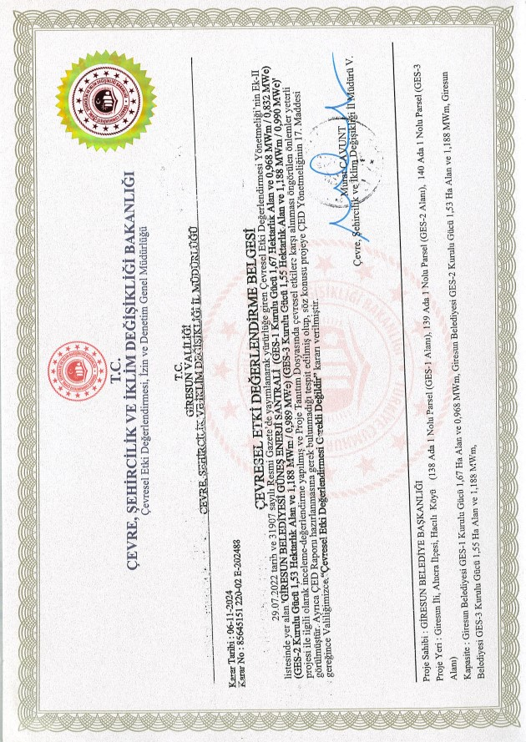

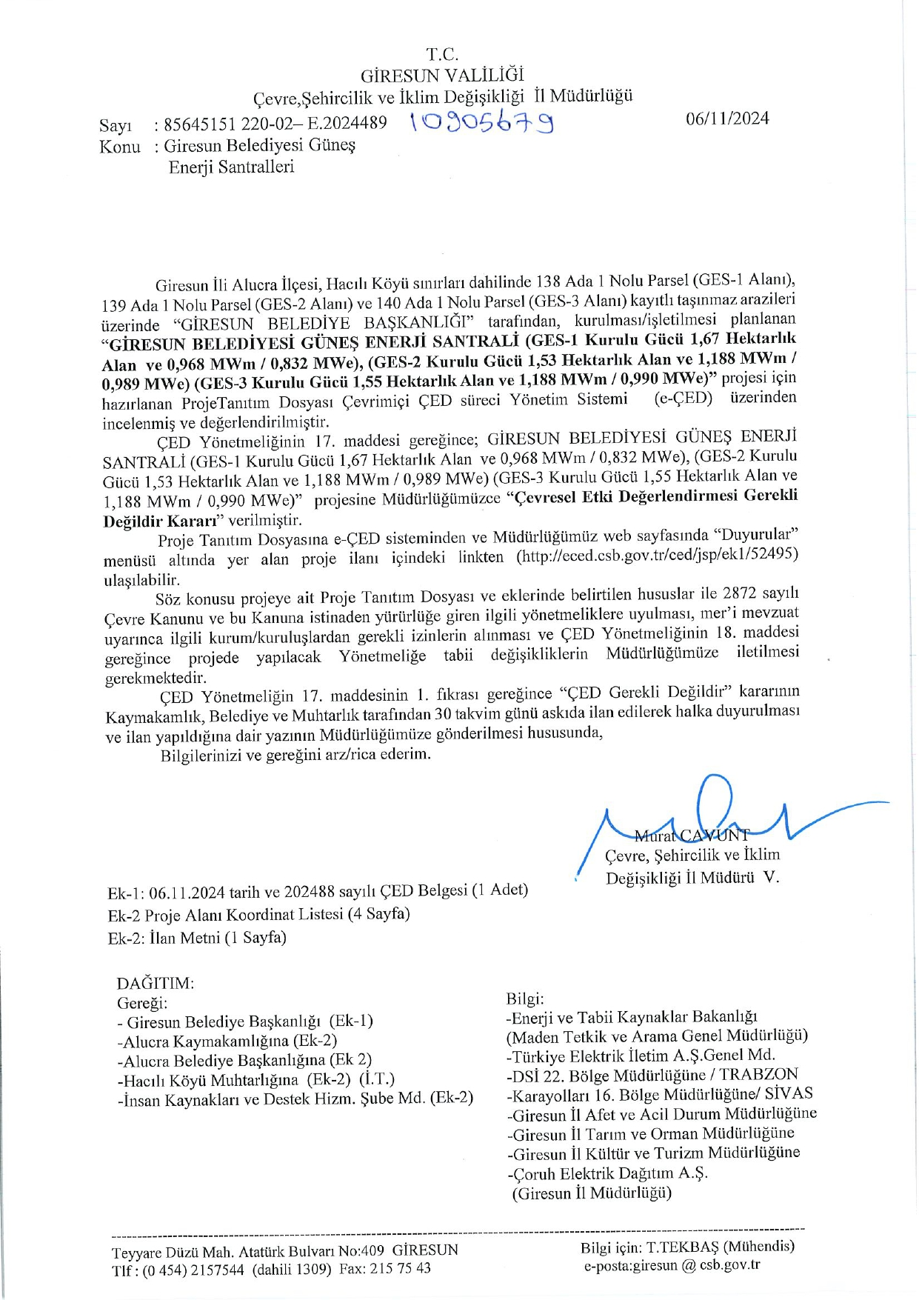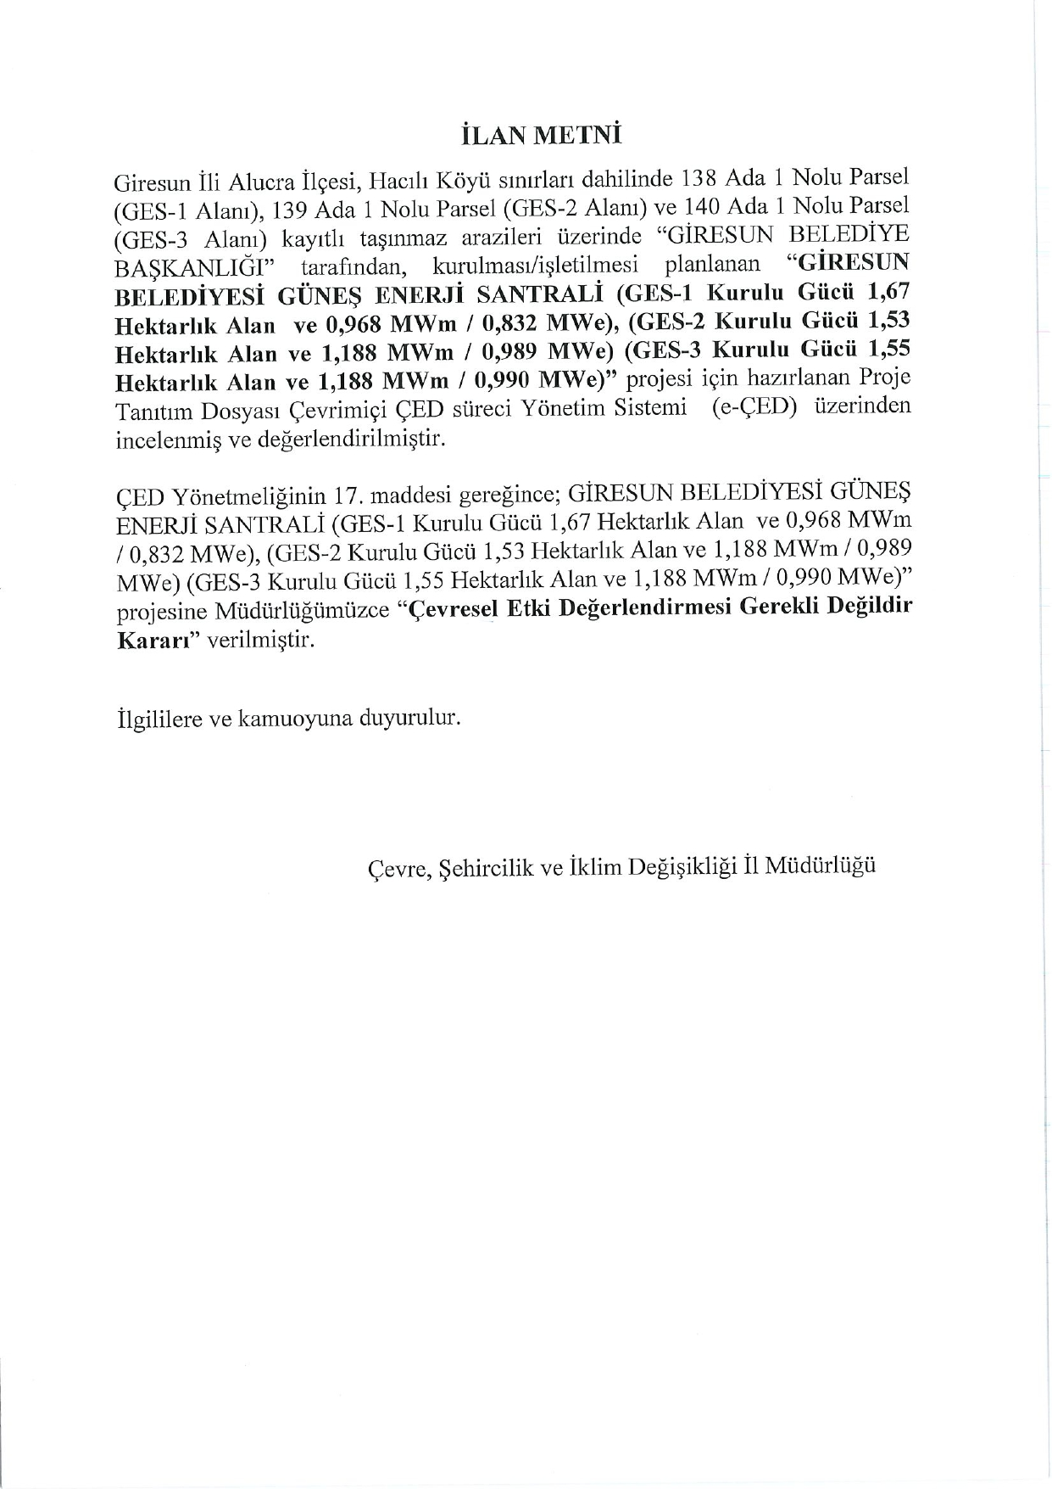
Coordinates of the Subproject Areas
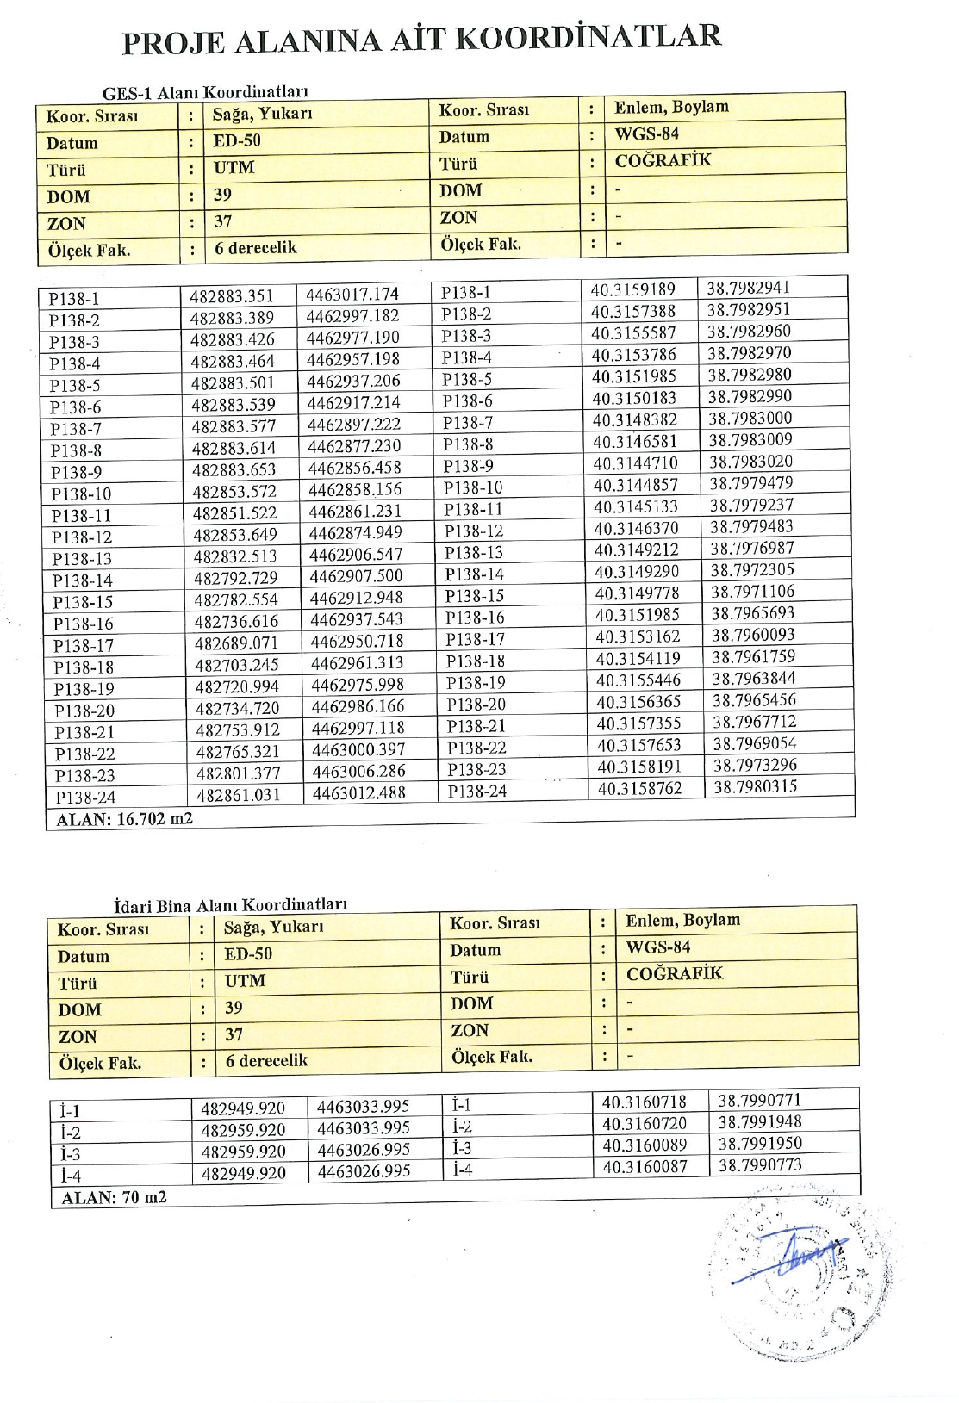
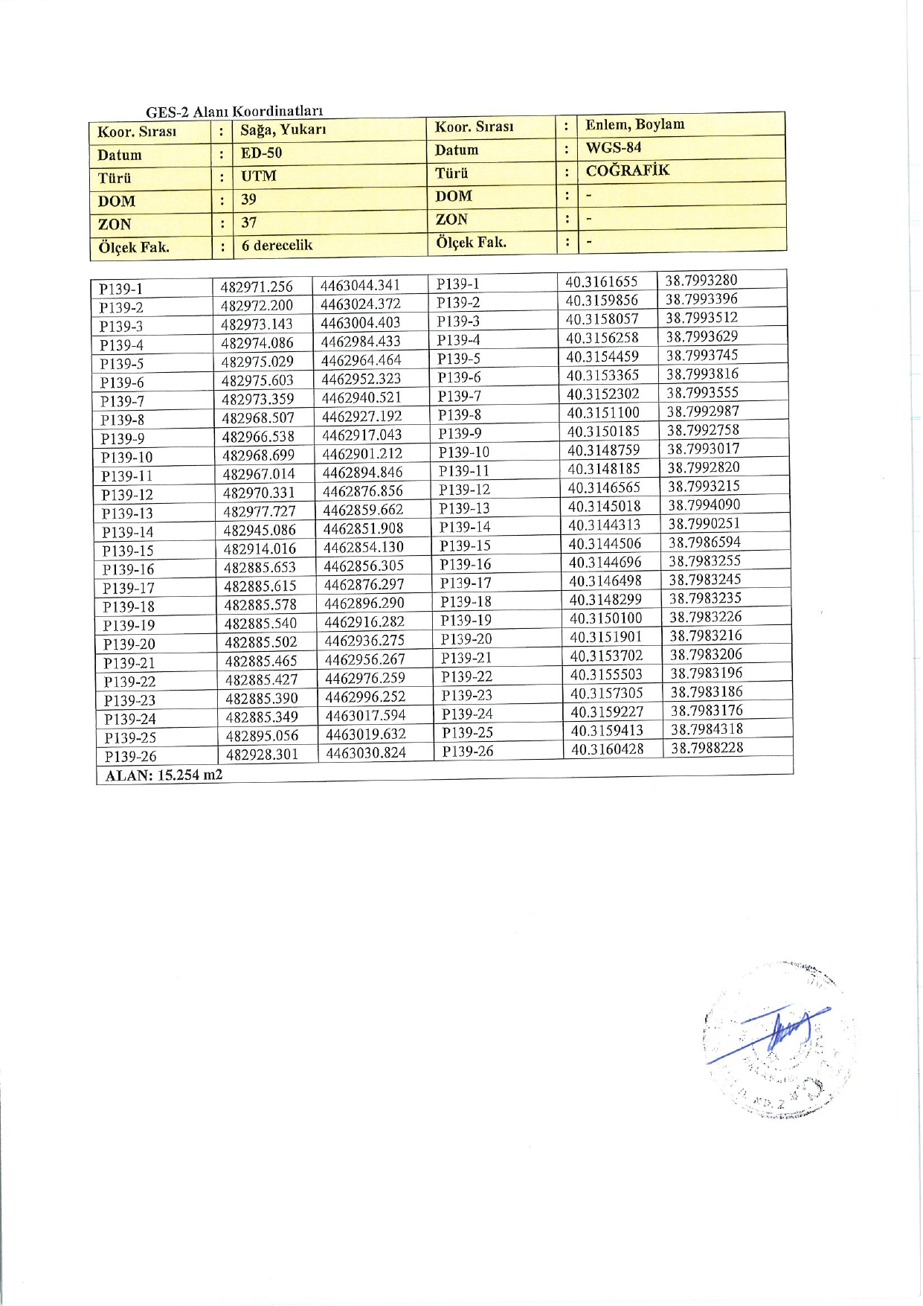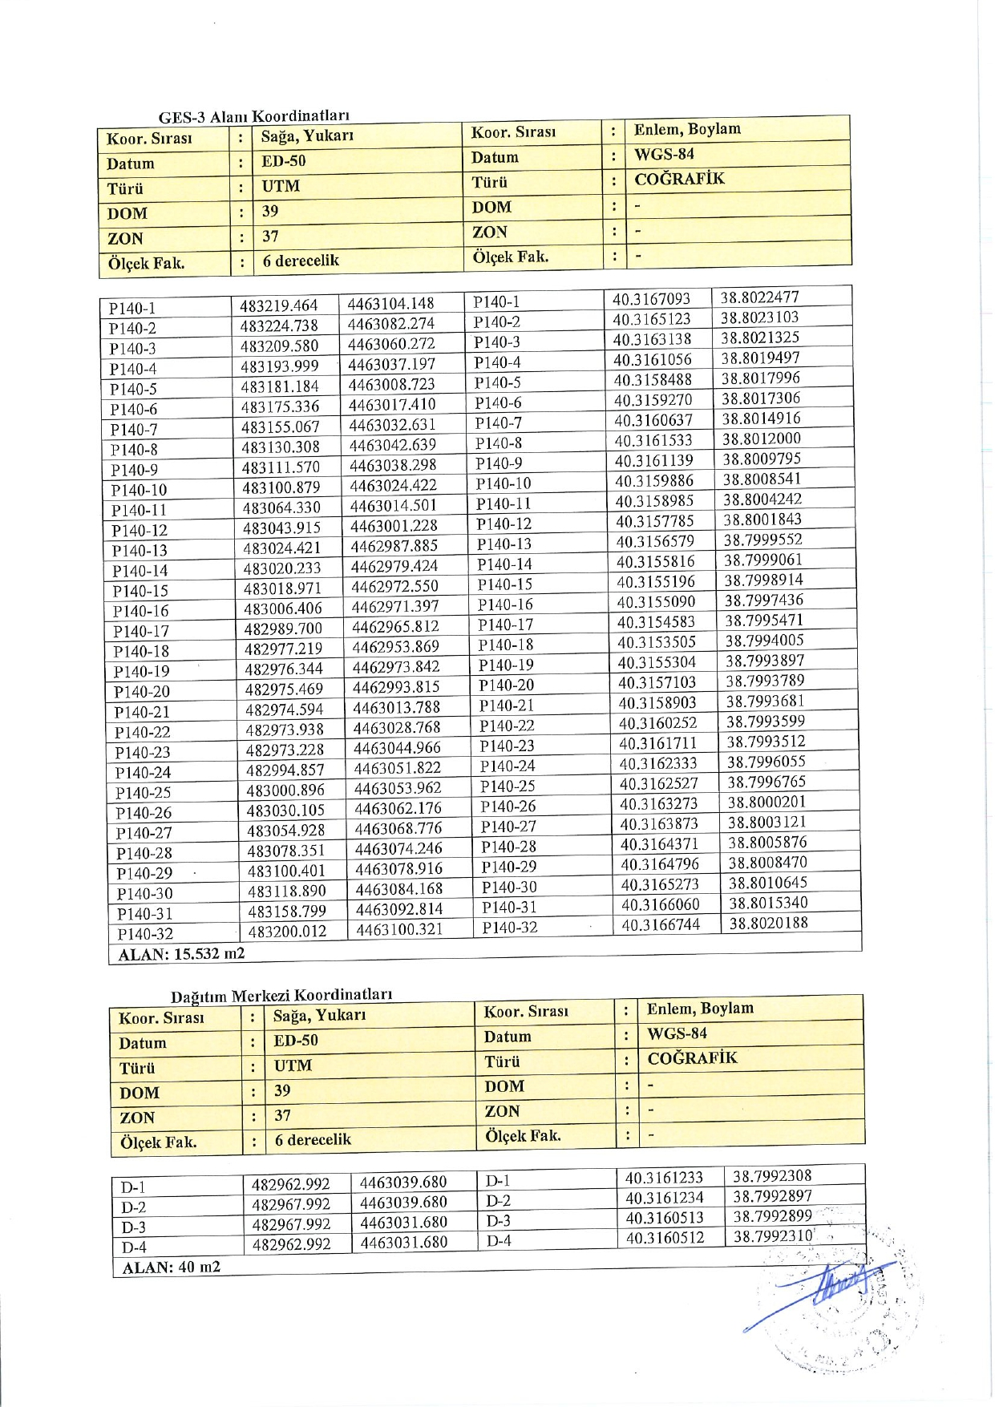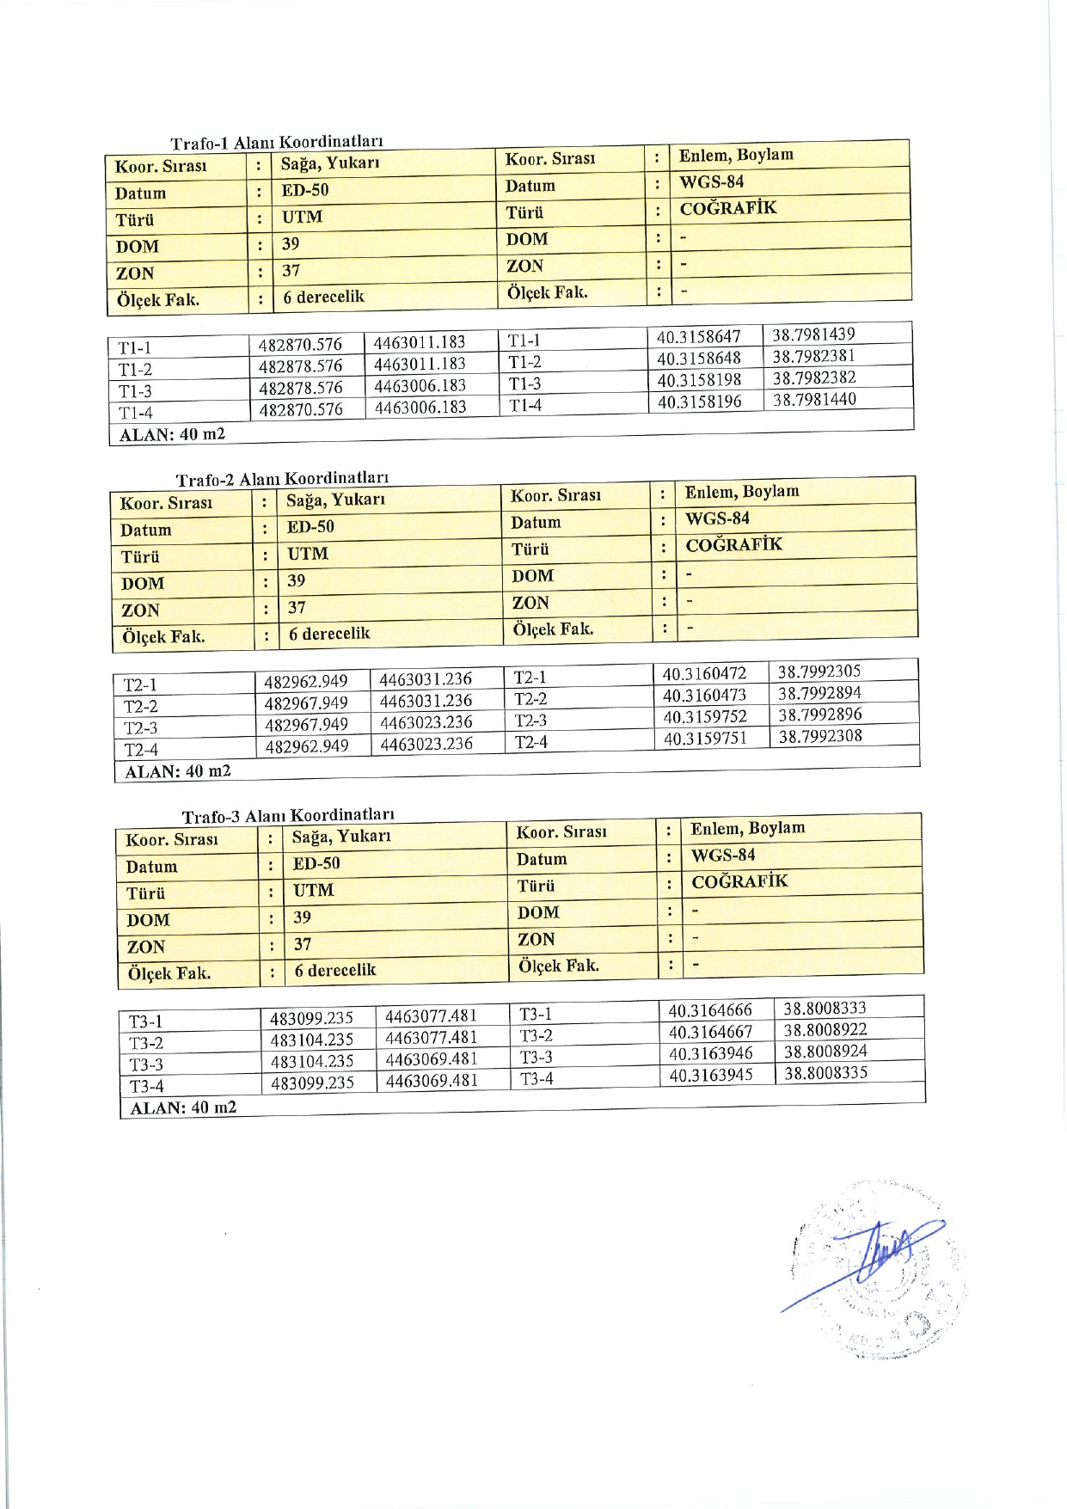
Official Letter of the Giresun Provincial Directorate of Culture and Tourism
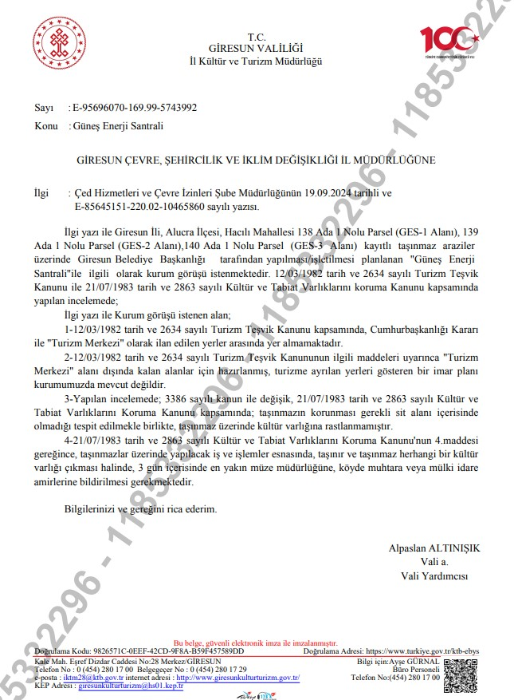
- – Title Deed and Lease Agreement

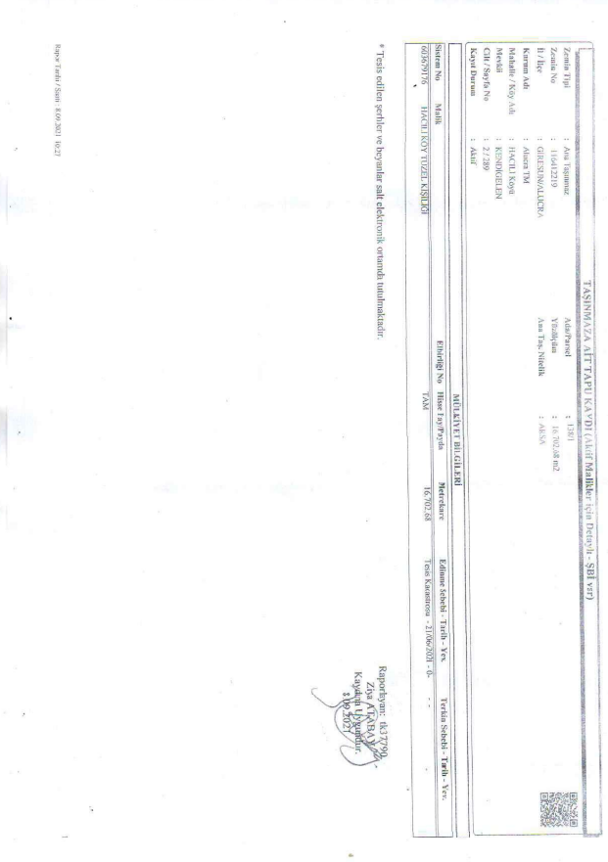
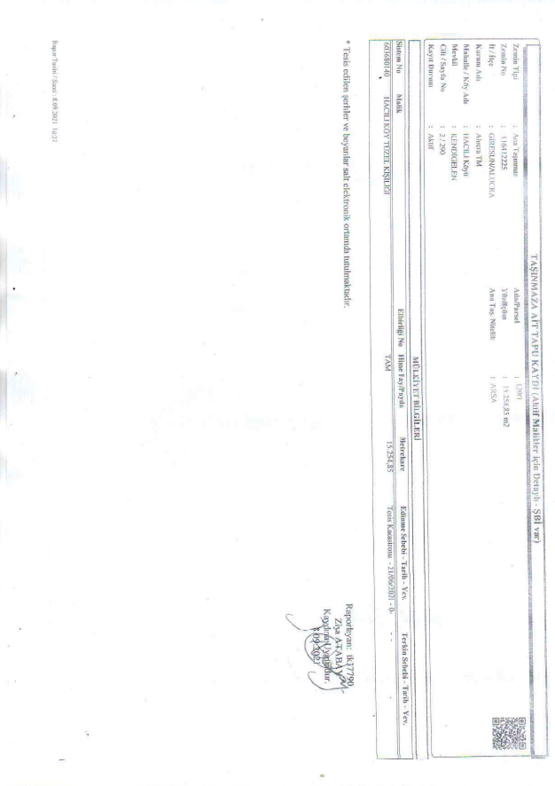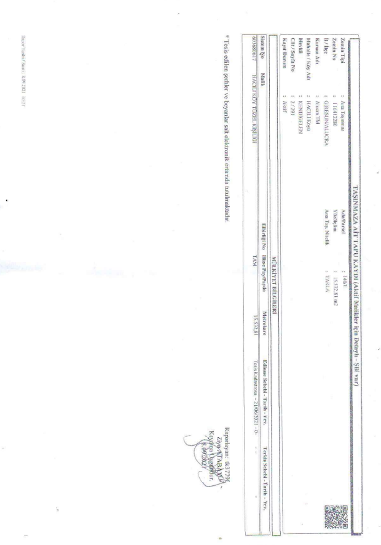

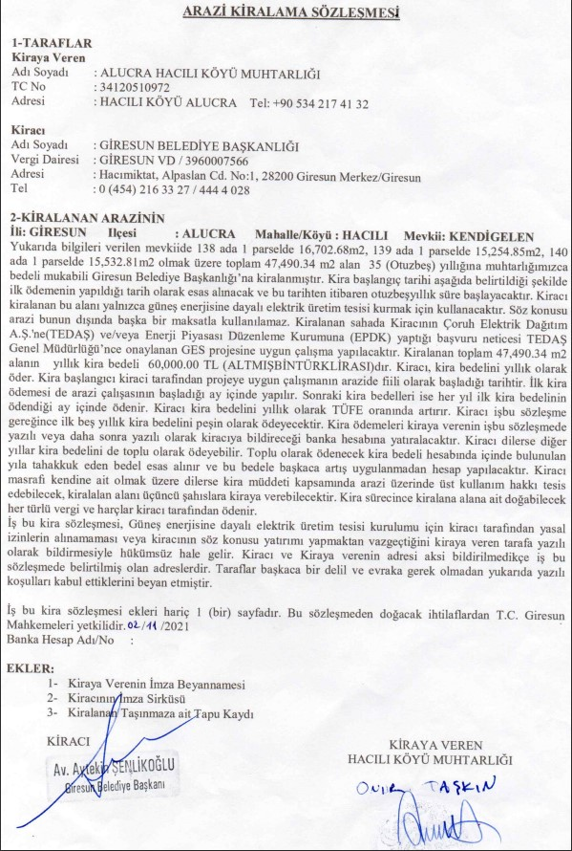

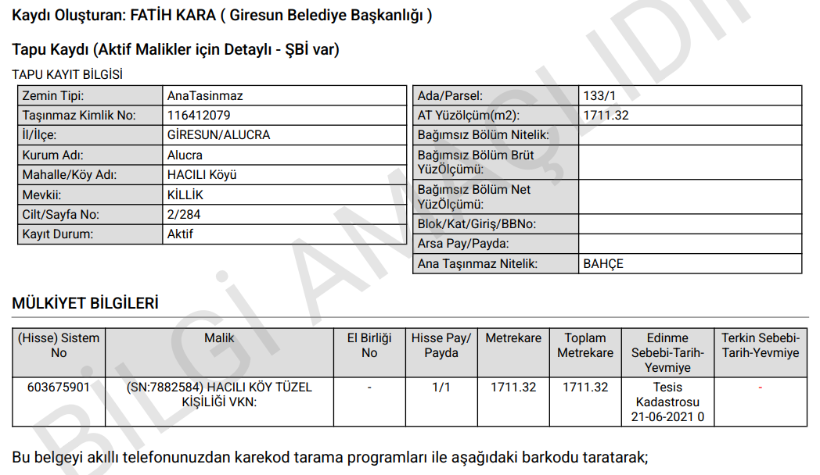
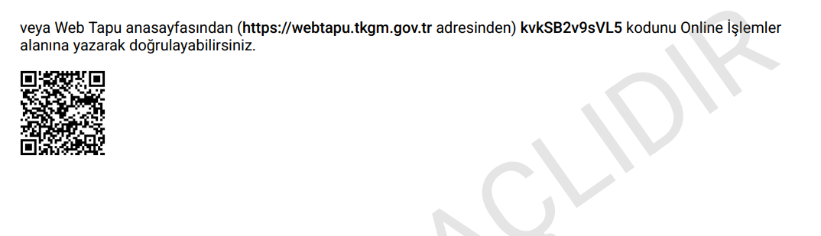

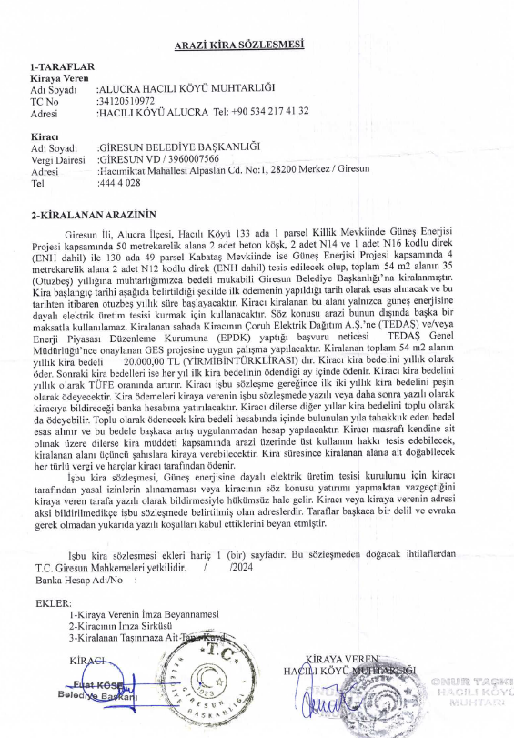
- – Site Photographs

Photo No: 01 | 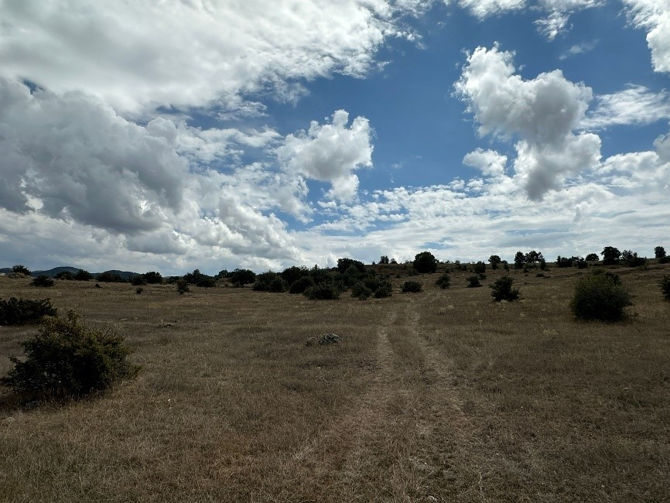
Date:
08.10.2024

Location:
139/1

Details/Notes: Lot 1 of block 139 photo showing south direction

Photo No: 02 | 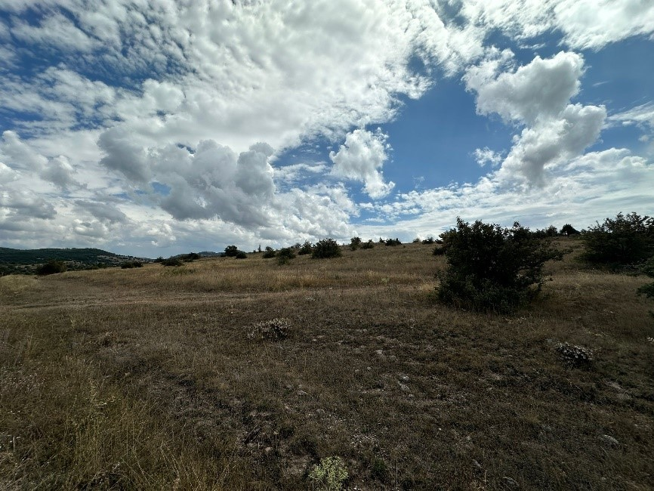
Date:
08.10.2024

Location:
139/1

Details/Notes: Lot 1 of block 139 photo showing east direction

Photo No: 03 | 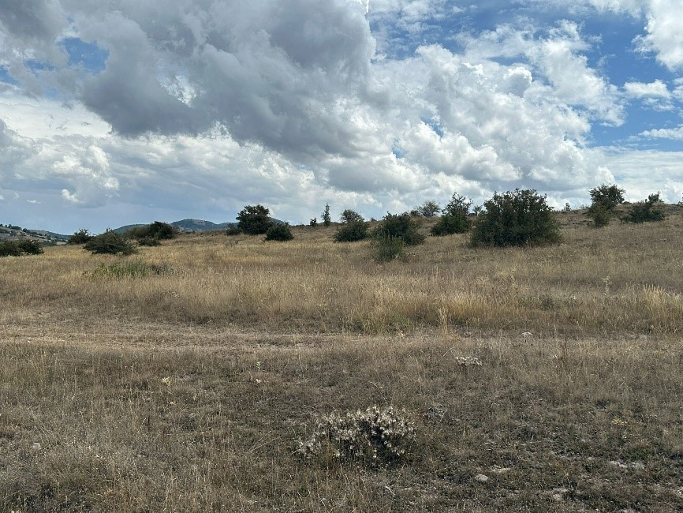
Date:
08.10.2024

Location:
139/1

Details/Notes: Lot 1 of block 139 photo showing west direction

Photo No: 04 | 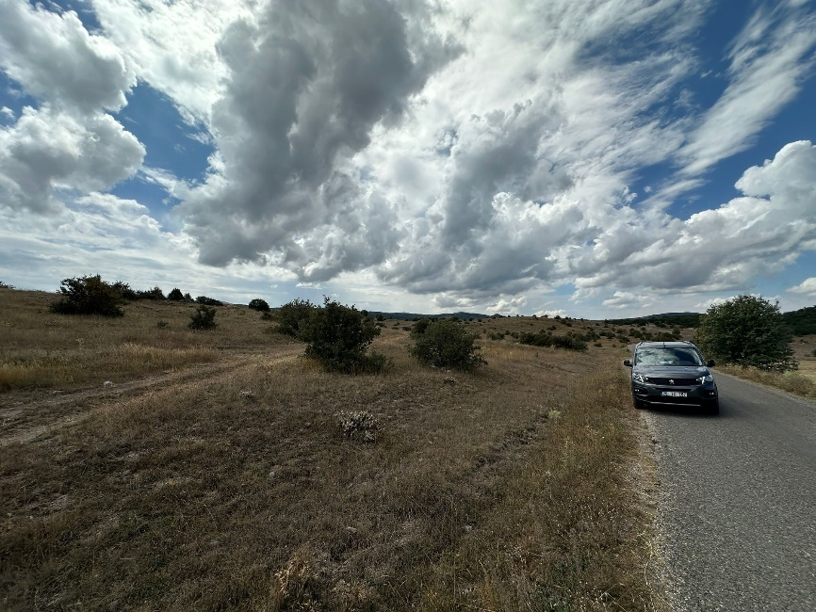
Date:
08.10.2024

Location:
140/1

Details/Notes:
Lot 1 of block 140 photo showing west direction

Photo No: 05 | 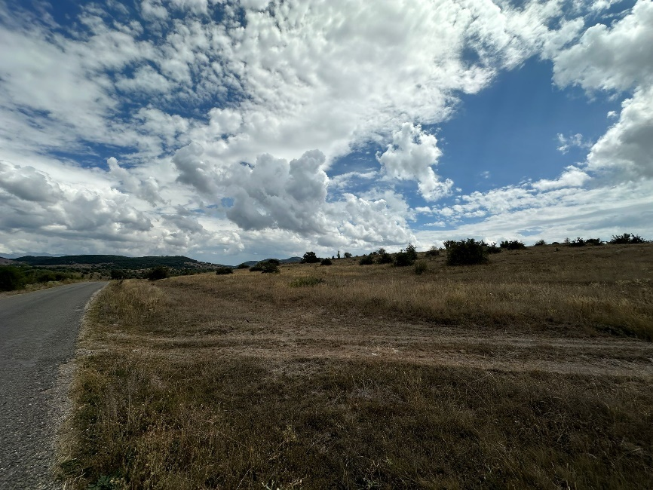
Date:
08.10.2024
Location:
140/1

Details/Notes:
Lot 1 of block 139 photo showing east direction
Photo No: 06 | 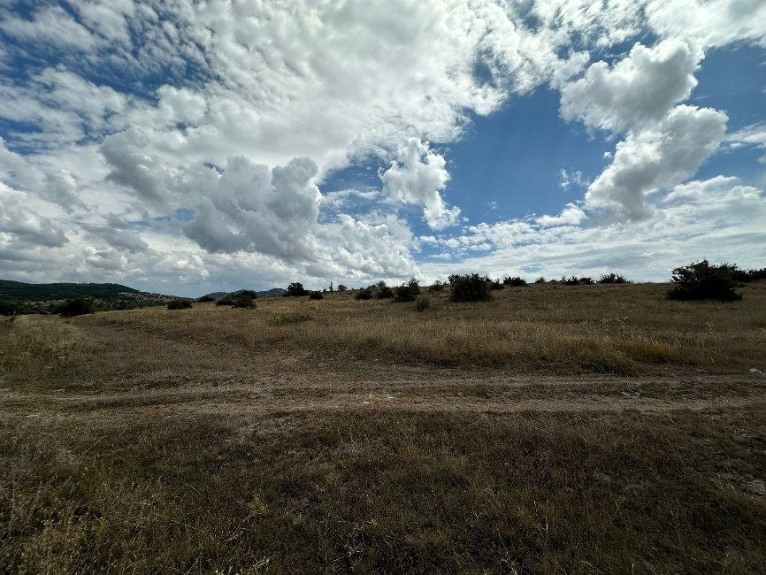
Date:
08.10.2024
Location:
140/1
Details/Notes:140/1
Lot 1 of block 139 photo showing south direction
Photo No: 07 | 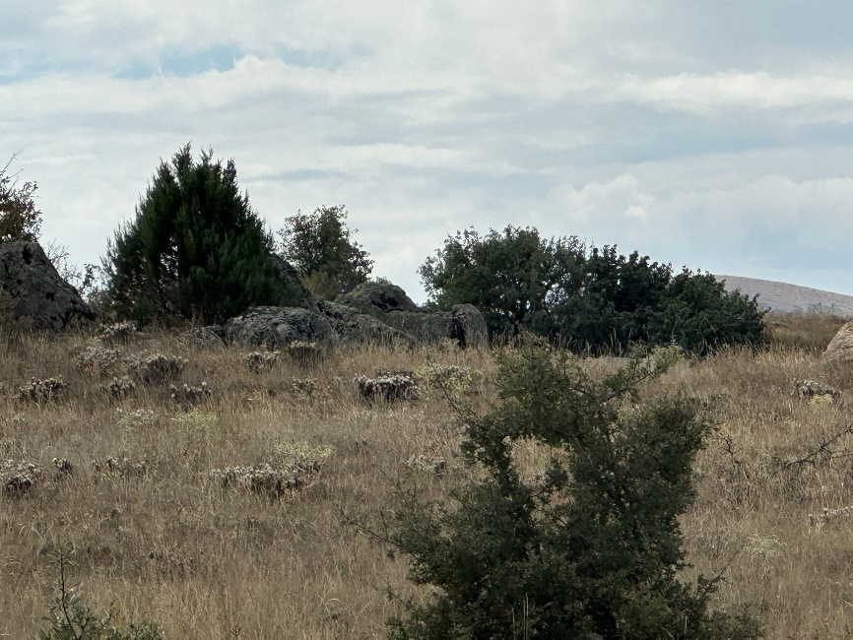
Date:
08.10.2024

Location:
138/1

Details/Notes:
Lot 1 of block 138 photo showing south direction
Photo No: 08 | 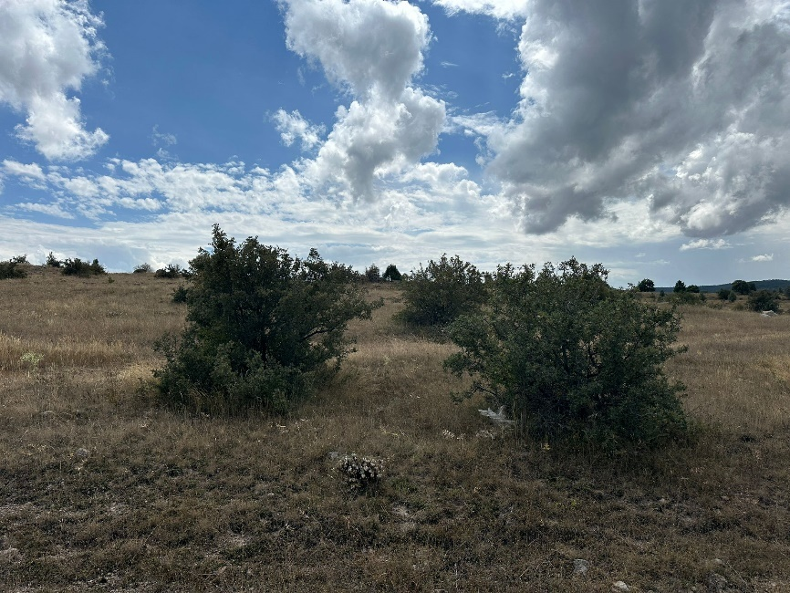
Date:
08.10.2024

Location:
138/1
Details/Notes:
Lot 1 of block 138 photo showing east direction
Photo No: 09 | 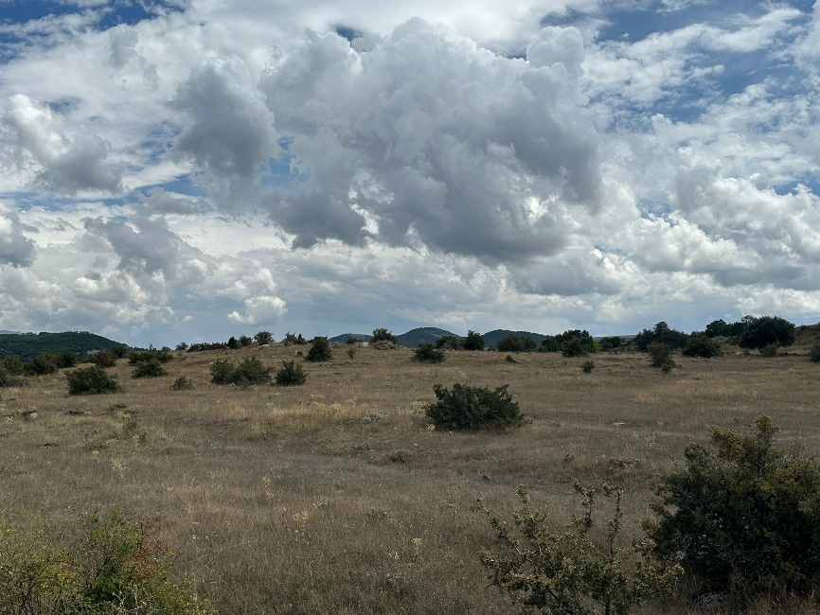
Date:
08.10.2024

Location:
138/1
Details/Notes:
Lot 1 of block 138 photo showing west direction

- – E&S Incident Notification Form Template
1) Incident Details

Date of Incident: [Please indicate] | Time of Incident: [Please indicate]
Location of the Incident: | [Please indicate]
Full Name of Sub-borrower: | [Please indicate]
Date Reported to ILBANK:  [Please indicate] | Reported to ILBANK by:  [Please indicate] | Notification Type:  [ Please indicate; e-mail/phone call/media notice/other ]
Date Reported to WB:  [Please indicate] | Reported to WB by:  [ Please indicate] | Notification Type:  [ Please indicate; e-mail/phone call/media notice/other ]
Full Name of the Contractor of the Subproject: | [ Please indicate]
Full Name of the Sub-contractor involved in the incident: | [ Please indicate]
2) Type of incident (please check all that apply)

☐ Fatality  ☐ Lost time injury  ☐ Displacement without due process  ☐ Child labor  ☐ Forced labor  ☐ Disease outbreaks | ☐ Acts of violence/protest  ☐ Unexpected impacts on heritage resources  ☐ Unexpected impacts on biodiversity resources  ☐ Environmental pollution incident  ☐ Dam failure  ☐ Other
3) Description/Narrative of Incident
For example:

- What is the incident? [Please briefly describe]

- What were the conditions or circumstances under which the incident occurred (if known)? [Please briefly describe]

- Are the basic facts of the incident clear and uncontested, or are there conflicting versions? What are those versions? [Please briefly describe]

- Is the incident still ongoing or is it contained? [Please briefly describe]

- Have any relevant authorities been informed? [Please briefly describe]

4) Actions taken to contain the incident
Short Description of Action | Responsible Party | Expected Date | Status
For incidents involving a Contractor:
Name of Contractor:
Have the works been suspended? Yes ☐ No ☐
Note: Please attach a copy of the instruction suspending the works
5) What support has been provided to affected people
[Please briefly describe]

APPENDICES
Appendix 1: Supporting documents
[Note: Please mark the relevant documents available at this stage and submit them attached to the report]:

☐ Copy of the social security registration records of the victims and involved persons
☐ Copy of the instruction suspending the works
☐ Statement of victims
☐ Statement of witnesses
☐ Copies of notifications done to the relevant authorities
☐ Copies of legal investigation reports of relevant authorities
☐ Copies of E&S training records of the affected and involved persons
☐ Copies of OHS training records of the affected and involved persons
☐ Photographs related to the incident
☐ Others

Appendix 2: Incident Types
The following are incident types to be reported using the environmental and social (E&S) incident response process:
Fatality: Death of a person(s) that occurs within one year of an accident/incident, including from occupational disease/illness (e.g., from exposure to chemicals/toxins).
Lost Time Injury: Injury or occupational disease/illness (e.g., from exposure to chemicals/toxins) that results in a worker requiring 3 or more days off work, or an injury or release of substance (e.g., chemicals/toxins) that results in a member of the community needing medical treatment.
Acts of Violence/Protest: Any intentional use of physical force, threatened or actual, against oneself, another person, or against a group or community, that either results in or has a high likelihood of resulting in injury, death, psychological harm, deprivation to workers or project beneficiaries, or negatively affects the safe operation of a project worksite.
Disease Outbreaks: The occurrence of a disease in excess of normal expectancy of number of cases. Disease may be communicable or may be the result of unknown etiology.
Displacement Without Due Process: The permanent or temporary displacement against the will of individuals, families, and/or communities from the homes and/or land which they occupy without the provision of, and access to, appropriate forms of legal and other protection and/or in a manner that does not comply with an approved resettlement action plan.
Child Labor: An incident of child labor occurs: (i) when a child under the age of 14 (or a higher age for employment specified by national law) is employed or engaged in connection with a project, and/or (ii) when a child over the minimum age specified in (i) and under the age of 18 is employed or engaged in connection with a project in a manner that is likely to be hazardous or interfere with the child’s education or be harmful to the child’s health or physical, mental, spiritual, moral or social development.
Forced Labor: An incident of forced labor occurs when any work or service not voluntarily performed is exacted from an individual under threat of force or penalty in connection with a project, including any kind of involuntary or compulsory labor, such as indentured labor, bonded labor, or similar labor-contracting arrangements. This also includes incidents when trafficked persons are employed in connection with a project.
Unexpected Impacts on heritage resources: An impact that occurs to a legally protected and/or internationally recognized area of cultural heritage or archaeological value, including world heritage sites or nationally protected areas not foreseen or predicted as part of project design or the environmental or social assessment.
Unexpected impacts on biodiversity resources: An impact that occurs to a legally protected and/or internationally recognized area of high biodiversity value, to a Critical Habitat, or to a Critically Endangered or Endangered species (as listed in IUCN Red List of threatened species or equivalent national approaches) that was not foreseen or predicted as part of the project design or the environmental and social assessment. This includes poaching or trafficking of Critically Endangered or Endangered species.
Environmental pollution incident: Exceedances of emission standards to land, water, or air (e.g., from chemicals/toxins) that have persisted for more than 24 hours or have resulted in harm to the environment.
Dam failure: A sudden, rapid, and uncontrolled release of impounded water or material through overtopping or breakthrough of dam structures.
Other: Any other incident or accident that may have a significant adverse effect on the environment, the affected communities, the public, or the workers, irrespective of whether harm had occurred on that occasion. Any repeated non-compliance or recurrent minor incidents which suggest systematic failures that the task team deems needing the attention of Bank management.

- – E&S Incident Investigation Form Template
1) Investigation Findings
For example:
- where and when the incident took place,
- who was involved, and how many people/households were affected,
- what happened and what conditions and actions influenced the incident,
- what were the expected working procedures and were they followed,
- did the organization or arrangement of the work influence the incident,
- were there adequate training/competent persons for the job, and was necessary and suitable equipment available,
- what were the underlying causes; where there any absent risk control measures or any system failures.

2) Corrective Actions from the investigation to be implemented (to be fully described in Corrective Action Plan)
Action | Responsible Party | Expected Date
3a) Fatality/Lost Time Injury Information
Fatality ☐ |  |  |  | Lost time injury ☐
Immediate cause of fatality/injury for worker or member of the public (please check all that apply) :
☐ Caught in or between objects  ☐ Struck by falling objects  ☐ Stepping on, striking against, or struck by objects  ☐ Drowning  ☐ Chemical, biochemical, material exposure  ☐ Falls, trips, slips  ☐ Fire & explosion  ☐ Electrocution  ☐ Homicide |  |  |  | ☐ Medical Issue  ☐ Suicide  ☐ Project Vehicle Work Travel  ☐ Non-project Vehicle Work Travel  ☐ Project Vehicle Commuting  ☐ Non-project Vehicle Commuting  ☐ Vehicle Traffic Accident (Members of Public Only)  ☐ Other
Name | Age/ Date of Birth | Nationality | Gender |  | Date of Fatality/ Injury | Cause of Fatality/  Injury | Affected Party (Employee/  Public)
 |  |  | ☐ Female  ☐ Male |  |  |  | ☐ Sub-borrower employee  ☐ Contractor employee  ☐ Sub-contractor employee  ☐ Public
3b) Financial Support/Compensation Types (to be fully described in Corrective Action Plan template – template is given in Appendix 3)
☐ No Compensation Required  ☐ Workman’s Compensation/National Insurance  ☐ Contractor Direct |  | ☐ Contractor Insurance  ☐ Other  ☐ Court Determined Judicial Process
Name | Compensation Type | Compensation Amount (TRY) | Responsible Party
4) Supplementary Narrative
Appendix 1: Definition of fatality/injury immediate causes
1. Caught in or between objects: caught in an object; caught between a stationary object and moving object; caught between moving objects (except flying or falling objects).
2. Struck by falling objects: slides and cave-ins (earth, rocks, stones, snow, etc.); collapse (buildings, walls, scaffolds, ladders, etc.); struck by falling objects during handling; struck by falling objects.
3. Stepping on, striking against, or struck by objects: stepping on objects; striking against stationary objects (except impacts due to a previous fall); Striking against moving objects; Struck by moving objects (including flying fragments and particles) excluding falling objects.
4. Drowning: respiratory impartment from submersion/emersion in liquid.
5. Chemical, biochemical, material exposure: exposure to or contact with harmful substances or radiations.
6. Falls, trips, slips: falls of persons from heights (e.g., trees, buildings, scaffolds, ladders, etc.) and into depths (e.g., wells, ditches, excavations, holes, etc.) or falls of persons on the same level.
7. Fire & explosion: exposure to or contact with fires or explosions.
8. Electrocution: exposure to or contact with electric current.
9. Homicide: a killing of one human being by another.
10. Medical Issue: a bodily disorder or chronic disease.
11. Suicide: the act or an instance of taking, or attempting to take, one’s own life voluntarily and intentionally.
12. Others: any other cause that resulted in a fatality or injury to workers or members of the public.

Vehicle Traffic
13. Project Vehicle Work Travel: traffic accidents in which project workers, using project vehicles, are involved during working hours and which occur in the course of paid work.
14. Non-project Vehicle Work Travel: traffic accidents in which project workers, using non-project vehicles, are involved during working hours and which occur in the course of paid work.
15. Project Vehicle Commuting: traffic accidents in which project workers, using project vehicles, are involved while travelling to (i) the worker's principal or secondary residence; (ii) the place where the worker usually takes his or her meals; or (iii) the place where he or she usually receives his or her remuneration.
16. Non-project Vehicle Commuting: traffic accidents in which project workers, using non-project vehicles, are involved while travelling to (i) the worker's principal or secondary residence; (ii) the place where the worker usually takes his or her meals; or (iii) the place where he or she usually receives his or her remuneration.
17. Vehicle Traffic Accident (Members of Public Only): traffic accidents in which non-project workers/members of the public are involved in an accident while travelling for any purpose.

Appendix 2: Supporting documents
[Note: Please mark the relevant documents available and submit them attached to the report]:

☐ Copy of the social security registration records of the victims and involved persons
☐ Copy of the instruction suspending the works
☐ Statement of victims
☐ Statement of witnesses
☐ Copies of notifications done to the relevant authorities
☐ Copies of legal investigation reports of relevant authorities
☐ Copies of E&S training records of the affected and involved persons
☐ Copies of OHS training records of the affected and involved persons (such as basic OHS training, induction training, visitors training, job-specific training, refreshment training, etc.)
☐ Photographs related to the incident
☐ Health examination records of the affected and involved employees
☐ Copies of Personal Protective Equipment delivery forms (signed copies)
☐ Root Cause Analysis completed for the incident
☐ Information/documentation related to any judicial process
☐ Others

Appendix 3: Corrective Action Plan template
Action No: | Brief Description of E&S non-compliance | Corrective Action | Financial and Human Resources Required | Responsible Party | Due Date for Completion of Corrective Action | Indicators for Successful Completion of Corrective Action | Status of Corrective Action

- – Chance Find Procedure

PART A
BÖLÜM A
Subproject Location  Altproje Sahası | District (İlçe):  Village (Köy): | Date  Tarih |  | Form No | Project Information  Proje Bilgisi
Name of person reporting chance find:
Rastlantısal Buluntuyu rapor eden kişinin ismi
Name of contractor employee contacted:
İletişime geçilen yüklenici çalışanının adı:
Was work stopped in the immediate vicinity of chance find? ☐Yes ☐No
Rastlantısal buluntunun tam çevresinde iş durduruldu mu? ☐Evet ☐Hayır
Was a buffer zone created to protect chance find? ☐Yes ☐No
Rastlantısal buluntuyu korumak için tampon bölge oluşturuldu mu? ☐Evet ☐Hayır
NOTIFICATION
BİLDİRİM
Site manager contacted. ☐Yes ☐No
Saha müdürü ile irtibata geçildi. ☐Evet ☐Hayır
The Subproject E&S manager contacted. ☐Yes ☐No
Altproje Çevre Müdürü ile irtibata geçildi. ☐Evet ☐Hayır
CHANCE FIND DETAILS
RASTLANTISAL BULUNTU AYRINTILARI
GPS coordinates  GPS koordinatları |  |  | Photo record ☐Yes ☐No  Fotoğraf Kaydı ☐Evet ☐Hayır  (HD quality – no cell phone photos)  (HD kalitesinde-cep telefonu fotoğrafı değil)  If not, explain why:  Değil ise nedenini açıklayınız.  Other records ☐Yes ☐No  Specify (drawings, HD quality videos, etc.)  Diğer kayıtlar ☐Evet ☐Hayır  Belirtin (çizimler, HD kaliteli videolar, vb.)
Description of chance find:
Rastlantısal buluntunun tanımı:

Description of site and vegetation: (e.g. surface sediment type, ground surface visibility, distance to closest watercourse, etc.)
Sahanın / bulgunun ve saha/bulgunun diğer özelliklerinin tanımı: (örn. Yüzey sediman türü, yüzey zemin görünürlüğü, en yakın suyoluna olan mesafe, vb.)

PART B
BÖLÜM B
NOTIFICATION OF MUSEUM DIRECTORATE ARCHAEOLOGIST
MÜZE MÜDÜRLÜĞÜ ARKEOLOĞUNA BİLDİRİ
The Project Environment Representative contacted museum directorate archaeologist. ☐ Yes ☐No
İzleme arkeoloğu, müze müdürlüğü arkeoloğu ile irtibata geçti. ☐ Yes ☐No

Date of notification:
Bildirim tarihi:

Name of museum directorate archaeologist:
Müze müdürlüğünün adı ve Müze müdürlüğü arkeoloğunun adı:

Contact number of museum directorate archaeologist:
Müze müdürlüğü arkeoloğunun iletişim numarası:

DECISION OF MUSEUM DIRECTORATE ARCHAEOLOGIST
MÜZE MÜDÜRLÜĞÜ ARKELOĞUNUN KARARI
Date of site visit:
Saha ziyaret tarihi:
Site of no significance - Construction to proceed with no further investigation – End of chance find.  Önemsiz Saha – Bulgu - daha fazla araştırma yapılmadan  inşaat devam edilebilir – Rastlantısal buluntu prosedürün sonu.  Date of notice to resume work:  İşe devam etme tarihinin bildirisi: | ☐ Site of significance - Further investigation required  ☐ Önemli Saha – Bulgu - Ek araştırma gerekmektedir  Fill out Part C.  Lütfen Bölüm C’yi doldurun.
Name of museum directorate archaeologist:
Müze müdürlüğü arkeoloğunun ismi:
Contact information:
İletişim numarası:
Site manager and E&S manager contacted ☐ Yes ☐ No
Saha Müdürü ve Ç&S müdürü ile irtibata geçildi ☐ Evet ☐ Hayır

PART C
BÖLÜM C
FURTHER FIELD INVESTIGATION
EK SAHA ARAŞTIRMASI
☐ Site of no significance  ☐ Az önem taşıyan saha/bulgu | ☐ Site of minor significance  ☐ Orta derecede önem taşıyan saha/bulgu |  | ☐ Site of major significance  ☐ Çok önemli saha/bulgu
Describe additional work to be conducted:
Yapılması gereken ek islerin tanımı:
Date started:  Başlangıç Tarihi: |  | Date completed:  Bitiş Tarihi:
Date of notice to resume work:
İşe geri dönme tarihi bildirisi:
Name of museum directorate archaeologist:
Müze müdürlüğü arkeoloğunun ismi:

Contact information:
İletişim numarası
Construction manager contacted ☐ Yes ☐ No
İnşaat müdürü ile irtibata geçildi ☐ Evet ☐ Hayır

CHANCE FINDING RECORD
Reporting Period
Total Incidental Findings
The Current Situation |  |  |  |  |  | This Reporting Period
IDENTITY (*) | DATE OF THE CHANCE FINDING | LOCATION | SUMMARY OF FINDINGS | NAME OF REPORTED INSTITUTION | DATE PART A WAS COMPLETED |  | COMPLETION DATE OF PART B | DATE PART C WAS COMPLETED | ACTION TAKEN | OPEN OR CLOSED STATUS | NOTES

Non-Significant Area | Minor Area | Area of ​​Great Importance
- The Environmental Engineer will notify their manager,  - The Environmental Engineer will record this decision in Section C of the Chance Find Form within 24 hours,  - The Environmental Engineer will keep a copy of the Chance Find Form as a record, No further action will be required,  - This step completes the chance find procedure,  - Construction activities may continue. | - A rescue excavation will be completed  - The Museum Directorate will provide instructions and/or supervision for the rescue archaeological excavation to the Project Environmental Engineer,  - The Environmental Engineer will inform their own managers,  - Under the guidance of the Museum archaeologist (following instructions from other authorities, Giresun Regional Board, etc.), the Project will provide a team of qualified archaeologists to conduct the rescue excavation,  - The Environmental Engineer will submit a report to the Museum Directorate,  - The Cultural Heritage Protection Regional Board Directorate will officially confirm that the rescue operation is complete and the Environmental Engineer will inform the construction manager that no further action is required,  - The Environmental Engineer will inform other managers,  - The Environmental Engineer will record the decision in Section C of the Chance Finding Form within 24 hours,  - The Project Environmental Engineer will keep a copy of the Chance Finding form as a record,  - No further action will be required,  - This step completes the chance finding procedure  - Construction activities can resume. | Excavation works will be completed,  • The area will be handled in accordance with the "Law on the Protection of Cultural and Natural Assets (2863)",  • The Museum Directorate will provide instructions and/or supervision for the salvage archaeological excavation to the Environmental Engineer, and the Project Environmental Engineer will inform the Construction Manager,  • When the excavation is completed, the Project Representative will submit a report to the Quality Assurance Manager,  • The Project Environmental Engineer will submit a report to the Museum Directorate,  • The Cultural Assets Protection Regional Board Directorate will officially confirm that the recovery is complete and inform the Environmental Engineer,  • The site will be officially registered and protected according to Turkish regulations,  • The Environmental Engineer will inform the Construction Manager that no further action is required or that a relocation is required,  • The Project Environmental Engineer will record the decision in Section C of the Chance Detection Form within 24 hours,  • The Project Environmental Engineer will keep a copy of the Chance Detection form as a record,  • No further action will be required,  • This step completes the chance finding procedure  • Construction activities may restart or relocation may be implemented.

Name | Communication | Address
Giresun Museum Directorate | +90 454 212 13 22  giresunmuzesi@ktb.gov.tr | Mustafa Kemal Ataturk Boulevard No:62 GIRESUN

Name | Communication | Address
Trabzon Cultural Heritage Protection Regional Board Directorate | +90 462 22 36 89  +90 462 326 29 88  trabzonkurul@ktb.gov.tr | Cumhuriyet Neighborhood Nemlioğlu Cemal Street No:25 TRABZON

- – Change Notification Form
Change Notification Form
Subproject Name

Subproject Location

Subproject Phase
  ☐ | Pre-construction
  ☐ | Construction
  ☐ | Operation
Name of the Institution Notifying the Change
Date

Category of the Change  (please select all that apply)
  ☐ | Legislative Change
  ☐ | Design Change
☐ | Schedule Change due to E&S factors
☐ | Project Schedule Changes due to technical, financial, legal or administrative factors

  ☐ | Changes due to E&S issues encountered at Subproject implementation
  ☐ | Contractor or Construction Supervision Consultant Change
  ☐ | Other (please specify below)
Detailed Description of the Change(s)

Documents Submitted with Change Notification Form

Name of the Staff Notifying the Change

Position of the Staff Notifying the Change

Signature

- - Institutional and Legal Framework in Türkiye
In Türkiye, institutional framework consists of central and local administrations. Türkiye is structured by provinces according to economical and geographical conditions. Each province is managed by local administrations consisting of municipalities, villages/neighborhoods. Representatives of the administrative structure of municipalities and villages/neighborhoods are mayors and mukhtar, respectively. Ministries, which are central administrative units, provide services to local areas through their local branches including provincial organizations affiliated to governor and district organizations affiliated to district governors.
Environmental impacts, permits, management and inspection of the project is under the scope of authority of MoEUCC, Ministry of Agriculture and Forestry, Ministry of Culture and Tourism, Ministry of Labor and Social Security and Ministry of Health. MoEUCC is the key authority regulating policies and procedures related to conservation and protection of natural environment, management of natural resources and settlements by its general directorates. Those principally related to the Project are given as follows:
- General Directorate of Environmental Impact Assessment, Permit, and Inspection
- General Directorate of Environmental Management
- General Directorate of Protection of Natural Assets
- General Directorate of Infrastructure and Urban Transformation Services
- General Directorate of Land Registry and Cadastral
Provincial, regional and district level administrations are the field organizations of ministries and relevant institutions. The sub-projects includes Giresun Municipality, Giresun Provincial Directorate of Environment, Urbanization and Climate Change, Giresun Provincial Directorate of Agriculture and Forestry, Alucra District Directorate of Agriculture and Forestry, Trabzon Cultural Heritage Protection Regional Board Directorate, State Hydraulic Works (DSİ) GAP 22th Regional Directorate. Hacılı neighbourhood and Pirili neighbourhood mukhtar administrations have been associated as local administration for the sub-projects.
The National Legislation applicable to the management of environmental, social, health and safety aspects of the proposed Project has been identified under this section.
The Environmental Law No: 2872 published in the Official Gazette No. 18132 dated 11.08.1983 and later revised in the Official Gazette No. 28661 and dated 29.05.2013 (Law No. 6486) constitutes the basic legal framework of the environmental legislation in Türkiye and is largely in line with the EU Directive on EIA.
This law is supported by numerous regulations. Article 10 of Environmental Law forms the main framework of the Environmental Impact Assessment (EIA Regulation) published in the Official Gazette No. 31907 dated 29.07.2022. As per the EIA Regulation, the projects that are listed in its Annex-I are subject to a full EIA process and those projects have to receive an “EIA Positive” certificate to proceed with investments. The projects that are listed in Annex-II of the Regulation are subject to a shorter process where the project proponents are required to submit a Project Information File (PIF) to the MoEUCC. MoEUCC gives its “EIA is Necessary” or “EIA is not necessary” decision regarding the project.
Unless the decision that “EIA is Positive” or “EIA is not Required” is made in accordance with the EIA Regulation for the project’s activities, incentive, approval, permit, building license and use permit for such projects cannot be granted, and no investment can be started or tendered for the project. However, this does not preclude applying for the processing of such incentives, approvals, permits, and licenses. As part of the European Union membership process, Türkiye has carried out a variety of organizational and legislative reforms. With these reforms, environmental legislation and environmental protection instruments have been harmonized with international standards. The activities and liabilities to be carried out within the scope of the sub-projects must adhere to the provisions of the relevant Turkish legislation.
According to the EIA Regulation (Official Gazette dated 29.07.2022 and numbered 31907), the sub-projects are within the EIA is not requiredRegulation. The EIA Positive Certificate for the sub-projects are given in Annex B
In addition to Environmental Law No: 2872, several associated laws are complementary regarding the protection and sustainability of the environment as well as the protection of health and safety rights of people. Those laws which would be applicable to the proposed sub-projects are listed below:
- Environmental Law No. 2872 (OG No:18132, dated 11.08.1983)
- Expropriation Law No. 2942 (OG No:18215, dated 08.11.1983)
- Forestry Law No. 6831 (OG No:9402, dated 08.09.1956)
- National Parks Law No. 2873 (OG No:18132, dated 11.08.1983)
- Conservation of Cultural and Natural Assets Law No. 2863 (OG No:18113, dated 23.07.1983, and revised through the amendment issued on 27.07.2004)
- Highways Traffic Law No. 2918 (OG No:18195, dated 13.10.1983)
- Soil Conservation and Land Use Law No. 5403 (OG No:25880, dated 19.07.2005)
- Terrestrial Hunting Law No. 4915 (OG No:25165, dated 11.07.2003)
- Animal Protection Law No. 5199 (OG No:25509, dated 01.07.2004)
- Labor Law No. 4857 (OG No:25134, dated 10.06.2003)
- Occupational Health and Safety Law No. 6331 (OG No:28339, dated 30.06.2012)
- Social Insurance and General Health Insurance Law (OG No:26200 dated: 16.06.2006)
The main national laws regarding Public Health and Safety are as follows:
- General Hygiene Law No. 1593
- Law No. 5378 on Disabled People
- Private Security Services Law No. 5188
- Law No. 7269 on Measures to be Taken and Assistance to be Provided Due to Disasters Affecting Public Life
- Building Earthquake Regulation in Türkiye (Official Gazette dated 18.03.2018 and numbered 30364)
- Disaster Regulation for Infrastructures (Official Gazette dated 15.02.2007 and numbered 30364)
- Law No. 4708 on Building Inspection (Construction and Usage Permits)
- Zoning Law No. 3194 (Construction and Usage Permits)
- Law No. 6306 on the Transformation of Areas Under Disaster Risk
The regulations developed under the Environmental Law aim to specify and identify the procedures and principles of the management of environmental aspects. Under the relevant laws, several regulations or communiques are summarized in Table 1 below.

Table 1. Environmental, Social, Labor, Health and Safety Legislation
Regulations / Communiques | OG Number | OG Date | Relevance/Implication for the Project
Environmental Permit and Licenses
Regulation on Environmental Impact Assessment | 31907 | 29.07.2022 | Scoping of the Project and evaluation of impacts for the pre-construction, construction and operation stages of the Project.
Regulation on Environmental Permits and Licensing | 29115 | 10.09.2014 | Requirements for environmental permits and licenses at all stages of the Project.
Regulation on Environmental Auditing | 31509 | 12.06.2021 | Requirements for environmental audits to be performed by either Project Owner or governmental authorities during construction and operation stages.
Regulation on the Implementation of the Law Concerning Private Security Services | 25606 | 07.10.2004 | During the construction phase for camp site security and during the operation phase for safety purposes.
Air Quality Control and Greenhouse Gas (GHG) Emissions
Industrial Air Pollution Control Regulation | 27277 | 03.07.2009 | During the construction phase, dust emissions.
Exhaust Gas Emission Control Regulation | 30004 | 11.03.2017 | Operation of Project vehicles, machinery, and equipment at all phases of the Project.
Biodiversity Conservation and Protection of Nature
Regulation on Protection of Wildlife and Wildlife Development Area | 259637 | 08.11.2004 | Measures to be taken for wildlife protection near to the Project area during the planning phase of the Project.
Chemicals and Other Dangerous Substances
Regulation on Classification, Labelling, and Package of the Materials and Mixtures | 28848 | 11.12.2013 | Taking measures for chemicals and mixtures to be used during construction and operation phases.
Regulation on Registration, Evaluation, Authorization and Restriction of Chemicals | 30105 | 23.06.2017 | Determination of chemicals to be used during the operation phase.
Regulation on the Control of Polychlorinated Biphenyls (PCBs) and Polychlorinated Terphenyls (PCTs) | 26739 | 27.12.2007 | Usage of transformers, capacitors, electrical equipment including voltage regulators, switches, oil used in motors, old electrical devices or appliances containing PCB capacitors, fluorescent light ballasts during the operational phase.
Noise
Environmental Noise Control Regulation | 32029 | 30.11.2022 | Determination of noise emissions and measures to be taken at construction and operation phases.
Regulation on the Environmental Noise Emissions Caused by Equipment Used Outdoors | 26392 | 30.12.2006 | Regulating the noise levels caused by noise sources within the Project site at the construction and operation phases.
Soil and Land Use
Regulation on the Control of Soil Pollution and Lands Contaminated by Point Sources | 27605 | 08.06.2010 | Determination of risks of soil contamination at construction and operation phases.
Regulation on Control of Excavated Soil, Construction and Demolition Wastes | 25406 | 18.03.2004 | Management of excavated soil and construction and demolition wastes at the source.
Regulation on Protection, Use, and Planning of Agricultural Lands | 30265 | 09.12.2017 | Management of change in the land use during the planning phase of the Project.
Waste
Regulation on Waste Management | 29314 | 02.04.2015 | Management of waste from generation to disposal without harming the environment and human health during construction and operation phases.
Zero Waste Regulation | 30829 | 12.07.2019 | General principles regarding the establishment, development, monitoring, financing, recording and certification of the zero waste management system in line with sustainable development goals during construction and operation phases.
Regulation on Packaging Waste Control | 30283 | 27.12.2017 | Preventing the formation of packaging waste, reducing the amount of unavoidable packaging waste to be disposed of using reuse, recycling and recovery methods in construction and operation phases.
Regulation on Waste Oil Management | 30985 | 21.12.2019 | Waste oils included in the definition of waste oil and the management, recovery, disposal of these wastes, precautions to be taken and notifications to be made
Regulation on Medical Waste Control | 29959 | 25.01.2017 | Collection of medical waste in the places where it is produced, temporary storage, transportation to the medical waste processing facilities and disposal
Regulation on Control of Waste Electrical and Electronic Equipment | 32055 | 26.12.2022 | Management of electrical and electronic equipment wastes during construction and operation phases.
Regulation on Control of Waste Batteries and Accumulators | 25569 | 31.08.2004 | Establishment of a collection system and management for the recovery or final disposal of waste batteries and accumulators.
Regulation on Control of End-of-life Tires | 26357 | 25.11.2006 | Establishing a collection and management system for ensuring the necessary regulations and standards in the management of end-of-life tires during the construction and operation phases.
Water and Wastewater
Regulation on the Protection of Ground Waters against Pollution and Deterioration | 28257 | 07.04.2012 | Protection of groundwater sources against pollution during construction and operation phases.
Regulation on the Control of Pollution Caused by Hazardous Substances in and around Water Environment | 26005 | 26.11.2005 | Management of hazardous substances during construction and operation phases.
Regulation on Wastewater Collection and Removal Systems | 29940 | 06.01.2017 | Procedures and principles regarding the planning, design and project design, construction and operation of wastewater collection and removal systems.
Structural Safety
Regulation on Structures to be Built in Natural Disaster Areas | 26582 | 14.07.2007 | Management of construction works within the scope of the Project.
Regulation on Building Constructions in Earthquake Zones | 26454 | 06.03.2007 | Management of construction works within the scope of the Project.
Regulation on Building Earthquake of Türkiye | 30364 | 18.03.2018 | Measures to be taken for the design and construction works under the impact of earthquakes and the evaluation of the performance of existing buildings under the impact of earthquakes.
Regulation on the Protection of Buildings from Fire | 26735 | 19.12.2007 | Measures to be taken for fire protection during construction and operation phases.
Traffic
Regulation on the Road Transportation of Hazardous Goods | 28801 | 24.10.2013 | Hazardous goods to be transported during construction and operation phase.
Regulation on Highway Traffic | 23053 | 18.07.1997 | Regulating speed limits of vehicles and machinery used during construction and operation phases.
Regulation on Traffic Signs | 18789 | 19.06.1985 | Regulating the traffic signs to be used during the construction and operation phases
Health and Safety and Labor
Regulation on Emergency Situations in Workplaces | 28681 | 18.06.2013 | Preparation of emergency plans, prevention, protection, evacuation, firefighting, first aid and similar studies in workplaces.
Regulation on duties and responsibilities of OHS Specialists | 28512 | 29.12.2012 | Defines roles and responsibilities of OHS specialists
Regulation on duties and responsibilities of Occupational Physicians and other medical personnel | 28713 | 20.07.2013 | Defines roles and responsibilities of Occupational physicians and the medial personnel
Regulation on Health and Safety at Construction Works | 28786 | 05.10.2013 | Measures to be taken during construction phase.
Regulation on Health and Safety Conditions Regarding Use of Work Equipment | 28628 | 25.04.2013 | Measures to be taken during construction phase related to use of equipment.
Regulation on Health and Safety Precautions Regarding Working with Chemicals | 28733 | 12.08.2013 | Measures to be taken during construction and operation phase related to use of chemicals.
Regulation on Protection of Employees from the Hazards of Explosive Environments | 28633 | 30.04.2013 | Procedures and principles regarding the precautions to be taken in order to protect the employees from the dangers of explosive atmospheres that may occur in the workplaces in terms of health and safety.
Regulation on Health and Safety Regarding Temporary and Time-Limited Works | 28744 | 23.08.2013 | Protection of employees with a temporary or fixed-term employment contract at the same level as other employees in the workplace in terms of health and safety.
Regulation on Health and Safety Signs | 28762 | 11.09.2013 | Measures to be taken during construction and operation phases.
Regulation on Management of Dust | 289812 | 05.11.2013 | Measures to be taken to combat dust in terms of occupational health and safety to prevent the risks that may arise from dust in the workplaces and to ensure that the workers are protected from the effects of dust.
Regulation on Material Safety Data Sheets on Hazardous Materials and Mixtures | 29204 | 13.12.2014 | Preparation of safety data sheets to ensure effective control and surveillance against the negative effects of harmful substances and mixtures on human health and the environment during construction and operation phases.
Law on Occupational  Health and Safety (6331) | 28339 | 20.06.2012 | Health and safety measures to be taken during construction and operation stages.
Regulation on Personal Protective Equipment | 30761 | 01.05.2019 | Measures to be taken during construction and operation phases to ensure the health and safety of employees.
Regulation on Protection of Workers from Risks Created by Noise | 28721 | 28.07.2013 | Measures to be taken during construction and operation phases to ensure the health and safety of employees.
Regulation on Risk Assessment for Occupational Health and Safety | 28512 | 29.12.2012 | Determination of occupational health and safety risks occurring during construction and operation phases.
Regulation on Sub-contractors | 27010 | 27.09.2008 | Management of contactors/sub-contractors during construction and operation phases.
Regulation on Use of Personal Protective Equipment in Workplaces | 28695 | 02.07.2013 | Measures to be taken during construction and operation phases to ensure the health and safety of employees.
Regulation on Vocational Training of the Employees Working in Dangerous and Highly Dangerous Workplaces | 28706 | 13.07.2013 | Measures to be taken during construction and operation phases to ensure the health and safety of employees.
Regulation on the Procedures and Principles of Employee Health and Safety Training | 28648 | 15.05.2013 | Measures to be taken during construction and operation phases to ensure the health and safety of employees.
Regulation on High Current Electrical Facilities | 24246 | 30.11.2000 | Covers measures regarding the safe installation, construction, operation and maintenance of high current electrical facilities.
Regulation on Manual Handling | 28717 | 24.07.2013 | Defines the safe procedures for safe handling of goods and equipment using manual manpower.
Cultural Heritage
Law on Protection of Cultural and Natural Assets | 18113 | 23.07.1983 | Although there will not be a major excavation on the project site, a chance finds procedure will be in place at the construction phase.
Regulation on Researches, Drillings and Excavations in relation to the Cultural and Natural Assets | 18485 | 10.08.1984 | Defining the procedures and obligations concerning the cultural and natural assets found out during construction.

International Agreements and Conventions:
The international agreements and conventions ratified by Türkiye are listed below:
- Paris Agreement (2021)
- UN Framework Convention on Climate Change (UNFCCC) (2004)
- Rio Declaration on Environment and Development and Statement on Forest Principles (1992)
- Convention on Biological Diversity (Rio Convention) (1992)
- Paris Convention on the Protection of the World Cultural and Natural Heritage (1975)
- Barcelona Convention on the Protection of the Mediterranean Sea Against Pollution (1976)
- The Convention for the Protection of Marine Environment and the Coastal Region of the Mediterranean (Barcelona Convention) (1981)
- Bern Convention on Protection of Europe's Wildlife and Living Environment (1982)
- Vienna Convention for the Protection of the Ozone Layer (1988)
- Montreal Protocol on Substances Depleting the Ozone Layer (1990)
- Convention on Wetlands of International Importance, Especially as Waterfowl Habitat (1994)
- Convention on International Trade in Endangered Species of Wild Fauna and Flora (1996)
- UN Convention to Combat Desertification (1998)
- United Nations Europe Economic Commission Convention on Transboundary Effects of Industrial Accidents (2000)
- Convention on Access to Information, Public Participation in Decision-Making and Access to Justice in Environmental Matters (Aarhus Convention) (2001)
- Stockholm Convention on Persistent Organic Pollutant (2010)
- Convention on the Conservation of Migratory Species of Wild Animals (Bonn Convention) (1972)
- Mediterranean Sea Protocol Concerning Specially Protected Areas and Biodiversity (1988), including related protocols
- International Labor Organization (ILO) Convention on Forced Labor (1930)
- ILO Convention on Freedom of Association and Protection of the Right to Organize (1948)
- ILO Convention on Right to Organize and Collective Bargaining (1949)
- ILO Convention on Equal Remuneration (1951)
- ILO Convention on Abolition of Forced Labor (1957)
- ILO Convention on Discrimination (Employment and Occupation) (1958)
- ILO Convention on Worst Forms of Child Labor (1999)

- - Solar panel site
SPP-1
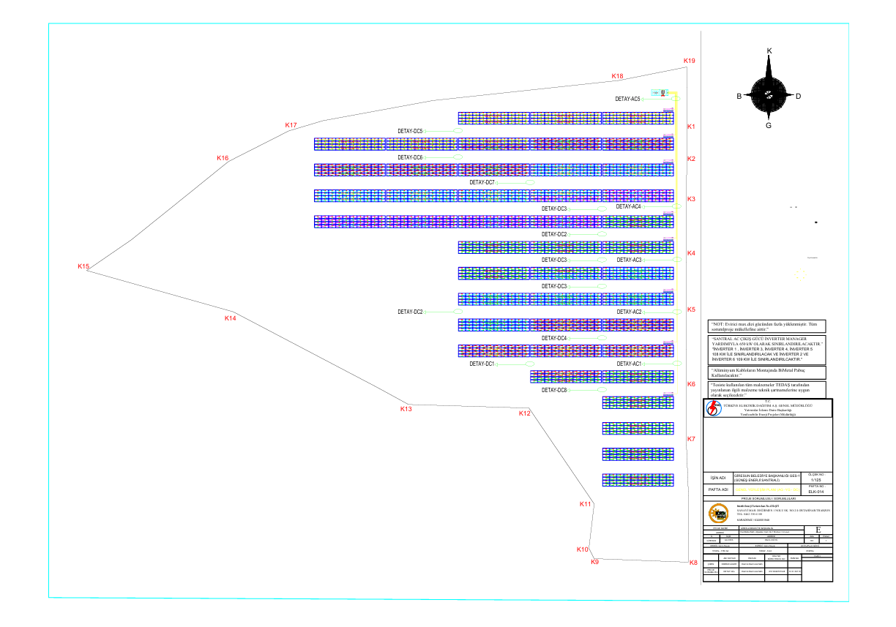

SPP-2
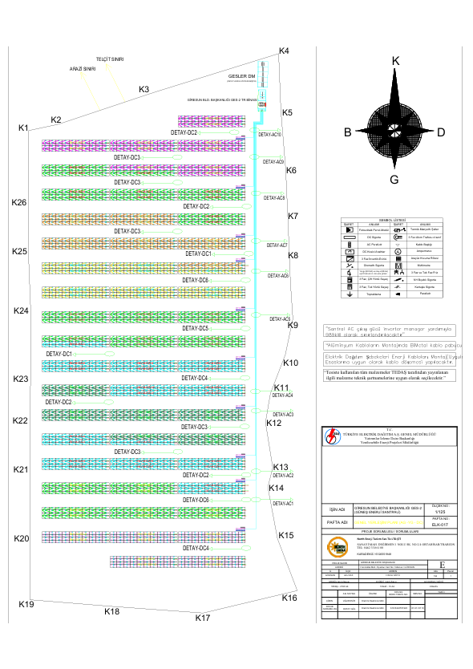

SPP-3
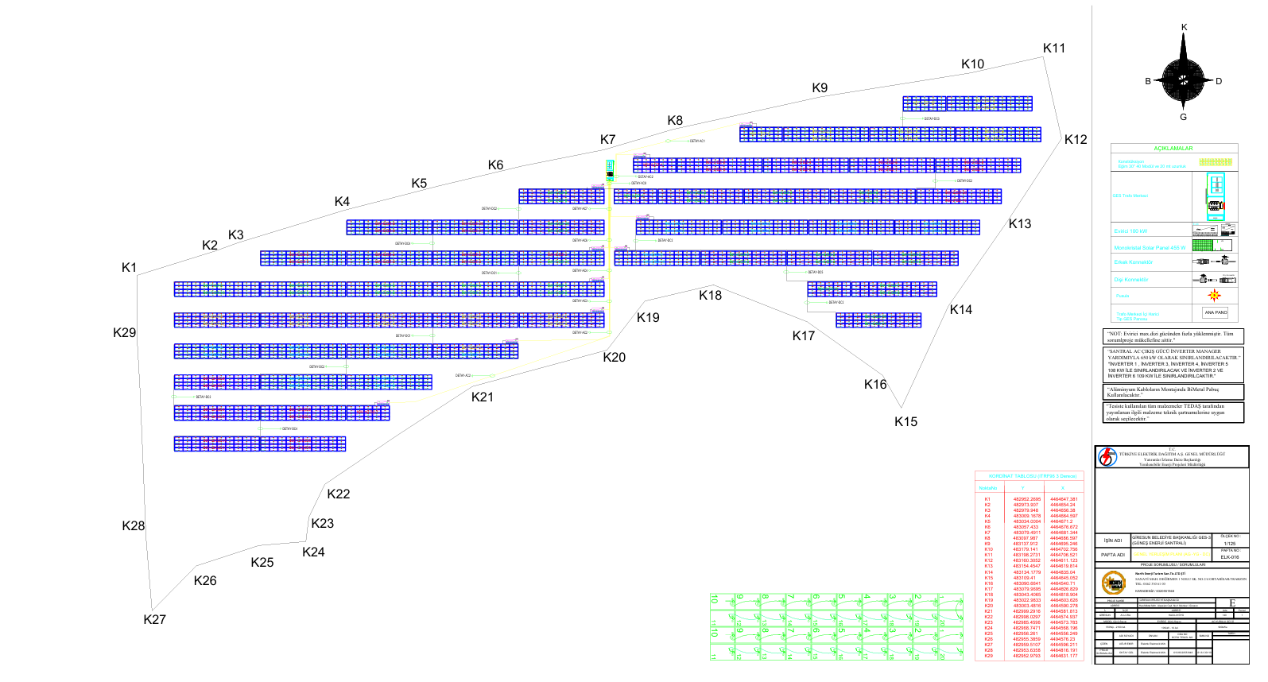

- Description of Conservation Status Categories

Under the Bern Convention, protected fauna species are classified into two categories:
- Appendix II: Strictly protected species
- Appendix III: Protected species
**Article 6 of the Bern Convention:**
Each Contracting Party shall take appropriate and necessary legislative and administrative measures to ensure the special protection of wild fauna species listed in Appendix II. The following are strictly prohibited for these species:
a) Any form of deliberate capture, keeping or killing;
b) Deliberate damage to or destruction of breeding or resting sites;
c) Deliberate disturbance of wild fauna, especially during breeding, development, and hibernation periods, in a manner contrary to the purpose of this Convention;
d) Taking eggs from the wild, or deliberately destroying or keeping them, even if empty;
e) Possession or domestic trade of these animals, alive or dead, including taxidermied specimens or any recognizable parts thereof.
**Article 7 of the Bern Convention:**
1. Each Contracting Party shall take necessary legislative and administrative measures for the protection of wild fauna species listed in Appendix III.
2. The exploitation of these species shall be regulated in a way that does not endanger their populations, taking into account their ecological conditions.
3. Measures may include:
a) Closed seasons and other exploitation rules;
b) Temporary or local bans on exploitation to restore populations;
c) Regulations on the sale, possession for sale, and transport of wild animals.
**IUCN Red List Categories:**
- EX: Extinct
- EW: Extinct in the Wild
- CR: Critically Endangered
- EN: Endangered
- VU: Vulnerable
- NT: Near Threatened
- LC: Least Concern
- DD: Data Deficient
- NE: Not Evaluated
**CITES Appendices:**
- Appendix I: Species threatened with extinction. Trade is only permitted in exceptional circumstances.
- Appendix II: Trade must be controlled to avoid utilization incompatible with their survival.
- Appendix III: Species protected in at least one country, which has asked other CITES Parties for assistance in controlling the trade.
**2024–2025 Central Hunting Commission (MAK) Decisions:**
- ANNEX-1: Game animals with regulated hunting periods
- ANNEX-2: Game animals under protection
**Red Data Book (Kiziroğlu, İ.) Categories:**
- A1–A5: Risk categories from extinct to low risk
- B: Migratory and non-breeding species
- A, G, K, KZ, T: Breeding and migratory status
**National Legislation:**
During project execution, compliance will be ensured with:
- Law No. 2873 (National Parks Law)
- Law No. 4915 (Land Hunting Law and Regulation)
- Bern Convention
- CITES Convention
According to Law No. 4915, as published in the Official Gazette (No. 29341, dated 29 April 2015) and enforced by the regulation dated 1 July 2003, fauna species are categorized as follows:
- Annex I: Wildlife species identified by the Ministry of Forestry and Water Affairs
- Annex II: Game species identified by the Ministry
- Annex III: Protected wildlife species identified by the Ministry
These lists are updated annually in accordance with Law No. 4915 and the decisions of the Central Hunting Commission.

- . Sub project Site Layout Plan
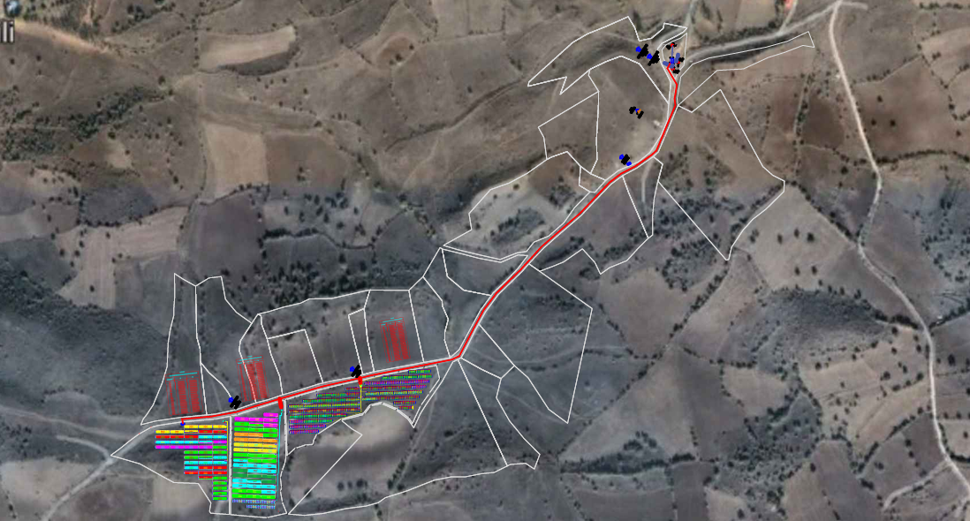

https://www.ilbank.gov.tr/sayfa/ilbank-environmental-and-social-policy https://www.ilbank.gov.tr/sayfa/ilbank-cevresel-ve-sosyal-politika-dokumani
https://www.soilquality.org.au/factsheets/bulk-density-measurement
See Appendix 2 for definitions.
See Appendix 1 for definitions

